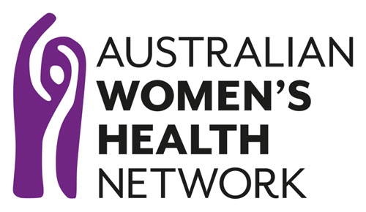
What works well to support women’s health in our communities?
How can we shift the way we understand ‘prevention’ when it comes to women’s health in all of the diversity, communities and contexts across Australia?
How can prevention strategies more effectively integrate with the broader ecosystem of health policy and programs?

At Australian Women’s Health Network (AWHN), our vision is “Health equity for all women”.

We know that women are the majority of health consumers, the majority of health service providers, and the majority of carers. We also recognise that throughout life, women and gender diverse people experience health, illness, and healthcare differently to men. Gender, is at the heart of all health and disease pathways, so gender needs to be considered in all health promotion, prevention, and care.

AWHN is leading a national online project to:
- define what effective prevention looks like across different thematic areas of women’s health and populations
- develop women’s health policy resources in response to identified areas of need
- bank these resources together with broader women’s health knowledge on effective prevention in a refreshed Women’s Health Hub
- share this evidence through a series of online education and training mechanisms on the Women’s Health Hub.

These will be designed to support health advocates, practitioners, Governments, funders, and others to embed a gender equity lens throughout our prevention work.

Resources that emerge from this project will be created in collaboration with AWHN members, reflect AWHN’s commitment to the determinants of health, and draw links between the National Women's Health Strategy 2020-2030 and National Preventive Health Strategy 2021-2030.

About us
The Australian Women’s Health Network (AWHN) provides a national voice on women’s health. It provides a gender equity lens on health care and research, understanding that women’s health is a key social, cultural, environmental, and political matter.

AWHN is the vehicle for women’s health organisations, consumers and advocates to connect and collaborate through our membership base and effective processes to represent the views of members and their constituents.

Project objectives

Increase evidence-based knowledge about effective prevention from a gender equity lens
Strengthen national advocacy and help members drive collective advocacy at local, regional, state, and national levels
Provide well-informed and impartial advice to the Commonwealth
Provide education and training to health practitioners to improve the quality of health services

Collaboration opportunities
We are engaging a broad cross-section of key contributors in the broader health ecosystem who are dedicated to improving women’s health outcomes. Collaborating with those who care about gender and health equity throughout the project will help us explore, develop online resources about, and share knowledge on effective prevention:

There will be opportunities to support design throughout the three key stages of the project: mapping; developing; and sharing knowledge and resources on effective prevention from a gender equity lens.

How will we communicate with key stakeholders?

Population health approach
There is no true ‘average’ woman in Australia, women and girls are diverse in age, social and economic circumstances, the type of work undertaken, as well as culture, language, education, beliefs and a range of other factors that can influence health behaviours and outcomes. Each individual has unique and often complex health needs, shaped by the context in which they live.
– National Women’s Health Strategy 2020-2030, p. 14

Implementing the National Preventive Health Strategy 2021-2030 and National Women's Health Strategy 2020-2030 must be informed by the diverse experiences of women. This project will explore ‘what works well’ to improve health outcomes and increase health equity for all women, including Aboriginal and Torres Strait Islander women, migrant and refugee women, women with disability, and LGBTIQ+ people. In doing so we recognise that women can also face health inequities due to compounding factors, including housing insecurity, economic insecurity, incarceration, precarious visa status, and isolation in regional, rural, and remote areas.
It is vital to learn from the past and strengthen new ways to approach prevention. The evidence that emerges from this project aims to support health outcomes within and across populations, responding to the changing contexts in which we live.
Project principles
A gender and equity lens
We shape processes and systems built on justice and improving health outcomes for everyone; we understand that an intersectional gender lens is integral to achieving health equity.

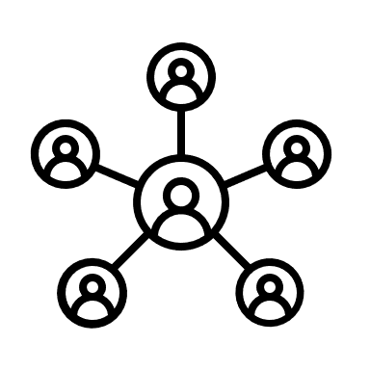 Population approaches
A population approach considers whole populations, communities and groups, to improve the health of all women while reducing inequities among and between those groups within the whole population. Population health work is the approach we use to think about health and the outcomes that can be achieved, asking, ‘Why are some populations healthier than others? What can be shifted to support the quality of health within and across populations?'’

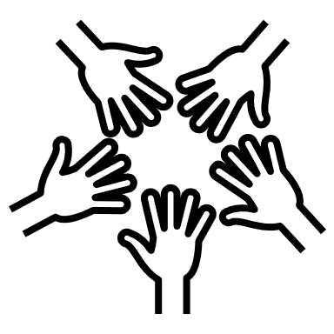 Social model of health
We use a social model of health to examine the social, cultural, political and ecological factors which contribute to the health of women, intergenerationally, within, and across populations.

Universality
We recognise the importance of universal access, equity and agency when it comes to care. We uphold the rights of people who experience social, cultural, economic, political and ecological barriers. Affordable, culturally appropriate and accessible health care is central to our prevention work and evidence building.

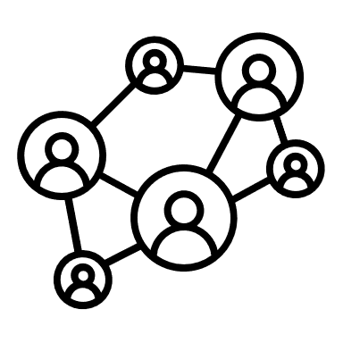 Systems thinking
We use systems thinking to better understand and address the complex issues that cause health inequity. Systems thinking is a way to investigate factors, inter-relationships and interactions that may contribute to better outcomes. By seeing the connectivity between elements that create complex problems, we move towards effective prevention.

Human rights approaches
The Right to Health includes access to healthcare free from any discrimination, including race, gender, sex, intersex status, religion, spirituality, age, and disability. Everyone has the right to the highest attainable standard of health, and effective prevention is key to achieving this.

Governance and leadership
AWHN is governed by a national board made up of State and Territory representatives, who work within thematic subcommittees. This project is managed and implemented by an AWHN staff member in a Senior Project Office role, supervised by the AWHN Chair. The AWHN Policy Subcommittee provides policy leadership to the project publications. A pool of ‘Critical Friends’ of organisations whose core business is health advocacy and/or engagement with key population groups will also inform the development and implementation of key deliverables across the life of the project.
Contact us
To speak about the Women’s Health Hub project, contact Sienna Aguilar, Senior Project Officer at sienna.aguilar@awhn.org.au.

To speak about AWHN governance and leadership, contact Bonney Corbin, AWHN Chair at chair@awhn.org.au.

Web: www.awhn.org.au
Social media: Twitter Facebook Instagram LinkedIn

This project is funded by the Australian Government Department of Health, Health Peak Advisory Body Program.

AWHN’s vision, purpose, and guiding principles are inclusive of cis women, trans, feminine identifying and non-binary people. Our work is guided by feminism, gender equity and human rights. Sometimes we include the terminology such as ‘gender diverse people’ in our communications to acknowledge this.
Women’s Health: The New National Agenda: AWHN Position Paper, March 2008.
Gender equity is the process of being fair to everyone regardless of our gender. The National Women’s Health Strategy 2020-2030 aims to “highlight the significance of gender as a key determinant of health and wellbeing, to strengthen gender-equity and gender-transformative research and services, and women’s and girls’ engagement with the health system.”
As a national project drawing on principles of equity and practicality, AWHN will have a limited number of engagement opportunities based on the resources available (e.g. attendance at online information gathering sessions will be capped if required). AWHN aims to offer different types of opportunities throughout the project.
“Right to health”, Australian Human Rights Commission
The AWHN Policy Subcommittee sets strategic policy priorities to drive social change for women’s health, establish evidence-based policy review processes and approve policy documents.
Critical Friends involved in the design of the project strategy include Multicultural Centre for Women's Health (MCWH), Women With Disabilities Australia (WWDA), and Women’s Health Research Translation Network (WHRTN). During the life of the project this will extend to numerous alliances, organisations, and individuals with intersectional expertise on gender equity and health equity.

