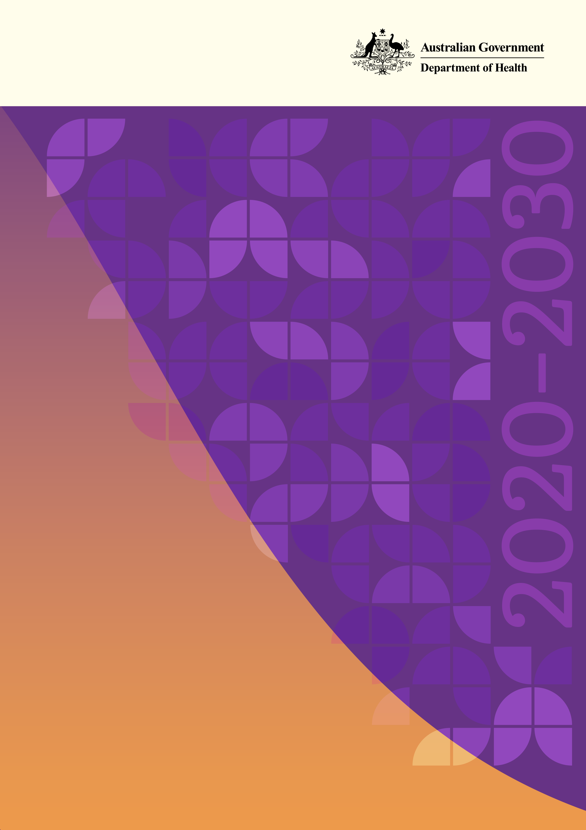

**National Women’s Health Strategy 2020-2030**

© Commonwealth of Australia as represented by the Department of Health 2018

**Creative Commons Licence**

cid:image001.png@01D10CD1.33FE7F70

This publication is licensed under the Creative Commons Attribution 4.0 International Public License available from <https://creativecommons.org/licenses/by/4.0/legalcode> (“Licence”). You must read and understand the Licence before using any material from this publication.

Restrictions

The Licence may not give you all the permissions necessary for your intended use. For example, other rights (such as publicity, privacy and moral rights) may limit how you use the material found in this publication.

The Licence does not cover, and there is no permission given for, use of any of the following material found in this publication:

* the Commonwealth Coat of Arms (by way of information, the terms under which the Coat of Arms may be used can be found on the Department of Prime Minister and Cabinet website http://www.dpmc.gov.au/government/commonwealth-coat-arms);
* any logos and trademarks;
* any photographs and images;
* any signatures; and
* any material belonging to third parties.

Attribution

Without limiting your obligations under the Licence, the Department of Health requests that you attribute this publication in your work. Any reasonable form of words may be used provided that you:

* include a reference to this publication and, where practicable, the relevant page numbers;
* make it clear that you have permission to use the material under the Creative Commons Attribution 4.0 International Public License;
* make it clear whether or not you have changed the material used from this publication;
* include a copyright notice in relation to the material used. In the case of no change to the material, the words “© Commonwealth of Australia (Department of Health) 2018” may be used. In the case where the material has been changed or adapted, the words: “Based on Commonwealth of Australia (Department of Health) material” may be used; and
* do not suggest that the Department of Health endorses you or your use of the material.

Enquiries

Enquiries regarding any other use of this publication should be addressed to the Branch Manager, Communication Branch, Department of Health, GPO Box 9848, Canberra ACT 2601, or via e-mail to [copyright@health.gov.au](mailto:copyright@health.gov.au)

## Minister’s foreword

Australia can rightly be proud of our nation’s health services and of the health and longevity of both women and men in our communities. However, we cannot be complacent as there are both ongoing and new health and wellbeing challenges that we face.

Importantly, recognising and responding to the differences in health outcomes—between women and men and between different groups of women and girls within our population, must be an ongoing focus of our efforts. Enabling women and girls to have access to support for their particular health issues and needs will help to improve the health of our nation.

This is a strategy for all women and girls. It has been developed by and for all women. It recognises that women have both general population and specific health needs.

In 2018, I proposed the establishment of a new strategy to build on the National Women’s Health Policy released in 2010. The years since 2010 have seen important changes in medicine, in health technologies and in society which have had positive impacts on our capacity to respond to the health needs of women and girls.

This National Women’s Health Strategy for 2020-2030 is the result of consultations with women from all walks of life, organisations representing disadvantaged groups, medical associations and with policy makers. Their diverse perspectives, experience and knowledge are valued and respected and I greatly appreciate their contribution.

The Strategy identifies policy gaps and new and emerging health issues for women and girls. It presents recommendations for action and highlights the need for collaboration between partners, including governments at all levels, the health sector, relevant organisations and women themselves. It outlines the importance of directing health system resources towards addressing the health issues affecting women and girls, from preconception to end of life.

The health of women and girls in Australia is fundamental to us all, to the individuals themselves, to their families and communities and to our nation. I am very pleased that this new Strategy could help all women and girls to enjoy the best possible mental and physical health through their lifetimes.

Sincerely



**The Hon Greg Hunt MP**

Minister for Health

## Acknowledgements

We acknowledge the advice and support of the many organisations and individuals that have contributed to the development of this Strategy.  These include (but are not limited to) all participants at the National Women’s Health Forum, state and territory governments, those that provided submissions through the online consultation process and our group of experts who provided technical advice on the draft Strategy.

### Expert Advisory Group members:

Ms LaVerne Bellear, National Aboriginal Community Controlled Health Organisation

Professor Susan Davis, President, International Menopause Society

A/Prof Anita Ghose, University of Notre Dame

Ms Emma Lonsdale, EO, Chronic Disease Prevention Alliance

Ms Christine Morgan, CEO, Butterfly Foundation

Dr Vijay Roach, President, Royal Australian and New Zealand College of Obstetricians and Gynaecologists

A/Prof Ruth Stewart, President, Australian College of Rural and Remote Medicine

## Contents

Minister’s foreword 3

Acknowledgements 4

Contents 5

Executive summary 6

Strategy overview 7

About the Strategy 8

The Strategy in context 8

International context 8

The health of women and girls in Australia 10

Factors contributing to health and health outcomes for women and girls 10

Women’s health at a glance 11

A life course approach 12

Improving health equity for women and girls 14

Priority groups among women and girls in Australia 14

The health of Aboriginal and Torres Strait Islander women and girls 16

Sex and gender diversity 16

What women want 17

Principles and Objectives 18

Priority areas 22

Priority area 1 – Maternal, sexual and reproductive health 23

Priority area 2 – Healthy ageing 28

Priority area 3 – Chronic conditions and preventive health 31

Priority area 4 – Mental health 36

Priority area 5 – Health impacts of violence against women and girls 42

Investing in research 45

What will be different 45

Strengthening Partnerships 49

Achieving progress 50

Appendix A Related policy and strategy documents 51

Appendix B References 53

## Executive summary

The National Women’s Health Strategy 2020-2030 (the Strategy) outlines Australia’s national approach to improving health outcomes for all women and girls in Australia. Building on the overarching National Women’s Health Policy 2010, the Strategy takes account of the changes in the policy environment, considers the latest evidence and identifying the current gaps and emerging issues in women’s health. It aims to inform targeted and coordinated action at the national and jurisdictional levels to address the priority health needs of women and girls in Australia.

The Strategy outlines key health risks and issues for women and girls in Australia. It highlights the range of factors, such as biomedical, behavioural, social, economic and environmental influences, that contribute to health outcomes; and key health inequities such as access to services, health literacy, stigma and gender inequality, that are experienced by many women and girls. Acknowledging the unique needs of different population groups is a key element of the Strategy, with priority populations recognised and targeted interventions identified to improve health outcomes.

Through a life course approach, the Strategy recognises there are a range of health needs, risks and influences experienced by women at different stages of life, and focuses on the importance of investing in awareness and education, health interventions, service delivery and research at these key stages to maximise physical, mental and social health at every age.

The principles and objectives of the Strategy provide a frame for both the development of the Strategy itself and to guide the subsequent implementation of priorities and actions outlined in the Strategy.

Key priorities and actions have been developed to drive change and improve health outcomes. The five priority areas are:

1. Maternal, sexual and reproductive health – increase access to information, diagnosis, treatment and services for sexual and reproductive health; enhance and support health promotion and service delivery for preconception, perinatal and maternal health.
2. Healthy ageing – adopt a life course approach to healthy ageing; address key risk factors that reduce quality of life and better manage the varied needs of women as they age.
3. Chronic conditions and preventive health – increase awareness and prevention of chronic conditions, symptoms and risk factors; invest in targeted prevention, early detection and intervention; tailor health services for women and girls.
4. Mental health – enhance gender-specific mental health awareness, education and prevention; focus on early-intervention; invest in service delivery and multi-faceted care.
5. Health impacts of violence against women and girls – raise awareness about, and address the health and related impacts of violence against women and girls; co-design and deliver safe and accessible services.

The improvement of health outcomes for women and girls is strongly influenced by the contributions made by a wide range of partners. These partners include:

* individuals, carers and families;
* communities;
* all levels of government;
* non-government organisations;
* the public and private health sectors, including health care providers and private health insurers;
* industry; and
* researchers and academics.

Greater cooperation between partners will lead to more successful individual and system outcomes. The priorities and actions outlined in this Strategy are intended to guide partner investment in activities to address the health of women and girls and should be implemented collaboratively to achieve the best health outcomes.

## Strategy overview

#### Figure 1: Overview of the National Women’s Health Strategy 2020-2030

Click to view the text version of Figure 1

Figure showing the overview of the National Women's Health Strategy 2020-2030.
Full description linked.

## About the Strategy

The health of our nation depends on the combined and individual health of Australians. Recognising that women’s experiences of mental and physical illness are different from men’s is essential for developing services that are effective in addressing the health needs of women and girls in Australia.

The Strategy has been developed through a consultative process that considered the latest evidence in relation to women’s health and drew on the input and opinions of leading Australian health experts, members of the health sector and the wider community.

The Strategy aims to drive continuing improvement in the health and wellbeing of all women in Australia, particularly those at greatest risk of poor health. It identifies specific actions to address the health issues that affect women and girls throughout their lives and aims to reduce inequities in health outcomes between men and women, and between sub­‑population groups of women and girls.

To improve the overall health and wellbeing of all women and girls in Australia, they need to be informed and empowered to be part of the decision-making process. The Strategy recognises that a woman’s needs will vary according to her physical, emotional, socioeconomic and cultural circumstances.

## The Strategy in context



The National Women’s Health Strategy is an overarching document designed to complement and align with other health-related policies and strategies. It is designed to provide a gender-specific approach to activities already underway and to guide the development of new and innovative policies and approaches aimed at addressing the specific health needs of women and girls in Australia. Figure 2 provides an overview of the Australian context for women’s health, with a more detailed list of complementary policy documents provided at Appendix A.

The Strategy works in tandem with the National Men’s Health Strategy 2020-2030. The aim of these strategies is to acknowledge the different biological and societal factors that impact women’s and men’s health and wellbeing, and to strengthen and improve national approaches for both.

## International context

The Strategy acknowledges the broader international health policy context for women’s health. As a member state of the World Health Organisation (WHO), Australia has endorsed the adoption of the United Nations 2030 Agenda for Sustainable Development and its seventeen Sustainable Development Goals (SDGs).[1] Within the health context, there is a particular focus on SDG3, SDG5 and SDG10, relating to good health and well-being, achieving gender equality and reducing inequalities, respectively.

The Strategy also aligns with the WHO Global Strategy for Women’s, Children’s and Adolescents’ Health (2016-2030) and the overarching objectives of the associated Survive, Thrive, Transform, to save the lives and improve the well-being of every woman, child and adolescent.[2]

Australia is an active member of the Organisation for Economic Co-operation and Development (OECD) by both contributing to the organisation’s work and utilising the research and recommendations produced to inform policy development. The OECD Health Indicators[3] related to health system performance and the international comparison of the health of Australians have been considered in the development of the Strategy.

#### Figure 2: Overview of the strategic policy context for women’s health

Click to view the text version of Figure 2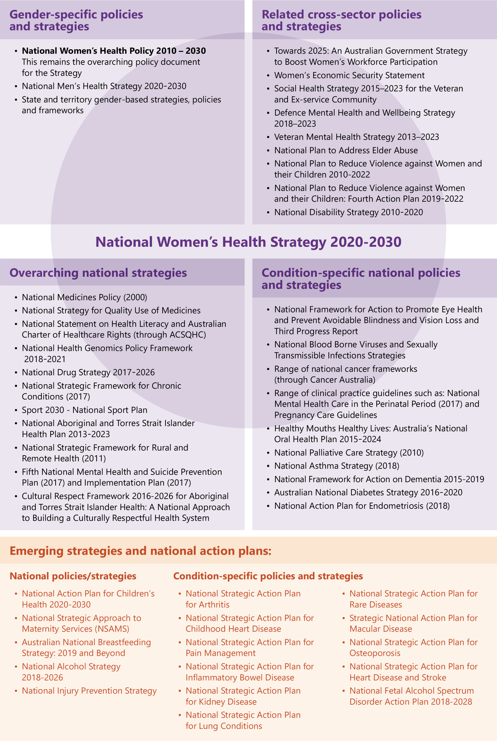

## The health of women and girls in Australia

Much has changed for women since the release of the first National Women’s Health Policy nearly 30 years ago. Societal shifts, as well as changing lifestyles and habits, continue to have a significant impact on the health and wellbeing of women and girls in Australia.

In global terms, Australian women and girls experience strong health outcomes – for example, an Australian girl born during the period 2014-16 can expect to live to nearly 85 years,[4] which sees Australia having the eighth highest female life expectancy when compared with 35 member countries of the OECD.[5]

However, there is a need to reduce the burden of disease and improve quality of life for women and girls by; improving sexual and reproductive health, ensuring we provide the best possible care for an ageing female population, combatting high rates of chronic conditions and mental ill-health, and addressing the health impacts of violence.

## Factors contributing to health and health outcomes for women and girls

Women’s health experiences and outcomes, like that of the population more broadly, are largely shaped by biomedical, behavioural and non-modifiable risk factors together with a broad range of social, economic and physical environment determinants. [6]

* Biomedical risk factors relate to the condition, state or function of the body that contributes to health outcomes, such as medically significant obesity.
* Behavioural risk factors can have positive or negative impacts on health. Physical activity and healthy eating habits reduce the risk of poor health, whereas risk factors such as smoking tobacco, alcohol and/or illicit drug misuse, or exposure to violence, may increase the likelihood of poor health.[7]
* Non-modifiable risk factors affecting women and girls can be genetic, such as hereditary breast cancers relating to an inherited genetic mutation.
* Social and economic determinants are difficult for individuals to control, however they impact how women and girls live their lives.
* Physical environment determinants consider both the natural and built environment in which women and girls live.

While these risk factors and determinants of health are common to both genders, some appear to have a greater influence on health outcomes for women than men, and it must be recognised that the presentation of some health conditions – for example, cardiovascular disease, may be influenced by gender.[8]

The context of women’s lives – including gender, age, ethnicity, sexuality, disability, geography, education and literacy, socioeconomic status, employment status and work conditions – can shape health outcomes by influencing access to health care and experiences of health, wellbeing, illness and death. [9]

## Women’s health at a glance

#### Figure 3: A snapshot of key health risks for women and girls in Australia. [10] [11] [12] [13] [14] [15] [16] [17]

Click to view the text version of Figure 3

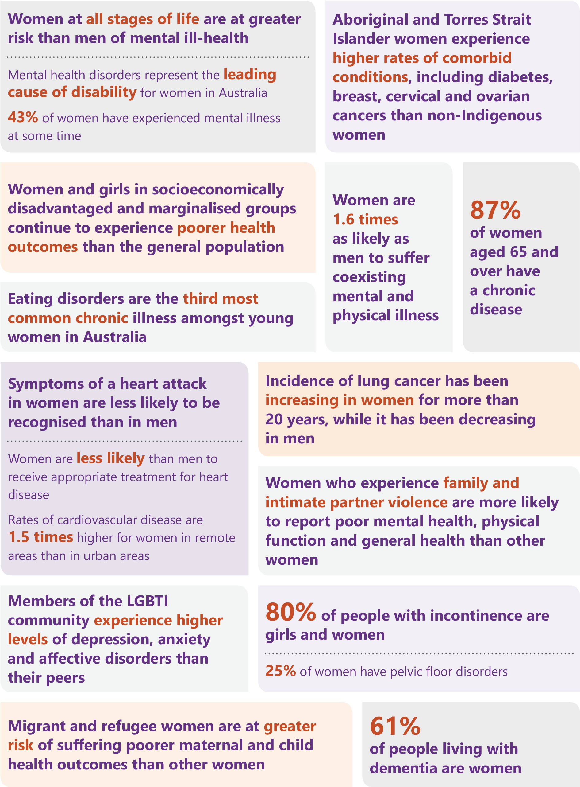

## A life course approach

The Strategy proposes a comprehensive approach to improving women’s health across the life course, recognising that women and girls can experience a range of diverse health needs and risks across their lifespan, and a person’s health at each stage of life affects health at other stages.[18] Different stages of life can trigger points of intersection between health, mental health and social and emotional wellbeing. These life stage intersections provide a potential patient-centred platform for governments, stakeholders, organisations and representative bodies to work together to plan and deliver better coordinated and focused programs to reduce health inequities.

To increase the effectiveness of health education, intervention and service delivery, there needs to be a strategic focus on these intervention points across the life course. Awareness and education campaigns, health services delivery and research investments need to be age appropriate, based on gender equity, and integrated to respond to women’s changing mental and physical health needs.

The Strategy acknowledges that the life course for Aboriginal and Torres Strait Islander women and girls is different from non-Indigenous women and girls, which in turn influences the potential points of intersection. This is addressed in greater detail through the Implementation Plan for the National Aboriginal and Torres Strait Islander Health Plan 2013-2023 and the National Strategic Framework for Aboriginal and Torres Strait Islander Peoples’ Mental Health and Social and Emotional Wellbeing 2017-23.

Figures 4 and 5 provide an overview of the leading causes of total burden of disease, and the changing health needs, risks and intervention points, across each stage of women’s lives.

#### Figure 4: Total burden of disease across the life course [19]

| **Girls** | **Adolescents and young women** | **Adult women** | **Older women** |
| --- | --- | --- | --- |
| Birth to 5 years:  Infant and congenital conditions account for a large portion of the burden in this age group. This is mostly due to  pre-term/low birthweight complications, birth trauma and asphyxia and other disorders of infancy.  5 to 14 years:  Anxiety disorders, asthma and depressive disorders are the leading causes of burden in young girls. | 15 to 24 years:  Anxiety disorders, depressive disorders and asthma continue to lead the cause of disease burden.  Suicide/self-inflicted injuries and motor vehicle accidents are the leading causes of fatal burden.  Young women are at greater risk of experiencing violence. | 25 to 44 years:  Anxiety and depressive disorders are leading non-fatal disease burden.  Burden due to intimate partner violence was highest among women aged 40 to 44 years.  Suicide/self-inflicted injuries and breast cancer are the leading causes of fatal burden.  45 to 64 years:  ‘Other’ musculoskeletal conditions, osteoporosis, back pain problems, anxiety disorders, breast, lung and bowel cancers, COPD and coronary heart disease are the leading causes of total burden. | 65 to 74 years:  ‘Other’ musculoskeletal conditions, osteoporosis, back pain and problems along with osteoarthritis and rheumatoid arthritis are the leading causes of non-fatal burden.  Lung, breast and bowel cancers, alongside coronary heart disease, are the leading causes of fatal burden.  75 years and older:  Dementia and coronary heart disease, hearing and vision disorders, various musculoskeletal conditions and osteoporosis increasingly account for the total burden of disease. |

#### Figure 5: Health focus and key intervention points across the life course [20] [21] [22] [23] [24]

| **Girls** | **Adolescents and young women** | **Adult women** | **Older women** |
| --- | --- | --- | --- |
| Early development of health literacy and help‑seeking behaviours are critical to establishing good health habits for life.  Establishing healthy eating habits in pre‑adolescent years, and regular engagement in physical activity, gives life-long health benefits.  Poor mental and physical health can mean long‑term risks for later in life.  Early detection and intervention for girls experiencing child abuse is essential for future health and wellbeing. | This is a critical time for education and awareness around resilience, respectful relationships and sexual and reproductive health.  Establishing early confidence in, and relationships with, primary health care providers is an important foundation for health literacy and help‑seeking behaviours.  Vulnerable years for health risks, poor mental health, body dissatisfaction, preconception health and lifelong health behaviours.  Peer influence, early sexual relationships, abusive relationships, cultural pressures and societal messaging adversely impact health. | Healthy lifestyles and help‑seeking behaviours are significantly influenced by sociodemographic factors and habits developed during childhood and adolescence.  Women are at increased risk of experiencing mental ill-health during pregnancy and the year following childbirth.  Menopause transition can affect women’s physical and mental health and increases risk for future cardiometabolic health.  Abusive relationships place women at risk of premature death and increased physical and mental ill health. | Support women to age well within their communities and their own homes by building and sustaining community networks; focus on preventable conditions and social determinants to help women maintain their independence.  Older women, who have disproportionately higher rates of chronic conditions, are disproportionately represented in the aged care population.  Older women with chronic conditions are disproportionately represented in the aged care population  Older women are at increased risk of experiencing loneliness and social isolation; which is linked to depression, dementia, and premature mortality.  Elder abuse, physical inactivity and financial insecurity are significant contributors for increased health risks. |

## Improving health equity for women and girls

Through the consultation process, a number of themes emerged as areas to focus on for improving health equity. These include:

| Increase access to services | * Barriers can be physical, geographic, financial, educational or cultural |
| --- | --- |
| Improve health literacy | * Low health literacy levels can result in less access to services, less understanding of issues related to health, poorer health management and social isolation |
| Acknowledge cultural impacts | * Cultural determinants of health are important for Aboriginal and Torres Strait Islander women and girls, as a ‘strong connection to culture is strongly correlated with good health, through strengthened identity, resilience and wellbeing’[25] |
| Break the ‘cycle of invisibility’ | * Information not captured in national health data collection, such as sexual variation, or gender disaggregation in research, results in specific groups being invisible in health care design and delivery. This in turn, negatively impacts on health outcomes for these groups, perpetuating the ‘cycle of invisibility’ |
| Reduce stigma | * Stigma and discrimination experienced by some population groups, and across certain health issues, is inextricably linked to poorer health outcomes |
| Reduce racism | * Institutional and individual prejudice experienced by Aboriginal and Torres Strait Islander women and girls, and some culturally and linguistically diverse population groups, is contributing to poorer health outcomes |
| Reduce gender inequality | * Women carry a disproportionate burden of care and often do not prioritise their own health needs. Additionally, gender pay gaps and less time spent in the workforce can lead to lower retirement incomes, financial insecurity and increasing rates of homelessness for older women |

## Priority groups among women and girls in Australia

There is no true ‘average’ woman in Australia, women and girls are diverse in age, social and economic circumstances, the type of work undertaken, as well as culture, language, education, beliefs and a range of other factors that can influence health behaviours and outcomes. Each individual has unique and often complex health needs, shaped by the context in which they live.

Addressing inequities in health care, between and within population groups, is a key focus of the Strategy. While there have been improvements in the lives and health of women and girls in Australia over the last decade, with a reduction in smoking and alcohol consumption and in death rates from some cancers,[26] many women remain disadvantaged, with greater health needs, lower access to quality health care and poorer health outcomes.

Many women and girls fall into more than one of the identified priority population groups and this can have a compounding effect on health needs and outcomes. For example, many women and girls from rural and remote backgrounds also have a lower socioeconomic status, may identify as Aboriginal and Torres Strait Islander or from a culturally and linguistically diverse background, and may have experienced violence and/or abuse, which singularly and collectively impacts on their health needs.

The Strategy also acknowledges that the sub-groups within the priority populations are not homogenous groups, with individual, social and cultural contexts shaping distinct health needs.

Through targeted health policy design, education and service delivery focusing on the particular needs and circumstances of priority groups of women and girls, there is substantial scope to improve health equity among all women and girls and across the whole population.

Figure 6 represents priority populations that are the focus of this Strategy.

#### Figure 6: Priority Populations for the National Women’s Health Strategy

| Pregnant women and their children | * Behavioural risk factors such as tobacco smoking and alcohol consumption during preconception and pregnancy, impact on pregnancy outcomes and infant health[27] * The rate of domestic violence is higher in pregnant women[28] |
| --- | --- |
| Women and girls from rural and remote areas | * **Women in rural and remote areas have poorer health outcomes than those in urban areas, with greater health risk factors and poorer access to, and use of, health services**[29] * **‘Metrocentric’ assumptions in health care design and delivery also impact on access to health services and poorer health outcomes**[30] |
| Aboriginal & Torres Strait Islander women and girls | * **For Aboriginal and Torres Strait Islander women born in 2010–2012, life expectancy was estimated to be 9.5 years lower than non-Indigenous women (73.7 years compared with 83.1)**[31] * **The impacts of intergenerational trauma, systemic racism and a lack of cultural safety remain significant barriers to health system access**[32] |
| Women and girls from low socio-economic backgrounds and older women with low financial assets | * **Lower socio-economic status is associated with higher morbidity, mortality rates, and health risk behaviours; increased social isolation, low levels of health literacy and poorer access to health services**[33] * **Women who have had no, or intermittent engagement with the workforce, low paid work, and/or have low financial assets may face financial insecurity and increased health risks in older age**[34] * **This includes homeless women and girls** |
| Women and girls living with disability and carers | * **Women and girls with intellectual or other disabilities, and their carers, have higher risk of poor mental health, early onset of chronic conditions and social and economic disadvantage than the general population[35]** |
| Culturally and linguistically diverse women and girls | * **Women from culturally and linguistically diverse backgrounds experience language and cultural barriers in accessing health facilities, services and information particularly in mental health and sexual health[36]** * **This includes migrants, refugees and their children** |
| Members of LBTI communities | * **Members of LBTI communities can experience discrimination and stigma which impacts on both health and health care access, with an increased risk of mental, sexual and chronic illness[37]** * **This includes female-identifying individuals and individuals assigned female at birth and may include transgender men and women, intersex, non-binary and gender diverse people** |
| Women and girls who experience violence and/or abuse | * **1 in 3 women have experienced physical and/or sexual violence and/or emotional abuse by an intimate partner since age 15[38]** * **Intimate partner violence is the greatest health risk factor for women aged 25-44[39]** |
| Women and girls affected by the criminal justice system | * **Key factors that impact on women affected by the criminal justice system are poor mental health, alcohol and substance abuse and histories of early victimisation, particularly child and/or family violence[40]** * **Female prisoners on average have poorer health and show signs of ageing 10-15 years earlier than the general population[41]** |
| Women veterans of Australia’s armed services | * **An emerging potential priority group are women veterans of Australia’s armed services (army, navy, air force and police), due to the stress, anxiety, vulnerability and uncertainty of transitioning from armed services to civilian life[42]** |

## The health of Aboriginal and Torres Strait Islander women and girls

There is a need for a greater focus on the health and wellbeing of Aboriginal and Torres Strait Islander women and girls. As expressed through the theme of NAIDOC week 2018, ‘*because of her, we can*;’ recognising the pivotal role Aboriginal and Torres Strait Islander women have in their communities, and that in order to thrive, to be healthy and well, women’s voices need to be heard.

Aboriginal and Torres Strait Islander women and girls are more likely to experience significantly poorer health and health outcomes than non-Indigenous women and girls.[43] These poorer health outcomes extend across many key areas including: life expectancy and mortality; incidences of mental illness and chronic conditions; health risk factors, such as smoking, alcohol, physical inactivity and unhealthy eating habits; sexual health and child and maternal health; and potentially avoidable deaths and hospitalisations.[44]

The Strategy aligns with the National Aboriginal and Torres Strait Islander Heath and Implementation Plans 2013-2023, the National Framework for Health Services for Aboriginal and Torres Strait Islander Children and Families 2016 and the National Cultural Respect Framework for Aboriginal and Torres Strait Islander Health 2016-2026. This Strategy also acknowledges the Australian Government’s commitment to Closing the Gap.[45]

## Sex and gender diversity

The Strategy takes a broad, inclusive approach to the topic of ‘women’s’ health. It recognises that individuals may identify and be recognised within the community as the gender other than the sex they were assigned at birth, or as a gender which is not exclusively male or femaleand that there is diversity in our bodies, sex characteristics, sexualities and gender identities. Although the terminology used throughout the Strategy generally refers to women and girls, this is not intended to exclude females with diverse sexualities, intersex women and women with a transgender experience.

Where appropriate and when describing the needs of lesbian, bisexual, transgender and intersex Australians, the Strategy adopts the acronym LBTI[46]. It is acknowledged, however, that this acronym does not describe a single category of people but rather communities of sometimes overlapping but distinct groups. The Strategy recognises that both the men and women’s health fields, and all mainstream health services, must appropriately cater for all these groups, not only because they experience a persistently high health burden, but because the prejudice and discrimination often faced can have a profound effect on all aspects of health and wellbeing. Where the acronym LBTI is used, it is with a sensitivity to the diverse needs it represents.

## What women want

Through consultations on the development of the Strategy, a number of themes have emerged as necessary factors to enable successful improvement in the health outcomes of women and girls in Australia. These themes are reflected in the following statements.

Click to view the text version

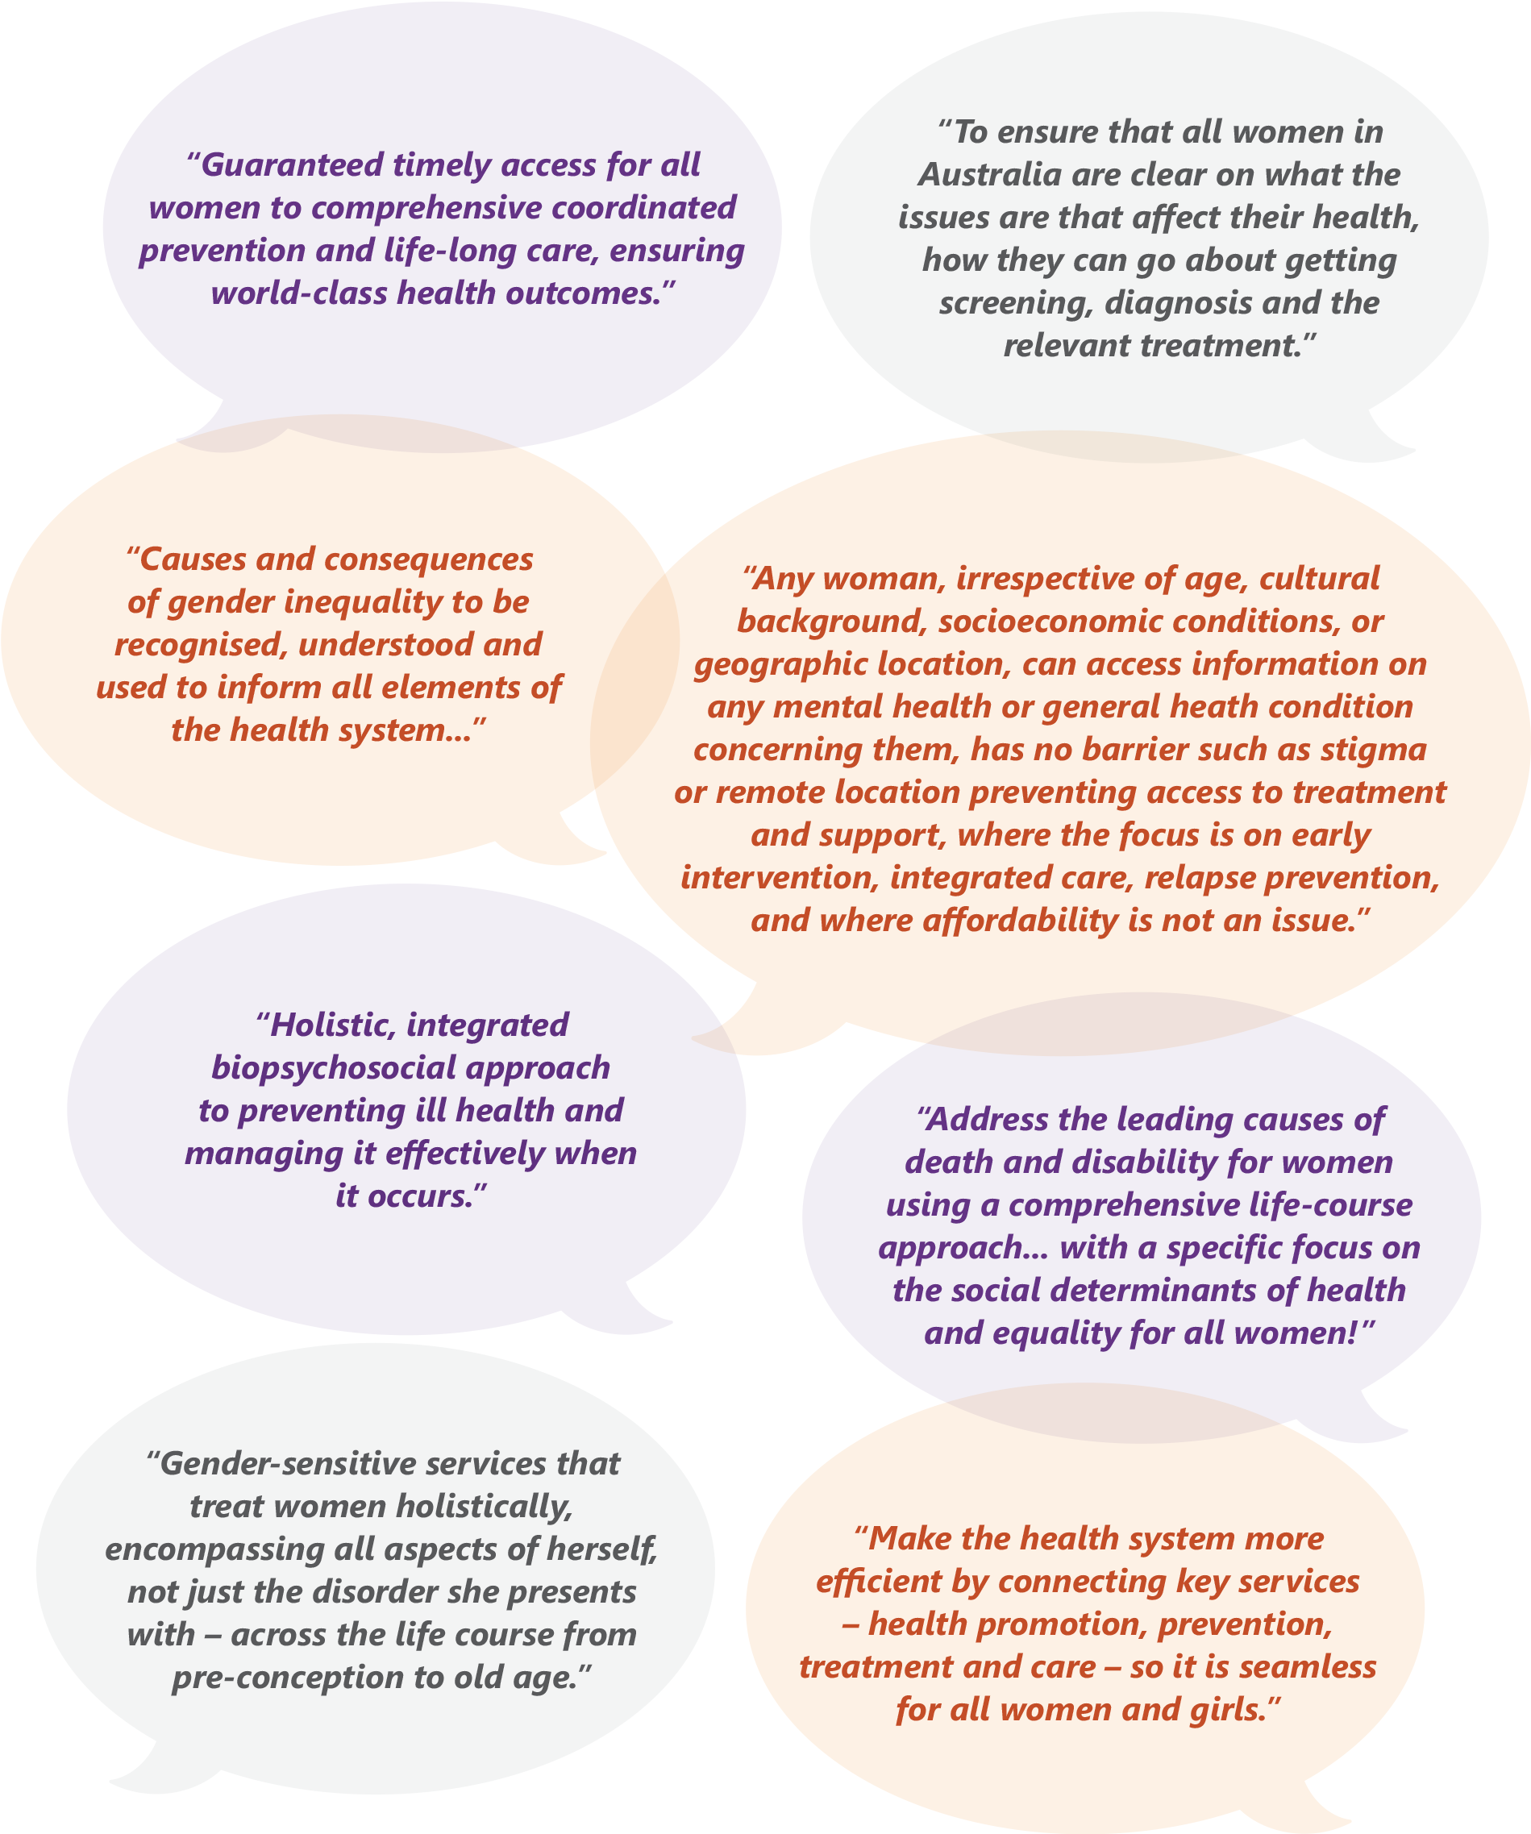

## Principles and Objectives

The five principles and associated objectives are detailed below.

## Principle 1 - Gender equity

### Objective

Highlight the significance of gender as a key determinant of women’s health and wellbeing, to strengthen gender-equity and to enhance women’s and girls’ engagement with the health system

* Recognise and address the gendered nature of specific health conditions and diseases
* Invest in translating gender into all health policy design, development and service delivery
* Support women-run services and women-centred care
* Use a gender-equity lens and an evidence-based approach, to tailor programs, interventions and initiatives to improve engagement, increase equity and combat biases related to sex and gender in the health system

## Principle 2 - Health equity between women

### Objective

Recognise the different health needs of priority populations, address gaps in services and target those women’s population groups where the worst health outcomes are experienced

* Deliver timely, appropriate and affordable care for women and girls in their own communities
* Prioritise and support the development of tools and initiatives that target health issues faced by women and girls that experience inequitable health outcomes
* Focus on the social, cultural and economic determinants of health to understand the needs of varying subpopulations and to deliver culturally and linguistically safe and responsive care
* Provide ongoing support for quality services that directly target priority populations, with reduced institutional and interpersonal discrimination in the health system
* Provide cultural safety training for health care professionals to support the physical, emotional and social health care needs of Aboriginal and Torres Strait Islander women and girls
* Ensure all women and girls have access to health services and information through the provision of culturally and linguistically safe and accessible documents and interpreter services (including Aboriginal and Torres Strait Islander interpreters) and accessible services and documents for people with a disability (such as women and girls with a hearing or vision impairment)
* Ensure appropriate care and recognition for transgender, intersex, non-binary and gender-diverse communities and individuals within health systems and training for health professionals

## Principle 3 - A life course approach to health

### Objective

Develop health initiatives that focus on improving health and target risk factors and critical intervention points for women across the life course

* Recognise that healthy ageing begins at preconception with healthy mothers, and continues on to birth and through the life course
* Acknowledge and respond to the intersectionality of health care and the determinants of health across the life span, and how this influences the health behaviours and outcomes for women and girls
* Strengthen the focus on prevention and self-care; including community, stakeholder and advocacy engagement
* Identify critical intervention points across the life course to better address and respond to relevant risk factors
* Recognise and build systems to account for genomics and family history, and focus on the genetic determinants of health to tailor diagnosis, support and health care provision

## Principle 4 - A focus on prevention

### Objective

Invest in positive prevention and early intervention from childhood, with a focus on the social and gendered drivers of health and holistic person-centred care

* Acknowledge that focusing on the individual as a whole and within their own context is key to effective health care
* Invest in health literacy, health promotion and disease prevention from early childhood
* Engage individuals, community and media platforms to create a culture that empowers all Australians to strive for better health and wellbeing
* Underpin service access improvement with investment in a skilled and culturally competent workforce and supporting technology
* Increase access to screening and immunisation programs, particularly in areas of low uptake
* Address under-use of preventive health by women who are socio-economically disadvantaged
* Shift from a purely medical model to a blended medical and psychosocial model, to consider an individual’s social, economic and cultural context to personalise health care
* Build collaboration and cross-sectoral engagement to improve health and wellbeing outcomes

## Principle 5 - A strong and emerging evidence base

### Objective

Support effective and collaborative research, data collection, monitoring, evaluation and knowledge transfer to advance the evidence base on women’s health

* Identify and focus on the collection of more detailed and nuanced data, particularly for women and girls in underrepresented population groups and with less prevalent conditions, to inform health policy development and program delivery and to break the ‘cycle of invisibility’
* Engage in and promote innovative and non-traditional ways of gathering data alongside quantitative, qualitative and scientific study
* Actively seek to link routinely collected datasets to enhance data collection across women’s health
* Align Australia’s health research investment with the priority health issues affecting women and girls
* Concentrate effort to strengthen research translation across jurisdictions and subject areas
* Recognise and adapt data collection and research methodology to meet the changing needs of women and girls in Australia, particularly as health technologies and information systems become increasingly sophisticated
* Encourage women and girls’ participation in clinical research studies

## Priority areas

There are five priority areas that identify the actions that will deliver a multifaceted approach to improving the health outcomes for women and girls in Australia. Each of these priority areas contributes towards the overall purpose and objectives of the Strategy.

The five priority areas are:

1. Maternal, sexual and reproductive health
2. Healthy ageing
3. Chronic conditions and preventive health
4. Mental health
5. Health impacts of violence against women and girls

These priority areas are inter-related, for example, mental health can be a chronic condition, but given its prevalence as a health issue both among priority populations and also across the life course of women and girls in Australia, it receives specific attention as a separate priority area. Similarly, the health impacts of violence against women and girls, and healthy ageing, can only be addressed if health improvements are made in all of the priority areas.

Each priority area is of equal importance and will require the cooperation of multiple parties. Attention must be paid to all five in order to achieve real progress and achieve holistic reductions in the impact and burden of disease. The integration of the priority areas is modelled in Figure 7.

#### **Figure 7: Priority areas for the National Women’s Health Strategy 2020-2030**

Click to view the text version of Figure 7

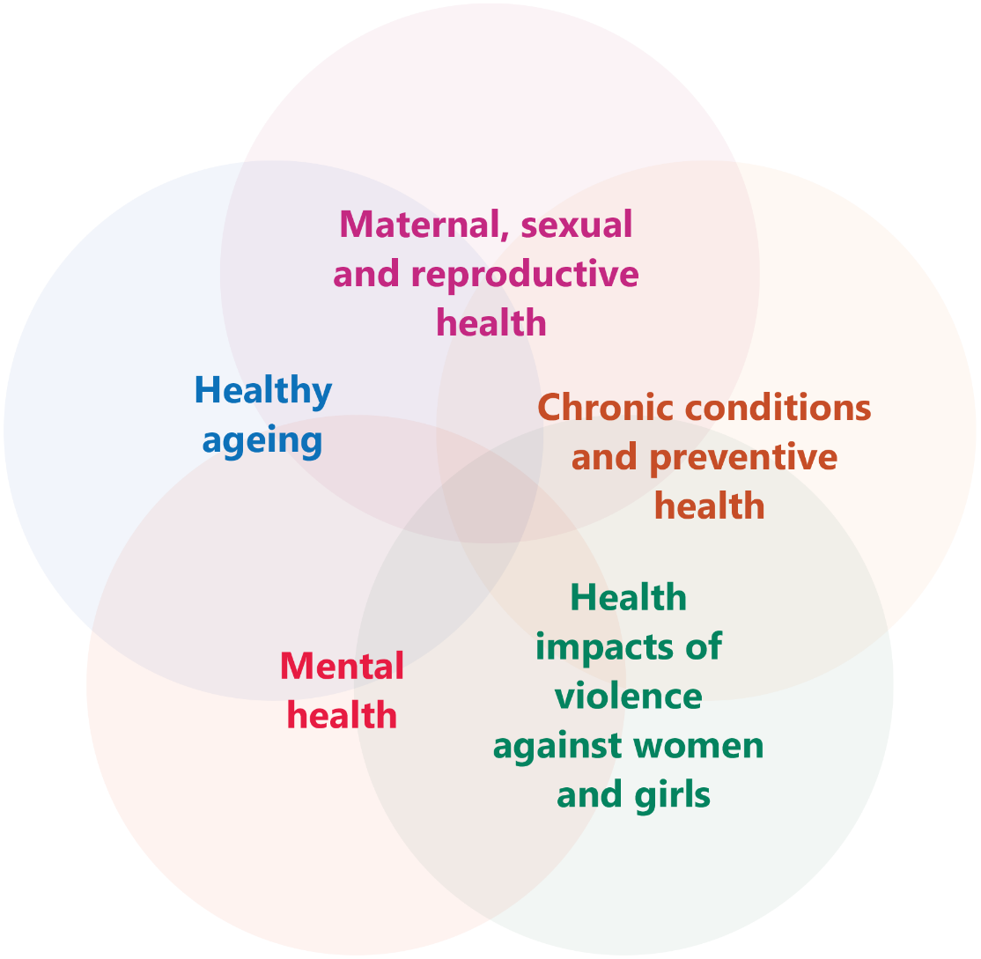

Priority area 1 – Maternal, sexual and reproductive health

Maternal, sexual and reproductive health is a priority for Australian women and girls and must be considered within the social and cultural context of women’s lives. It is not simply about the absence of disease, but refers to a state of physical, mental and social wellbeing across all stages of life. Factors contributing to maternal, sexual and reproductive health include the role of women in society and the control women have over their own bodies, reproductive choices and lifestyle. This highlights the need for women and girls to be informed of, and to have access to, safe, effective, affordable and acceptable forms of fertility regulation, health services and support.[47]

### What’s working well

In December 2018, the Australian Government announced an investment of $7.2 million to help reduce the rate of stillbirth in Australia. This will be achieved through education and awareness programs for women and medical practitioners, research to minimise preventable stillbirth through the use of biomarkers and ultrasound in late pregnancy and stillbirth research through the Medical Research Future Fund.

The successful National Human Papillomavirus (HPV) Vaccination Program has led to a rapid and significant decline in genital warts and is expected to reduce the rates of HPV-related cancers in the coming years, such as cervical cancer.[48]

The Australian Government has delivered a National Action Plan for Endometriosis – the first ever blueprint seeking to improve treatment, awareness and understanding of this condition and related chronic pelvic pain.

There is also a focus on improving maternity services and providing breastfeeding support for mothers and babies in Australia, through the development of a National Strategic Approach for Maternity Services and a new Australian National Breastfeeding Strategy 2019 and beyond. There are also a range of other strategies that are relevant for sexual and reproductive health (refer Figure 1).

### What needs more attention

The incidence and impact of poor sexual and reproductive health on women and girls varies between different population groups, influenced by factors such as socioeconomic status, geographic location and age. Improved sexual and reproductive health outcomes are reliant on the availability of, and access to, appropriate health promotion and education material that is suitable for people with limited sexual health literacy.

Three key priority areas for action have been identified to improve maternal, sexual and reproductive health for Australian women and girls:

1. Increase access to sexual and reproductive health care information, diagnosis, treatment and services
2. Increase health promotion activity to enhance and support preconception and perinatal health
3. Support enhanced access to maternal and perinatal health care services

### Key measures of success

* Decrease in the notification rates of sexually transmissible infections for priority populations
* Increase in the availability and uptake of Long Acting Reversible Contraception (LARCs)
* Equitable access to pregnancy termination services
* A continued increase in the rate of vaccinations under the National HPV Program
* Increased early access to antenatal services by Aboriginal and Torres Strait Islander women and culturally and linguistically diverse women
* De-stigmatisation of urinary and faecal incontinence and improved access for women to care for these conditions, including pelvic floor physiotherapy
* Improved access to counselling and care of adult women with sexual function concerns

### Priorities and actions

1. Increase access to sexual and reproductive health care information, diagnosis, treatment and services

|  |  |
| --- | --- |
| Action | Detail |
| Promote access to resources for students and parents to learn more about sexual and reproductive health | Update sexual health curriculums in schools to include information on:   * + Sexually transmissible infections (STIs) and access to screening, and the long-term effect of STIs on fertility   + Available contraception options   + Respectful relationships   + Safe and consensual sex   Education needs to be delivered in partnership with teachers, parents and the local community.  Education should be inclusive of sex, gender and sexual diversity, be sex positive and culturally and linguistically safe and appropriate. |
| Improve access to information, screening services, self-education and self-management tools to encourage self-informing and help-seeking behaviours in relation to women’s sexual and reproductive health | Promote and support national access to cervical screening.  Develop interactive tools (phone applications, web-based tools and symptom checkers) to increase sexual and reproductive health literacy and health-seeking behaviour.  Promote these tools to health professionals and health networks to facilitate information sharing and to raise awareness of their application. |
| Raise community and health care provider awareness to improve visibility and diagnosis of under-recognised sexual and reproductive health conditions and reproductive risk factors | Promote existing and emerging information sources for conditions such as:   * + Endometriosis and other chronic pelvic pain conditions (as outlined in the National Action Plan)   + Polycystic ovarian syndrome   + Primary ovarian insufficiency   + Pelvic inflammatory disease   + Complications from transvaginal mesh implants   + Complications from menopause |
| Improve treatment and support for urinary and fecal incontinence in women | Establish specialist primary care services for incontinence:   * + Provide access to pelvic floor physiotherapy for older women with urinary and faecal incontinence and pelvic organ prolapse |
| Remove barriers to support equitable access to timely, appropriate and affordable care for all women, including culturally and linguistically sensitive and safe care | Work towards universal access to sexual and reproductive health information, treatment and services that offer options to women to empower choice and control in decision-making about their bodies, including contraception and options for addressing unplanned pregnancies, including access to termination services.  Improve access to and uptake of appropriate contraceptive methods including long acting reversible contraception through education for GPs, nurses and other health care providers, and expansion of service provision.  Improve equitable access to evidence-based IVF.  Expand family planning services for priority population groups, including Aboriginal and Torres Strait Islander women, women with disability, health care card holders, migrants and refugee populations and incarcerated women. |
| Strengthen access pathways to sexual and reproductive health services across the country, particularly in rural and remote areas | Ensure strong referral pathways between primary care services and specialised services and practitioners.  Invest in and support the development and expansion of telehealth services and new models of care.  Continue to support women’s health services at a national, state and local level.  Provide education and training to GPs, nurses and other relevant health care providers, to provide comprehensive sexual and reproductive services.  Develop a suite of approaches for information sharing and access to sexual and reproductive health services for women who have limited access to mobile and digital channels and local services, such as women in rural and remote areas.  Increase access to services for conditions such as polycystic ovarian syndrome, endometriosis, vaginismus, premature and early menopause, prolapse, incontinence, sub-fertility and infertility.  Increase access to government-funded health services that offer sexual and reproductive health services, particularly for women living in rural and remote areas. |

1. Increase health promotion activity to enhance and support preconception and perinatal health

|  |  |
| --- | --- |
| Action | Detail |
| Promote the importance of good preconception health, particularly regarding nutrition, lifestyle and pelvic floor health, for all women who are planning a pregnancy | Increase awareness of gestational diabetes as an indicator of Type 2 diabetes later in life and support affected women to make healthy life choices.  Increase awareness of the link between hypertensive disorders during pregnancy and risk of cardiovascular disease.  Develop and deliver preventive health and awareness programs for pelvic floor health.  Map family history and previous health experiences for preconception and newly pregnant women to understand and manage risks for women and their babies. |
| Engage with existing whole-of-life preventive health campaigns to promote awareness of pregnancy complications, pregnancy loss and infertility | Support health care services, including genetic counsellors, involved in preconception and perinatal health care to enable women to lower pregnancy and infertility risks.  Promote awareness of the link between excess weight gain from a young age and infertility and ill health during pregnancy.  Support awareness and support for miscarriage. |
| Tailor service delivery and communication messages to ensure cultural safety in maternal and perinatal care for all women | Design campaigns and programs which celebrate positive and relatable mother figures and role models across priority populations.  Support the implementation of the Cultural Respect Framework 2016-2026 for Aboriginal and Torres Strait Islander Health. |

1. Support enhanced access to maternal and perinatal health care services

|  |  |
| --- | --- |
| Action | Detail |
| Support primary and community health care services to complete all pre-pregnancy activity and education about available screening options, alongside existing sexual and reproductive health services | Encourage primary and community health care services (including GPs, women’s health care centres, family planning clinics and community pharmacists) to leverage perinatal health care interactions with pregnant women to provide support and referral to appropriate services to address other physical and/or mental health conditions.  Ensure women planning pregnancy are aware of screening tests available to them prior to and during pregnancy.  Promote screening for available genetic testing and carrier screening, mental health assessments, indicators of domestic or sexual abuse and consideration of risk factors for chronic conditions. |
| Create clear pathways for women to access relevant services to prevent or minimise the impact of the reoccurrence of pre-existing conditions, emergence of conditions as a result of pregnancy, as well as plan for subsequent pregnancies | Equip GPs to address and support pre-existing conditions both previously known and discovered during the first pregnancy and refer to other services where appropriate. For example, genetic counsellors.  Develop and encourage use of follow up postnatal care pathways to identify at-risk women to prevent chronic conditions, and treatment of issues which either emerged during pregnancy, such as gestational diabetes, or are a direct result of pregnancy and/or birth, such as pelvic floor problems and/or incontinence.  Promote health care services that support women in addressing common postnatal health problems such as urinary incontinence, haemorrhoids and bowel issues. |
| Support women’s capacity to establish and maintain breastfeeding | Facilitate breastfeeding education and awareness for health professionals who may encounter women in the perinatal period to protect, promote and support breastfeeding.  Promote breastfeeding information and support programs.  Promote the NHMRC Australian Infant Feeding Guidelines to relevant health professionals.  Support the implementation of the Australian National Breastfeeding Strategy 2019 and Beyond. |
| Promote access to Aboriginal and Torres Strait Islander specific maternity programs that support cultural safety | Align with and support the implementation of the National Approach to Maternity Services. |
| Improve access to, and integration of, mental health services throughout preconception and perinatal stages. Engage with health care practitioners to promote and utilise the Mental Health Care in the Perinatal Period: Australian Clinical Practice Guideline | Provide mental health support for women with sub-fertility, infertility, women going through IVF and women who experience miscarriage or stillbirth.  Increase support for women at risk of experiencing perinatal mental ill-health and encourage mothers to seek help and social support.  Break down the stigma surrounding postnatal depression, perinatal anxiety and other mental ill-health experienced in the perinatal period.  Include screening for indicators of violence. |
| Tailor awareness campaigns to address late presentation to antenatal care for Aboriginal and Torres Strait Islander, migrant and culturally and linguistically diverse women | Co-design education and awareness materials and campaigns with each cohort across the community, to develop the specific messages required for each group.  Include peer support and education. |
| Set sustainable national accreditation criteria, measurements and standards for maternal and perinatal care | Collaborate with peak bodies to work towards consistent national implementation of best practice guidelines.  Enhance workforce capability through training to upskill GPs, nurses and midwives. |

Priority area 2 – Healthy ageing

Australian women are living longer, healthier lives, with more women in all age groups from 65 years and above experiencing ‘excellent’ or ‘very good’ health, and less disability, than in previous decades.[49]

Healthy ageing and its associated concepts (successful ageing, positive ageing, ageing well and ageing productively) have been developed over the years as a response to changing population demographics. Healthy ageing is defined as ‘the process of developing and maintaining functional ability that enables wellbeing in older age’.[50] It is about optimising the health, wellbeing and engagement of older women by creating opportunities and conducive environments.

### What’s working well

There have been significant advances in medical science, which reduce the impact of some major conditions (e.g. premature deaths from heart disease), but also increase the likelihood of more people living longer with multiple conditions (multimorbidity and disabilities).[51]

This priority aligns with the *National Strategic Framework for Chronic Conditions*, the *National Framework for Action on Dementia* and a range of other strategies, including emerging condition-specific Action Plans (refer Figure 1).

### What needs more attention

The consequences of population ageing for the health system need greater recognition. In particular, the disease specific structure of many health services, especially medical specialties, needs re-orientation to cope with people with multiple complex chronic conditions. This requires greater emphasis on the person and not on the disease.

There are three key priority areas for healthy ageing:

1. Adopt a life course approach to healthy ageing for women
2. Address key risk factors that reduce quality of life for women as they age
3. Better manage the needs of the ageing population

### Key measures of success

* Reduction in the number of preventable and avoidable deaths
* Increased screening for a wider spread of comorbidities, inclusive for dementia and cardiovascular disease
* Increase in the proportion of women and girls meeting the physical activity guidelines in line with the WHO Global Action Plan on Physical Activity

### Priorities and actions

1. Adopt a life course approach to healthy ageing for women

|  |  |
| --- | --- |
| Action | Detail |
| Build awareness that healthy ageing starts with young women and girls to embed a preventive and health promotion approach throughout life | Engage with individuals, education institutions and healthcare providers to reinforce that ‘healthy ageing begins early’ and is the ongoing aim of healthy lifestyles and habits. |
| Acknowledge the need for targeted conversations and interventions relating to healthy ageing at different points in the life course and across priority populations | Reduce stigma and normalise the conversation about ageing across all stages of the life course.  Support whole-of-life preventive approaches that embrace wellness and self-care. |

1. Address key risk factors that reduce quality of life for women as they age

|  |  |
| --- | --- |
| Action | Detail |
| Monitor emerging patterns of multimorbidities in older women and tackle the risk factors that cut across conditions | Support programs that improve musculoskeletal health of women to achieve long term prevention of frailty and fracture.  Educate Australians on the role of frailty as an emerging indicator of poor health in women.  Target the high-risk ratio for neurodegenerative disorders in older Aboriginal and Torres Strait Islander women.  Address the increase in homelessness experienced by older women in Australia.  Educate and support GPs, pharmacists, aged care workers, nurses, community care and other health care providers to recognise and respond to elder abuse. |
| Support women and their health care providers to manage the effects of menopause | Increase training for health professionals in menopause and older women’s health. |
| Recognise and equip health care practitioners to support women’s sexual wellbeing as they age | Provide information for mid-life and older women on sexual wellbeing, including on sexually transmissible infections. |
| Address conditions that impact on the non-fatal burden of disease | Use national, regional and local data to inform and improve access to:   * + dental services for priority populations   + audiology advice and hearing devices   + services to reduce vision loss   + neuropsychiatric conditions |
| Target risk factors for dementia across the life course | Promote screening of all women at clinically indicated ages for risk factors for dementia including cardiovascular risk. |
| Enhance screening for cardiometabolic disease | Identify women at increased risk of cardiovascular disease through the promotion of heart health checks over the age of 45 years (35 years for Aboriginal and Torres Strait Islander women).  Promote integrated care for women identified at increased risk of vascular conditions such as those associated with:   * + Prior pregnancy   + Diagnosis with polycystic ovarian syndrome   + Breast cancer |
| Enhance prevention efforts to reduce the risk of falls and fractures | Ensure implementation of falls and fracture prevention strategies in health services and community and residential aged care services. |
| Promote awareness around incontinence | * Target communication strategies to promote the National Continence Program. * Promote mechanisms to enable the discreet public disposal of continence products. |

1. Better manage the needs of an ageing population

|  |  |
| --- | --- |
| Action | Detail |
| Build capability within the health system to identify and effectively manage the increasing complexity and health needs of older women | * Acknowledge the amplification of trauma that occurs at end of life and support trauma-informed aged care services. * Incentivise GPs and other health care providers to undertake relevant health checks at 45+ and 70+ years. * Invest in services which provide holistic, affordable and integrated care for older women with chronic conditions. * Improve access to assistive technologies and support for older women with disabilities or with restrictive functional capacity. * Invest in and improve access to services for older women in regional, rural and remote areas. |
| Recognise loneliness experienced by older women as a key issue and encourage increased physical and social interactions and promotion of community and workforce participation for older women | * Continue to invest in key health promotion and social support initiatives that are inclusive of women from diverse backgrounds, and promote and support evidence informed community-based interventions such as peer group support and allied health education and support programs. * Promote and support health promotion and social support initiatives for women in regional, rural and remote areas. |
| Recognise and respond to the intersecting needs of women’s health care as they age | * Develop culturally and linguistically safe training for health care practitioners and aged care workers that includes recognition of, and responds to, diversity among older women. * Provide support to meet the specific needs of priority population groups as they age, such as Aboriginal and Torres Strait Islander women, LBTI communities, culturally and linguistically diverse women and women with disability. |
| Acknowledge the role of carers and provide resources and social support through multiple sources, including peer support platforms | * Recognise the particular circumstances and health needs arising for women providing intergenerational care within families and networks. * Promote and facilitate access to condition-specific support organisations. |

Priority area 3 – Chronic conditions and preventive health

Chronic conditions are the leading cause of illness, disability and death in Australia.[52] They place a significant burden on individuals, families and carers, the community and the health system, with 1 in 2 Australians experiencing at least one of the eight major chronic conditions (arthritis, asthma, back pain and problems, cancer, cardiovascular disease, chronic obstructive pulmonary disease, diabetes or mental health conditions).[53] While chronic conditions are of concern for both men and women, there are differences in how some chronic conditions can affect men and women.

In 2016, the leading causes of death, accounting for 11 per cent of deaths, for women was dementia and Alzheimer disease, closely followed by coronary heart disease.[54]

### What’s working well

Outcomes for chronic conditions, such as cardiovascular disease, have been broadly improving over the last half century due to medical advancements, reduction in some risk factors and increasing availability of services. Smoking rates within Australia have decreased when compared internationally.[55]

Despite increases in some diagnosis rates, death rates from many cancers have also been decreasing, due to screening to detect early cancers and substantial improvements in diagnosis and treatment.[56]

The Practice Nurse Incentive Program allows practice nurses to have a greater focus on the prevention and management of chronic conditions and financial support to expand the number of nurses employed in general practice has also provided benefits.

This priority aligns with the National Strategic Framework for Chronic Conditions and a range of other strategies and emerging condition-specific Action Plans (refer Figure 1).

### What needs more attention

A large proportion of the burden of disease in Australia is preventable.[57] In the period leading to 2030, there is a need to increase primary and secondary prevention and early detection of factors that greatly affect the development of chronic conditions. In 2011, the risk factors causing the most burden were tobacco use, high body mass, alcohol use, physical inactivity and high blood pressure.

There are three key priorities for chronic conditions and preventive health:

1. Increase awareness and primary prevention of chronic conditions and associated risk factors for women and girls and embed a life course approach in policy and practice
2. Invest in targeted prevention, timely detection and intervention of chronic conditions affecting women and girls
3. Tailor health services to meet the needs of all women and girls
4. Reduce the prevalence and impact of endometriosis and associated chronic pelvic pain

### Key measures of success

* Reductions in the prevalence of obesity, tobacco use, alcohol consumption, increased physical activity and improved eating behaviours for women - broken down into priority population data
* Lower incidence of cancers
* Improved rates of breast, cervical and bowel cancer screening for under-screened populations, including women from Aboriginal and Torres Strait Islander, culturally and linguistically diverse, rural and remote and LBTI communities
* Decrease in prevalence of chronic conditions in women
* Better identification and detection of hidden conditions such as endometriosis and associated chronic pelvic pain, and improved mechanisms for treating and managing these conditions.

### Priorities and actions

1. Increase awareness and primary prevention of chronic conditions and associated risk factors for women and girls and embed a life course approach in policy and practice

|  |  |
| --- | --- |
| Action | Detail |
| Develop and deliver an education campaign that raises awareness of the characteristics across a woman’s lifespan which impact risk of chronic conditions and multimorbidity | Target a range of messaging about prevention of modifiable chronic conditions risk factors for women and girls of all ages.  Acknowledge breastfeeding as a preventive strategy for a range of chronic conditions and cancers.  Promote and support evidence-based information and services for women that recognise and respond to psychosocial risk factors such as stress and trauma, affecting women’s physical and mental health.  Promote information to enhance self-management and health system navigation, supported by regular access to health system gateways such as clinics, general practitioners (GPs) and pharmacists. |
| Empower women and girls to better prevent illness and manage their own health care needs | Support peer to peer health through health data sharing applications such as ‘PatientsLikeMe’, which promotes behaviour change and self-care by tracking progress and allowing people to compare themselves to others.[58] |
| Develop and publicise an authoritative ‘map’ of risk factors and chronic condition intervention points across women's lifespans, from childhood to older age | Articulate the impact of different events over the life course (such as adverse events, relationship breakdowns, pregnancy loss and childbirth) to identify care pathways within the health system.  Ensure that the map is tailored to meet the needs of priority populations, for example, include the impact of CALD specific and migration experiences and cultural impacts for Aboriginal and Torres Strait Islander women and girls.  Identify opportunities to streamline access to health care.  Encourage and support wide dissemination of, and engagement with, the map through all health care settings.  Utilise the existing health prevention and promotion infrastructure at the local level to support awareness and dissemination of information.  Ensure the map is accessible to all priority populations in both digital and print forms. |

1. Invest in targeted prevention, timely detection and intervention of chronic conditions affecting women and girls

|  |  |
| --- | --- |
| Action | Detail |
| Support the development of healthy habits through family and institutional settings to improve health for women and girls | Pursue cross-government and service sector partnerships to:   * + embed nutrition education and provision of healthy food options in all schools   + reduce children’s exposure to the promotion of unhealthy foods   + promote active school travel for all children   + advocate for support for healthier food choices in a range of community settings, such as sport and recreational facilities   + Improve the capacity of health care practitioners to provide support for education and engagement in healthy eating behaviours for priority populations |
| Develop and deliver a national campaign to promote awareness of the different risks for and symptoms of cardiovascular disease in women | Design a campaign that:   * + Improves awareness of key risk factors and warning signs to health professionals and the community   + Builds knowledge to reduce their risk factors   + Changes behaviour so more women get heart health checks   Promote awareness of cardiovascular risks for women particularly through universal and consistent screening for cardiovascular risk for women in relevant age related and other risk groups.  Develop a national approach for screening and medication of rheumatic heart disease.  Support delivery of these activities through a range of health care settings including general practice, community pharmacies, women’s health centres and community health centres. |
| Increase access to, and promote uptake of, cancer screening and immunisation programs, particularly among identified priority populations | Raise awareness of, and provide access to, genetic screening for recognised cancer risk in at risk women.  Enhance access to and support the continued use of mobile cancer screening services for women in rural and remote areas or from lower socioeconomic quintiles.  Enhance workforce capacity and capability through education and training to deliver culturally and linguistically safe and appropriate cancer screening services.  Design tailored campaigns and programs aimed at increasing knowledge and awareness of cancer screening.  Build capacity in rural and remote areas to facilitate timely follow up and treatment services.  Continue to maximise uptake of the HPV vaccine. |
| Improve the diagnosis and treatment of cancers predominantly affecting women | Establish gynaecological cancer centres of excellence across Australia. |
| Promote healthy behaviours, particularly physical activity, to reduce the risk from poor health and chronic conditions | Establish adolescent health checks to provide early intervention and support for physical and mental health risks in young women.  Design tailored programs to increase engagement of women and girls with low levels of physical activity in priority populations.  Improve the capacity of health care practitioners to provide access to support for health improving behaviours for priority populations.  Improve the ‘exercise literacy’ of health care practitioners to provide support for education and engagement in healthy behaviours, particularly physical activity for priority populations. |

1. Tailor health services to meet the needs of all women and girls

|  |  |
| --- | --- |
| Action | Detail |
| Apply a gendered approach to tailor programs, interventions and initiatives to women, with the aim of increasing health literacy to enable self-advocacy and empowerment of women | Celebrate healthy and diverse role models and encourage health services that tap into a strengths-based engagement strategy.  Develop platforms and programs for peer support among women with chronic conditions, encouraging women to share information, stories and support. |
| Ensure health policy development for women and girls addresses the needs of priority populations | Promote and support evidence-based information and services to address social determinants of health, including education, welfare, employment and participation, for priority population groups and communities.  Focus on women's population groups where poor health outcomes are experienced, including Aboriginal and Torres Strait Islander women and women in rural, regional and remote locations, homeless women, previously incarcerated women, recent migrants and refugees, women with disability, members and veterans of the armed forces and LBTI communities. |
| Allocate specific, sustainable funding for women’s health programs and services | Engage in service re-design to reduce or remove systemic barriers for women and girls accessing appropriate health care.  Design services through wider consultation with the women who access (or should access) them to best meet their diverse needs while focusing on holistic person-centred care.  Pursue needs-based funding arrangements and strategies to address the higher burden of chronic conditions and risk factors experienced by Aboriginal and Torres Strait Islander women and girls. |
| Support educational, advocacy and support networks, providing information on available services and helping women and girls navigate the health system | Highlight existing clinical and education tools that clarify care pathways for women and girls with any stage of chronic conditions initiation and progression.  Support women impacted by the psychosocial impacts of chronic illness recurrence, through linkage to ongoing care and peer support systems. |
| Provide holistic, affordable and integrated care for women and girls with chronic conditions | Recognise and address the co-occurrence of chronic mental and physical health conditions.  Promote multidisciplinary team participation in consultation regarding women’s health programs and the development of clinical tools. |

1. Reduce the prevalence and impact of endometriosis and associated chronic pelvic pain

|  |  |
| --- | --- |
| Action | Detail |
| Stronger awareness, recognition, acknowledgement and education regarding endometriosis and associated chronic pelvic pain | Develop widespread, visible and context-specific community awareness campaigns delivered through multiple channels.  Promote early education on women’s health, delivered in school settings, and provided for all genders.  Improve access to information, self-education and self-management tools for individuals living with endometriosis at all stages of their journey.  Improve awareness and understanding of endometriosis among health professionals working at every stage in the clinical pathway. |
| Ensure availability of, and access to, affordable and consistent healthcare options, and better treatment options, for endometriosis patients. | Develop clinical guidelines and clinical care standards to promote integrative care for all stages of the care pathway.  Target diagnostic delay and promote early access to intervention, care and treatment options.  Improve the affordability, accessibility and national consistency of management and care options throughout Australia.  Endure endometriosis is recognised as a chronic condition by all health practitioners, acknowledging its physical, psychological and social impacts.  Narrow the gap in quality of life between patients and their peers. |
| Strengthen the national research agenda for endometriosis and associated chronic pelvic pain to enable: more accurate quantification of disease burden; investigation of causes; and increase the potential for finding a cure. | Build a collaborative environment that enables world-leading research on endometriosis.  Mine existing data and improve data linkage between sources to improve understanding of the current state of endometriosis in Australia.  Conduct further research to understand the causes and impacts of endometriosis and progress towards the development of a cure. |

Priority area 4 – Mental health

There are a number of critical life points experienced by women and girls, such as puberty, pregnancy, motherhood and menopause that can result in poor mental health.[59] In addition, a variety of situations typically associated with women can lead to anxiety and depression. These include; infertility and perinatal loss, being a primary care giver, relationship breakdowns, violence or abuse, discrimination, unemployment or under‑employment, isolation and socioeconomic disadvantage.[60]

It is estimated that approximately one in five women in Australia will experience [depression](https://www.beyondblue.org.au/the-facts/depression) and 1 in 3 women will experience [anxiety](https://www.beyondblue.org.au/the-facts/anxiety) during their lifetime.[61] Women also experience [post-traumatic stress disorder (PTSD)](https://www.beyondblue.org.au/the-facts/anxiety/types-of-anxiety/ptsd)[62] and eating disorders at higher rates than men.[63]

Eating disorders may occur at any stage of life, but research suggests that they occur most often among young women. The Australian Child and Adolescent Survey of Mental Health and Wellbeing estimated that, in 2012–13, 2.4% of young people aged 11–17 reported problem eating behaviours. A greater proportion of females (3.5%) than males (1.4%) reported these behaviours. [64]

### What’s working well

There is an increasing awareness throughout Australia about common mental health conditions and a subsequent reduction in associated stigma. The prevalence of common mental disorders, including anxiety and depression, has been stable over the last decade, with a rate of 1 in 5 women.[65]

There has been growth in help-seeking behaviours with an increase in numbers of people accessing psychologist services through the Australian Government’s Better Access initiative.[66] The initiative has also been expanded to include telehealth consultations to improve access to mental health services for people in regional, rural and remote Australia.[67] Additionally, the Australian Government funds a number of digital mental health services, including telephone and online mental health treatment, counselling and support, which are delivered through a person-centred, stepped care approach, providing a range of services to better match individual needs.

In December 2018, the Australian Government announced an investment of more than $110 million to fund the first dedicated Medicare services for patients with eating disorders. From 1 November 2019, patients with anorexia nervosa and patients with other eating disorders with complex needs will be eligible to receive Medicare rebates for the development and review of a comprehensive treatment and management plan and up to 40 psychological and 20 dietetic services per year, depending on their needs. This announcement responds to the recommendations of the independent, clinician-led Medicare Benefits Schedule (MBS) Review Taskforce (the Taskforce).

This priority area complements the actions of the Fifth National Mental Health and Suicide Prevention Plan and Implementation Plan, along with a range of other relevant strategies (refer Figure 1).

### What needs more attention

Federal and state and territory governments have identified mental health as a policy priority, and whilst access to mental health services has improved, there remains ongoing challenges in reducing the burden of mental illness in Australia.

Five key priority areas for action have been identified to improve mental health outcomes for women and girls in Australia:

1. Enhance gender-specific mental health education, awareness and primary prevention
2. Focus on early intervention, diagnosis and access to mental health care
3. Invest in service delivery for priority populations
4. Adopt a multi-faceted approach to support women and girls with eating disorders
5. Raise awareness and embed practices to reduce stigma and discrimination associated with mental ill-health

### Key measures of success

* Lower incidents of mental health reporting, self-harm and suicide
* A reduction in mental health related illness
* Increase in the number of mental health services and the ability for priority populations to access these
* Greater integration of mental and physical health care

### Priorities and actions

##### 1. Enhance gender-specific mental health education, awareness and primary prevention

|  |  |
| --- | --- |
| Action | Detail |
| Collaborate with existing early learning institutions and schools to strengthen early education and promote opportunities to screen young girls and adolescents who may be at high-risk | Promote access to resources for parents and for school students to learn more about mental health, including peer support and mentors.  Support provision of resources for early years centres and for school curriculums to include a gendered focus on building resilience, managing depression and anxiety, promoting positive body image and resolving conflict through social media.  Support the national roll out of relationship education in schools. |
| Equip primary and secondary school educators, as well as physical and mental healthcare staff in these environments, to recognise the factors, such as sexual and family violence, discrimination or distorted body image, that influence mental health in young girls and adolescents | Provide resources, guidance, support and information regarding referral pathways to:   * + students and their families   + adolescents in out-of-home care or living with a disability   + foster families and carers   + Aboriginal and Torres Strait Islander education officers/assistants in schools with a high indigenous population |
| Increase awareness of the impact of sex and gender on mental health for women and girls | Support training for service providers and health care practitioners.  Develop gender sensitive resources and support services. |
| Identify and address the longer‑term systemic forms of discrimination in information provision, service delivery and other social determinants that impact on mental health | Address institutional and individual prejudice in health care service delivery experienced by Aboriginal and Torres Strait Islander women and girls.  Provide culturally and linguistically appropriate resources, guidance and support to women, healthcare professionals and education providers about the impact of childhood trauma, bullying, relationship breakdown, financial distress, unemployment, housing insecurity, chronic conditions and substance use across the life course.  Support middle aged and older women dealing with mental health issues. |
| Support the development of media and community awareness materials covering a range of mental health conditions affecting women and girls across the priority populations | Tailor education and awareness materials and campaigns for each cohort across the community, with time taken to work with these groups to investigate and co-design the specific messages required for each group at a local level.  Utilise the existing prevention and health promotion infrastructure at the local level to support implementation. |
| Develop and deliver ‘protective’ mental health strategies to reduce the onset of mental ill-health | Establish adolescent health checks to provide early intervention and support for physical and mental health risks in young women.  Promote physical activity and cultural and recreation initiatives to protect an individual’s mental health.  Raise awareness of, and develop strategies to, address mental health impacts of social isolation in vulnerable groups of women.  Address the barriers to awareness of the importance of mental health early intervention resulting from stigma.  Invest in measures to support the mental health and wellbeing of carers. |

##### 2. Focus on early intervention, diagnosis, integration and access to mental health care services

|  |  |
| --- | --- |
| Action | Detail |
| Invest in an expansion of community mental health services to focus on diagnosis, early intervention and integration of services | * Equip Primary Health Networks to coordinate services and use national, regional and local data sources to plan future workforce capacity based on projected demand. * Continue work to refine referral pathways, improve screening and diagnosis tools and align federal and state health policy to better integrate national and state-based services. * Prioritise investment into mental health services in rural and remote areas:   + Include culturally and linguistically safe services tailored for Aboriginal and Torres Strait Islander women and girls   Promote and support early intervention through referrals to community health services, women’s health centres and services established to meet the needs of women and girls who experience violence or abuse. |
| Develop additional targeted programs to address the specific mental health care needs of women and girls | Increase specific services for young women and girls (0-18) that recognise and respond to early childhood experiences such as trauma or adolescent experiences such as body image and eating disorders.   * Invest in developing appropriate programs to target eating disorders in adolescent women, and provide support for women with eating disorders across the lifespan. * Emphasise prevention and early intervention in mental health and wellbeing, focusing on perinatal mental health, including mental health care for those who have experienced miscarriage or stillbirth. * Recognise and monitor the specific mental health needs of women from Australia’s armed services and the police force, particularly in the period as they transition out of service. |
| Deliver a system that provides universal and equitable access to people in mental health crisis | * Facilitate access to rapid response high quality and culturally and linguistically appropriate services for women and girls experiencing suicidal crisis, including immediate after-care and crisis support. * Include freely accessible, digital or phone-based suicide prevention information sources and applications, which enhance system navigation from prevention services, through immediate after-care and crisis support. * Increase access to, and support for, peer support and trauma informed care in emergency departments and front-line health services. * Provide education and support for front-line health care professionals to facilitate the provision of trauma informed care and support for women in mental health crisis. * Promote and support existing digital mental health services available through the Australian Government’s digital mental health gateway, Head to Health ([www.headtohealth.gov.au](http://www.headtohealth.gov.au)). |
| Integrate physical and mental health care in recognition that poor mental health is a major risk factor for poor physical health (and vice versa) | * Promote and support evidence-based services to ensure women and girls being treated for mental health conditions have their physical health regularly assessed. * Promote regular mental health assessments of women and girls with chronic conditions, and those requiring extended cancer care and support. |

##### 3. Invest in service delivery for priority populations

|  |  |
| --- | --- |
| Action | Detail |
| Focus on access to mental health support services for groups with lower access and greater need | * Tailor services and messaging to respond to the cultural determinants of health. * Develop specific strategies to target and reduce mental ill health among priority populations. * Recognise and respond to the mental health needs and risk factors for women and girls with intellectual or other disabilities. * Collect demographic data for priority populations to enable measurement of improvements in service access. * Fill gaps for key populations, for example 0-12 and 25+ categories of young people who are not served by existing services. |
| Expand existing services for lower prevalence high impact conditions | * Invest in services for bipolar disorder, schizophrenia and perinatal psychosis. * Equip Primary Health Networks to coordinate services and support lower prevalence conditions through development of capability protocols and clinical governance models. |
| Support innovative initiatives to develop a new generation of mental health services | * Engage in targeted co-design with adolescents and young women, and with older women to build engagement. |
| Support measures to address the impact of violence, complex trauma and intergenerational trauma | * Undertake systemic capacity building and professional development for trauma informed approaches across the health sector. * Provide trauma-sensitive care and recovery-oriented care that recognises women’s experiences of violence and trauma. |

1. Adopt a multi-faceted approach to support women and girls with eating disorders

|  |  |
| --- | --- |
| Action | Detail |
| Provide schools with easily accessible information about available services for students at risk of developing eating disorders | Develop and deliver resources to be used in family and institutional settings to raise awareness of the risk factors and symptoms of eating disorders.  Continue to develop and promote freely accessible, digital prevention information and support resources and applications. |
| Deliver a system that provides universal access to rapid response high quality services for women with eating disorders | Replicate best practice approach eating disorder strategies to inform a consistent and collaborative national approach.  Support existing community-based models for prevention, early intervention and relapse support. |

1. Raise awareness and embed practices to reduce stigma and discrimination associated with mental ill-health

|  |  |
| --- | --- |
| Action | Detail |
| Promote and support positive mental health messaging through mobile and digital channels, to combat stigma, discrimination and misinformation that affects women and girls | Messaging should highlight the importance of giving all women and girls a voice, in particular the lived-experience voice, through employment of peer workers, consumer and carer representatives, including women and girls from diverse population groups.  Use these diverse voices to reflect diverse experiences on a variety of forms of mental ill-health, including lesser-understood conditions.  Promote and support existing positive mental health messaging such as ‘Life in Mind’.  Acknowledge and address the role of trauma in mental ill-health. |
| Educate the Australian community on the use of appropriate, non-stigmatising language around mental health | Use a co-design approach and lived experience to identify language preferences.  Advertise online resources for organisations and institutions to adopt similarly responsible language   * + Promote the use of guidelines such as the Mindframe National Communications Charter, to ensure consistent messaging in the media around suicide, mental illness and alcohol and other drugs   Continue working to normalise everyday conversations around subjects considered taboo such as suicide and pregnancy loss. |
| Invest in continuing education and awareness-raising for health professionals to embed inclusive practices and trauma informed care in the health system | Focus on the effects of violence against women and girls and the life-long impacts on physical and mental health.  Focus on the mental health needs of transgender, intersex, non-binary and gender-diverse Australians.  Consider specific actions to reduce harm and improve engagement with the health system. |

Priority area 5 – Health impacts of violence against women and girls

Violence against women is recognised as a serious and widespread problem in Australia, with enormous individual and community impacts and social costs.[68] In a 2016 national survey, about one in six (17 per cent or 1.6 million) women had experienced physical and/or sexual violence by a current or previous partner since age 15, and almost one in four (23 per cent or 2.2 million) women had experienced emotional abuse by a current or previous partner. [69] Of these women, 54 per cent experienced more than one incident of violence.[70]

Women who experience intimate partner violence and/or sexual violence are more likely to report poorer mental health, physical function, and general health, as well as higher levels of bodily pain.[71] Intimate partner violence is the greatest health risk factor for women in their reproductive years. It contributes more to the burden of disease (the impact of illness, disability and premature death) of adult women in their reproductive age (18-44 years) than any other risk factor, including smoking, alcohol and obesity. It contributes an estimated 5.1 per cent of the burden in women aged 18-44 years.[72] Abuse and trauma across the life course may have a cumulative deleterious effect on health and wellbeing.

### What’s working well

The National Plan to Reduce Violence against Women and their Children 2010-2022. This National Plan and subsequent action plans, focus on stopping violence before it happens and building the evidence-base about what works to reduce violence.[73] The Strategy focuses on the health impacts of violence against women and girls and ways to reduce these impacts.

### What needs more attention

Women who experience multiple forms of inequality and discrimination experience higher rates of family and intimate partner violence, sexual violence and reproductive coercion. This is particularly prevalent among young women, pregnant women, Aboriginal and Torres Strait Islander women, women from culturally and linguistically diverse backgrounds -particularly refugee and migrant women, women with disabilities, LBTI women, experiencing financial hardships and women who were exposed to violence or abuse as a child.[74]

According to an Australian Institute of Family Studies report, women in regional, rural and remote Australia are more likely than women in urban areas to experience domestic and family violence. In addition, these women may face specific issues related to their geographical location, the availability of services, and the cultural and social characteristics of living in small communities.[75] [76]

There are three key priorities for health impacts of violence against women and girls:

1. Raise awareness of the health impacts of violence against women and girls
2. Address health and related impacts of family and sexual violence
3. Co-design and deliver safe and accessible services for women experiencing family, intimate partner and/or sexual violence

### Key measures of success

* Increase in number of services available, and women accessing these services
* Decrease in deaths from physical violence on women
* Reduction in the proportion of women who have experienced abuse or trauma in their life
* Reduction in the rate of reproductive coercion
* Reduction in the gap in mental and physical health trajectories between women who have and have not experienced violence

### Priorities and actions

1. Raise awareness of the health impacts of violence against women and girls

|  |  |
| --- | --- |
| Action | Detail |
| Promote peer education of children, young people and adults to raise awareness and educate both genders about the health impacts of violence against women and girls | Collaborate with work under the National Plan to Reduce Violence against Women and their Children 2010-2022 to address and reduce health impacts on women and children:   * + Engage with both men and women from diverse backgrounds in the design of awareness campaigns to promote positive relationships and educate both genders about the health impacts of violence towards women, on women and girls, men and communities |
| Raise awareness of the physical and mental health manifestations of violence against women and girls and the pathways to support | Develop and deliver an awareness campaign that:   * + Empowers women to speak up about their experiences of sexual and/or domestic violence or harassment   + Creates safe environments to enable disclosure and ongoing support   + Uses diverse voices to reflect different experiences of a variety of forms of violence, abuse or harassment and their long-term physical and mental health impacts |

1. Address health and related impacts of family and sexual violence

|  |  |
| --- | --- |
| Action | Detail |
| Develop innovative models to address the health impacts of violence against women and girls, particularly focusing on those at greatest risk | Support projects to develop place-based strategies addressing the health impacts of violence on women and girls and communities that are owned and managed by Aboriginal and Torres Strait Islander people and linked to initiatives around prevention of violence.  Increase the capacity of health care practitioners to recognise and address the physical and mental health impacts of violence against women, with particular investment in services for pregnant women, women from culturally and linguistically diverse backgrounds and women with disability. |
| Educate the broader health workforce about indicators that a woman or her children may be experiencing family and/or sexual violence | Increase the capacity of the workforce, particularly frequently accessed health care practitioners such as: GPs, community pharmacists, Aboriginal Health practitioners and community health organisations, with tools to provide support and links to services while ensuring safety as a priority.  Consider specific actions to reduce harm and improve engagement with the health system, including:   * + Provision of trauma informed care   + Mother and child-only clinic appointments   + Flexible arrangements for health service access |

1. Co-design and deliver safe and accessible services for women experiencing family, intimate partner and/or sexual violence

|  |  |
| --- | --- |
| Action | Detail |
| Improve access to, and invest in, immediate crisis intervention support as well as longer-term advocacy, support, education and training for women experiencing family, intimate partner and/or sexual violence | Involve affected women (and their families) in the design and redevelopment of these services to ensure that services are matching the needs of their users.  Embed inclusive practices in the system to ensure services are culturally and linguistically safe and appropriate, taking account of vulnerability experienced by women escaping family and/or intimate partner violence. |
| Provide women with a choice of pathways to recovery after sexual and/or domestic violence or harassment | Increase the capacity of health services and health care practitioners to support women in their recovery. |
| Continue to develop and invest in freely accessible, digital information sources and applications and 24-hour phonelines, which can connect women who have difficulty accessing physical services due to their circumstances | These digital information sources and applications should always include mechanisms that facilitate both:   * + an immediate referral to services   + an immediate exit from the application   Link services for survivors of family, intimate partner and/or sexual violence closely to mental health support services, as recovery is strongly linked to experiences of mental ill-health. |

## Investing in research

Investing in research is critical for successful delivery of the priorities and actions outlined in the Strategy. Due to the strength, collaborative will and specialised knowledge of its research community, Australia is well placed to lead and develop research into improving health outcomes for women and girls, both nationally and internationally.

A Commonwealth investment of $18 million through the National Health and Medical Research Council (NHMRC) will support research focusing on significant health challenges that affect Australian women including breast cancer, maternal health, immunisation rates and cardiovascular disease - a leading cause of death in Australian women.[77] This funding will support priorities specifically identified in the Strategy.

Additional Commonwealth investment of $17.5 million through the Medical Research Future Fund was also announced in the context of the 2018-19 Budget under the Maternal Health and First 2000 Days/Women’s Health program.[78]

In August 2018, the Australian Government announced a further $200 million investment through the NHMRC and the Medical Research Future Fund, which also aligns with the priorities and actions outlined in the Strategy. These projects aim to find solutions to a wide range of health challenges, including cancer, cardiovascular disease, stillbirths and mental health; and will support research into specific conditions such as improved care for premature babies, arthritis and osteoporosis, treatment for depression and anxiety in young people and improved health for older Aboriginal and Torres Strait Islander people.[79]

## What will be different

The research opportunities offered by the NHMRC and the funds made available through the Medical Research Future Fund will offer significant scope to make immediate and longer-term improvements in health outcomes for women and girls both in Australia and internationally. Research techniques will be collaborative and innovative, and will include the development of novel diagnostics and therapies and research translation, and will be supported by discerning, effective use of clinical trials. Investing in research is needed to:

1. Strengthen and diversify research and data collection across identified health priorities for women and girls

|  |  |
| --- | --- |
| Action | Detail |
| Map the gap between current needs and available services to understand the scope of mental health services for women and girls and where integration across the health system is needed | * Invest in ongoing delivery of the National Survey of Mental Health and Wellbeing:   + Include eating disorders, injury and self-harm in the survey to obtain nuanced national estimates of their prevalence and impact * Use non-traditional data collection methods including qualitative, ethnographic and narrative, to understand the effect of social determinants of health and the lived experience of women and girls with mental ill-health. |
| Establish and improve data collection processes and disaggregation of existing and future data and research to develop better understanding of health access, experiences and outcomes, and to inform policy design | * Include identifiers for:   + Aboriginal and Torres Strait Islander women and girls   + culturally and linguistically diverse women and girls - including women from migrant and refugee backgrounds   + Intersex Australians and national population-level data for LBTI communities |
| Invest in more timely data collection, translation and research for under-researched groups and conditions affecting women and girls, particularly focusing on the priority populations | * Invest in existing longitudinal studies, such as the Longitudinal Study on Women’s Health to deepen the understanding of long-term trends in women’s health, with particular emphasis on priority populations. * Utilise existing national data sets to undertake regular analysis and monitoring of health conditions affecting priority populations of women and girls. * Commission research into perinatal health and mental health. * Commission research to understand the life-long impacts of childhood trauma, including family and sexual violence. * Commission research as appropriate into mental and physical health needs of women veterans as the number of women in the armed services increases. * Include research on participation in screening programs for women. |
| Advocate for adequate representation in clinical, biomedical, public health and health services research and data analysis to include sex and gender in research addressing mainstream conditions such as cardiovascular disease | * Ensure funded research includes appropriate numbers of female participants as a requirement when funding or commissioning research. * Support gender specific research in prevention and treatment of cardiometabolic diseases. * Encourage clinical trials to actively recruit women in equal proportion to men in all relevant research. |
| Fill gaps in research, ensuring there are up-to-date figures for prevalence and measures for underreported conditions, such as chronic pain | * Utilise existing health promotion, public health research and evaluation evidence to drive future actions. |
| Support research into low survival gynaecological cancers, such as ovarian cancer | * Prioritise the development of screening and early detection tools. * Develop a standardised clinical registry to track treatment outcomes. * Improve access to clinical trials. |
| Support targeted research into sex- and gender differences in profiling for chronic conditions | * Consider implications and hormonal influence for treatment and secondary prevention. * Support research to understand why breastfeeding is a modifiable risk factor for a range of cancers and chronic conditions. |
| Disaggregate data for sexual and reproductive health conditions | * Support research to understand comorbidities and linkages between violence and sexual and reproductive health, including the link between STIs and family violence. |
| Maintain awareness of the outcomes of research undertaken through the $500 million Australian Health Genomics Futures Mission and implement new technology to improve access to early diagnosis and prevention of disease in women and girls | * Monitor the outcomes from the Mackenzie’s mission pre-conception carrier testing project. * Continually review effectiveness of new findings from genomic medicine to develop improved and targeted treatment for women and girls. * Continue to educate primary health care providers and non-genetic specialists in the use of genomic testing and genomic medicine to support improved and earlier diagnosis of conditions and potential options for targeted treatments. |
| Increase data and research relating to the risk factors affecting pregnancy and pregnancy complications | * Commission research on maternal anxiety and depression, stillbirth, miscarriage, pregnancy complications, and obesity during pregnancy. * Support research which examines the impacts of infertility treatment outcomes on mental health and productivity, and seeks to mitigate causes of infertility. |
| Commission further research into the impact of menopause | * Examine the impact of early or medically-induced menopause on mental and physical health as well as the overall impact of menopause on work. * Consider research into women’s experiences of menopause alongside its economic impact. |
| Support research into the short and long-term impacts of family and intimate partner violence and/or sexual violence and develop targeted strategies to support those affected | * Support the work of research centres such as Australia’s National Research Organisation for Women’s Safety (ANROWS) to undertake ongoing research into the long-term health effects of violence and sexual abuse on women and children and the translation of research into practice. * Support research strategies focused on primary prevention of violence against women and girls. * Disaggregate existing and future data and research to provide a more nuanced understanding about the intersection of family and intimate partner violence with all aspects of women and children’s lives. * Support existing research into the prevalence and measures of health impacts experienced by underreported population groups, including the intersecting drivers of violence against different groups and the effectiveness of prevention strategies, to ensure adequate services are available. |
| Invest in research to better understand the pathogenesis of dementia in women | * Develop resources for the prevention of dementia across the life course, as well as ongoing research to improve diagnosis, treatment and care options for women living with dementia. * Develop strategies to reduce dementia risk and slow the progression of the disease. |
| Promote the scalable uptake of interventions that have proven effective in women’s health | * Commission reviews on what works for women and girls’ health with the aim of translating effective programs into routine practice. * Support the closing of the research-to-practice gap by investing in the distribution and understanding of evidence-based interventions that work. |

1. Build research capacity and capability in women’s health

|  |  |
| --- | --- |
| Action | Detail |
| Increase and support the number of research-focused clinicians and social scientists working to solve health problems specific to women and girls | * Through the Medical Research Future Fund, create more career development fellowships, research translation and practitioner fellowships and investigator grants, that are targeted towards women’s health. * Create pathways to engage and support more women working as researchers in women’s health. |
| Increase support for Indigenous researchers | * Ensure Aboriginal and Torres Strait Islander identified research positions are built into research studies involving Indigenous participants. |

## Strengthening Partnerships

The achievement of the overall goal and objectives of the Strategy will require strong and continued collaboration with women and girls, specifically those from priority populations, to ensure they are partners in decision making and that their health needs are central to the ongoing design and delivery of health care services.

Implementation partners will include organisations from across various sectors, operating at local, state, territory and national levels. Dependent on the priority and action, partners may be required to work in direct collaboration or in parallel. Working with and alongside governments and policymakers, professionals from across the health sector, and specifically women’s health, community organisations and advocacy sectors, families and carers, must partner to oversee the actions outlined in this document.

The Strategy acknowledges the vital role that specialist health delivery services for women, migrant health services, Aboriginal and Torres Strait Islander health services, LBTI services, and others play in improving the outcomes for women with intersectional issues such as gender, race, ethnicity, sexuality, and disability.

Above all, action must be driven and owned by women – proactive participation and increased engagement in prevention, self-care and health care will drive the most rapid improvements in health outcomes for all women and girls in Australia.

#### **Figure 8: Key partners in women’s health**

Click to view the text version of Figure 8

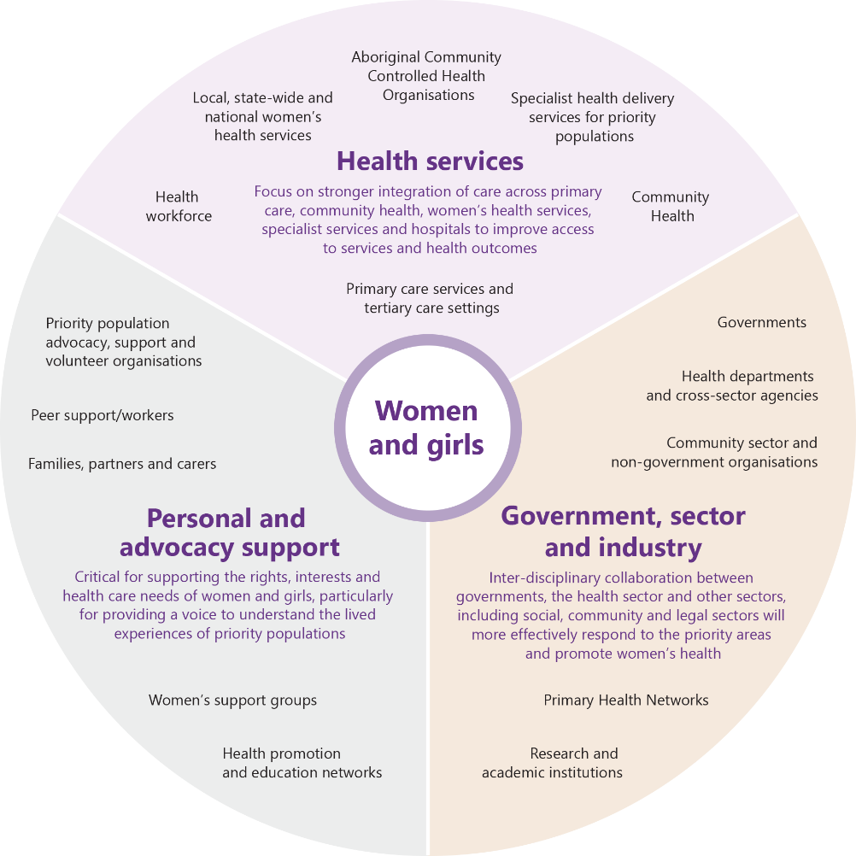

## Achieving progress

To ensure the effectiveness of the Strategy in fulfilling its objectives, the following is proposed:

1. Establish an Implementation Steering Group to facilitate and drive implementation of the National Women’s Health Strategy; and
2. Conduct a five-year review, with twelve-month and three-year development checks, to assess progress made in each of the priorities.

In addition, regular reporting on health outcomes for women will enable the community to appreciate the extent to which the actions are contributing to its ultimate goal of improving the health and wellbeing of women and girls in Australia.

## Expectations for the future

In five years’ time, we would expect to see a marked improvement against the objectives of the Strategy, with indication of progress against the overarching goal of improving the health and wellbeing of all women and girls in Australia, providing appropriate, accessible and equitable care, especially for those at greatest risk of poor health.

### Australian Health Performance Framework

It is proposed that the new Australian Health Performance Framework (AHPF) be used as the framework for assessing improvements against the objectives of the Strategy. The AHPF comprises both a health system conceptual framework and performance logic model, which enables assessment of the health system on a continuum, from a ‘whole of health system’ perspective through to evaluation of specific health intervention outcomes.[80] The AHPF includes patient reported experience and outcome measures to assess health service delivery from the patient’s perspective.

## Next steps

Further work is required to operationalise each of the priorities in the National Women’s Health Strategy. It is proposed that an Implementation Steering Group:

* coordinate the effort to develop an interventional timeline to prioritise the actions
* identify the sector area responsible for driving implementation of each action, including key implementation partners
* where appropriate, identify and agree on targets and outcome measures
* determine how to progress implementation to achieve the overall objectives of the Strategy.

## Appendix A Related policy and strategy documents

The following list identifies some of the key documents that inform the Women’s Health Strategy, and to which it refers:

* [Fifth National Mental Health and Suicide Prevention Plan (2017)](http://www.coaghealthcouncil.gov.au/Portals/0/Fifth%20National%20Mental%20Health%20and%20Suicide%20Prevention%20Plan.pdf) and [Implementation Plan (2017)](http://www.coaghealthcouncil.gov.au/Portals/0/Fifth%20National%20Mental%20Health%20and%20Suicide%20Prevention%20Plan_Implementation%20Plan.pdf)
* [Australian National Diabetes Strategy 2016-2020](http://www.health.gov.au/internet/main/publishing.nsf/content/3AF935DA210DA043CA257EFB000D0C03/$File/Australian%20National%20Diabetes%20Strategy%202016-2020.pdf)
* [Healthy Mouths Healthy Lives: Australia’s National Oral Health Plan 2015 - 2024](http://www.coaghealthcouncil.gov.au/Portals/0/Australia%27s%20National%20Oral%20Health%20Plan%202015-2024_uploaded%20170216.pdf)
* [Healthy, Safe and Thriving: National Strategic Framework for Child and Youth Health (2015)](http://www.coaghealthcouncil.gov.au/Portals/0/Healthy%20Safe%20and%20Thriving%20-%20National%20Strategic%20Framework%20for%20Child%20and%20Youth%20Health.pdf)
* [Implementation Plan for the National Aboriginal and Torres Strait Islander Health Plan 2013-2023](http://www.health.gov.au/internet/main/publishing.nsf/Content/AC51639D3C8CD4ECCA257E8B00007AC5/$File/DOH_ImplementationPlan_v3.pdf)
* [National Aboriginal and Torres Strait Islander Health Plan 2013-2023](https://www.health.gov.au/internet/main/publishing.nsf/content/B92E980680486C3BCA257BF0001BAF01/$File/health-plan.pdf)
* [National Action Plan for Endometriosis (2018)](http://www.health.gov.au/internet/main/publishing.nsf/Content/58AD1EF08402AC9FCA2582D5001A271E/$File/National%20Action%20Plan%20for%20Endometriosis.pdf)
* [National Ageing and Aged Care Strategy for people from culturally and linguistically diverse (CALD) backgrounds (2015)](https://agedcare.health.gov.au/sites/g/files/net1426/f/documents/07_2015/dss1582_aged_care_strategy_cald_a4_vaccessible.pdf)
* [National Asthma Strategy (2018)](https://assets.nationalasthma.org.au/resources/National-Asthma-Strategy-2018.pdf)
* [National Blood Borne Viruses and Sexually Transmissible Infections Strategies](http://www.health.gov.au/sexual-health)
* [National Cultural Respect Framework for Aboriginal and Torres Strait Islander Health 2016-2026](http://www.coaghealthcouncil.gov.au/Portals/0/National%20Cultural%20Respect%20Framework%20for%20Aboriginal%20and%20Torres%20Strait%20Islander%20Health%202016_2026_2.pdf)
* [National Digital Health Strategy (2018)](https://conversation.digitalhealth.gov.au/sites/default/files/adha-strategy-doc-2ndaug_0_1.pdf)
* [National Disability Strategy 2010-2020](https://www.dss.gov.au/sites/default/files/documents/05_2012/national_disability_strategy_2010_2020.pdf)
* [National Drug Strategy 2017-2026](http://www.health.gov.au/internet/main/publishing.nsf/Content/55E4796388E9EDE5CA25808F00035035/$File/National-Drug-Strategy-2017-2026.pdf)
* [National Framework for Action on Dementia 2015-2019](https://agedcare.health.gov.au/sites/g/files/net1426/f/documents/09_2015/national-framework-for-action-on-dementia-2015-2019.pdf)
* [National Framework for Action to Promote Eye Health and Prevent Avoidable Blindness and Vision Loss](http://www.health.gov.au/internet/main/publishing.nsf/content/D3175B31C04E3D72CA257C750078F76B/$File/frame.pdf) and [Third Progress Report](http://www.health.gov.au/internet/main/publishing.nsf/Content/8F3A179870AE7DC2CA258035007E09C1/$File/3rd%20Progress%20report%20under%20National%20Framework%20for%20Eye%20Health.pdf)
* [National Framework for Communicable Disease Control (2014)](http://www.health.gov.au/internet/main/publishing.nsf/Content/E5134F29919E9D74CA257CFB0082C7C5/$File/National-framework.pdf)
* [National Framework for Health Services for Aboriginal and Torres Strait Islander Children and Families (2016)](http://www.coaghealthcouncil.gov.au/Portals/0/National%20Framework%20for%20Health%20Services%20for%20Aboriginal%20and%20Torres%20Strait%20Islander%20Children%20and%20Families.pdf)
* [National Framework for Universal Child and Family Health Services (2011)](http://www.health.gov.au/internet/main/publishing.nsf/content/AFF3C1C460BA5300CA257BF0001A8D86/$File/NFUCFHS.PDF)
* [National Health Genomics Policy Framework 2018-2021](http://www.health.gov.au/internet/main/publishing.nsf/Content/national-health-genomics-policy-framework-2018-2021)
* [National Medicines Policy (2000)](http://www.health.gov.au/internet/main/publishing.nsf/content/B2FFBF72029EEAC8CA257BF0001BAF3F/$File/NMP2000.pdf)
* [National Palliative Care Strategy (2010)](http://www.health.gov.au/internet/main/publishing.nsf/content/EF57056BDB047E2FCA257BF000206168/$File/NationalPalliativeCareStrategy.pdf)
* [National Plan to Reduce Violence against Women and their Children 2010-2022](https://www.dss.gov.au/sites/default/files/documents/08_2014/national_plan1.pdf)
* [National Plan to Reduce Violence against Women and their Children: Third Action Plan 2016-2019](https://www.dss.gov.au/sites/default/files/documents/10_2016/third_action_plan.pdf)
* [National Statement on Health Literacy](https://www.safetyandquality.gov.au/wp-content/uploads/2014/08/Health-Literacy-National-Statement.pdf) and [Australian Charter of Healthcare Rights](https://www.safetyandquality.gov.au/wp-content/uploads/2012/01/Charter-PDf.pdf) (through ACSQHC)
* [National Strategic Framework for Aboriginal and Torres Strait Islander Peoples’ Mental Health and Social and Emotional Wellbeing 2017-23](https://pmc.gov.au/resource-centre/indigenous-affairs/national-strategic-framework-mental-health-social-emotional-wellbeing-2017-23)
* [National Strategic Framework for Chronic Conditions (2017)](http://www.health.gov.au/internet/main/publishing.nsf/content/A0F1B6D61796CF3DCA257E4D001AD4C4/$File/National%20Strategic%20Framework%20for%20Chronic%20Conditions.pdf)
* [National Strategic Framework for Rural and Remote Health (2011)](http://www.health.gov.au/internet/main/publishing.nsf/content/A76BD33A5D7A6897CA257F9B00095DA3/$File/National%20Strategic%20Framework%20for%20Rural%20and%20Remote%20Health.pdf)
* [National Strategy for Quality Use of Medicines](http://www.health.gov.au/internet/main/publishing.nsf/content/8ECD6705203E01BFCA257BF0001F5172/$File/natstrateng.pdf)
* [National Women's Health Policy 2010 – 2030](https://www.health.gov.au/internet/main/publishing.nsf/Content/3BC776B3C331D5EECA257BF0001A8D46/$File/NWHP_access_final.pdf)
* [Sport 2030 - National Sport Plan](https://www.sportaus.gov.au/nationalsportplan/home/featured/have_a_say2/Sport_2030_-_National_Sport_Plan_-_2018.pdf)

Emerging strategies and national action plans

* Australian National Breastfeeding Strategy: 2019 and Beyond
* National Action Plan for Children’s Health 2020-2030
* National Alcohol Strategy 2018-2026
* National Fetal Alcohol Spectrum Disorder Action Plan 2018-2028
* National Injury Prevention Strategy
* National Strategic Action Plan for Arthritis
* National Strategic Action Plan for Childhood Heart Disease
* National Strategic Action Plan for Heart Disease and Stroke
* National Strategic Action Plan for Inflammatory Bowel Disease
* National Strategic Action Plan for Kidney Disease
* National Strategic Action Plan for Lung Conditions
* National Strategic Action Plan for Macular Disease
* National Strategic Action Plan for Osteoporosis
* National Strategic Action Plan for Pain Management
* National Strategic Action Plan for Rare Diseases
* National Strategic Approach to Maternity Services (NSAMS)

This Strategy also directly aligns with its companion document, the National Men’s Health Strategy 2020-2030 and recognises state and territory gender-based strategies, policies and frameworks.

## Appendix B References

1. [United Nations. Sustainable Development Goals](https://www.un.org/sustainabledevelopment/sustainable-development-goals/). (accessed November 2018)
2. World Health Organisation. The Global Strategy for Women’s, Children’s and Adolescents’ Health (2016-2030). Italy: WHO, 2015.
3. [Organisation for Economic Co-Operation and Development. Health at a Glance 2017: OECD Indicators](http://www.oecd.org/health/health-systems/health-at-a-glance-19991312.htm). (accessed November 2018)
4. Australian Institute of Health and Welfare. Deaths in Australia. Canberra: AIHW, 2018.
5. Australian Institute of Health and Welfare. Australia’s Health 2018 – in brief. Canberra: AIHW, 2018.
6. Department of Health. National Women’s Health Policy 2010. Canberra: Commonwealth of Australia, 2010.
7. Australian Institute of Health and Welfare. The health of Australia’s females. Canberra: AIHW, 2017.
8. [Department of Health. Sex and gender as determinants of health](http://www.health.gov.au/internet/publications/publishing.nsf/Content/whdp-09~whdp-09-ch5~whdp-09-ch5-1). (accessed November 2018).
9. Department of Health. National Women’s Health Policy 2010. Canberra: Australian Government, 2010.
10. Australian Institute of Health and Welfare. Australian Burden of Disease Study: Impact and causes of illness and death in Australia 2011. Australian Burden of Disease Study series no. 3. BOD 4. Canberra: AIHW, 2016.
11. Australian Bureau of Statistics. National Survey of Mental Health and Wellbeing 2007. Canberra: ABS, 2007.
12. Leonard W, Pitts M, Mitchell A, et al. Private lives 2: The second national survey of the health and wellbeing of gay, lesbian, bisexual and transgender (GLBT) Australians. Melbourne: The Australian Research Centre in Sex, Health & Society, La Trobe University, 2012.
13. Duggan M. Investing in women’s mental health: Strengthening the foundations for women, families and the Australian economy. Australian Health Policy Collaboration Issues paper No. 2016-02. Melbourne: Australian Health Policy Collaboration, 2016.
14. Australian Institute of Health and Welfare. Trends in cardiovascular deaths. Bulletin No. 141. Cat. No. AUS 216. Canberra: AIHW, 2018.
15. [Continence Foundation of Australia. Prevalence: Fact sheet](https://www.continence.org.au/data/files/Access_economics_report/dae_summary_final_web_version). (accessed November 2018).
16. Australian Institute of Health and Welfare. Family, domestic and sexual violence in Australia 2018. Cat. no. FDV 2. Canberra: AIHW, 2018.
17. Ussher JM, Perz J, Metusela C, Hawkey A, Morrow M, Narchal R, Estoesta J, Monteiro, M. Sexual and reproductive health of migrant and refugee women. Research report and recommendations for healthcare providers and community workers. Sydney: Western Sydney University 2017.
18. World Health Organisation. The Global Strategy for Women’s, Children’s and Adolescents’ Health (2016-2030). Italy: WHO, 2015.
19. Australian Institute of Health and Welfare. Australian Burden of Disease Study: Impact and causes of illness and death in Australia 2011. Australian Burden of Disease Study series no. 3. BOD 4. Canberra: AIHW, 2016.
20. Australian Institute of Health and Welfare. Family, domestic and sexual violence in Australia 2018. Cat. no. FDV 2. Canberra: AIHW, 2018.
21. Ayre J, Lum On M, Webster K, Gourley M, L M. Examination of the burden of disease of intimate partner violence against women in 2011: Final report. Sydney: ANROWS, 2016.
22. Australian Bureau of Statistics. Life Tables, States, Territories and Australia, 2014-2016. Canberra: ABS, 2017.
23. Australian Institute of Health and Welfare. Perinatal Depression: Data from the 2010 Australian National Infant Feeding Survey. Information Paper, Cat. No. PHE 161. Canberra: AIHW, 2012.
24. [VicHealth. Loneliness: a new public health challenge emerges. Victorian Government](https://www.vichealth.vic.gov.au/letter/articles/vh-letter-47-loneliness), (accessed November 2018).
25. Department of Health. My Life, My Lead – Opportunities for strengthening approaches to the social determinants and cultural determinants of Indigenous health: Report on the national consultations. December 2017. Canberra: Australian Government, 2017.
26. Australian Institute of Health and Welfare. Australia’s Health 2018. Canberra: AIHW, 2018.
27. Australian Institute of Health and Welfare. Australia’s mothers and babies 2015—in brief. Perinatal statistics series no. 33. Cat no. PER 91. Canberra: AIHW, 2017.
28. Australian Institute of Health and Welfare. Family, domestic and sexual violence in Australia 2018. Cat. no. FDV 2. Canberra: AIHW, 2018.
29. Australian Bureau of Statistics. Health outside major cities. Australian Social Trends. Cat. No. 41020.0. Canberra: ABS, 2011.
30. [Rural Doctors Association of Australia. Submission to the Productivity Commission Study of the Health Workforce. August 2005](https://www.pc.gov.au/inquiries/completed/health-workforce/submissions/sub161/sub161.pdf). (accessed November 2018).
31. Australian Institute of Health and Welfare. Life expectancy and disability in Australia: expected years living with and without disability. Canberra: AIHW, 2017.
32. Department of Health. My Life, My Lead – Opportunities for strengthening approaches to the social determinants and cultural determinants of Indigenous health: Report on the national consultations. December 2017. Canberra: Australian Government, 2017.
33. Australian Institute of Health and Welfare. Australia's Health 2018. Canberra: AIHW, 2018.
34. Australian Institute of Health and Welfare. Australia's Health 2016. Canberra: AIHW, 2016.
35. [VicHealth. Disability and health inequalities in Australia: Research summary, 2012](http://www.vichealth.vic.gov.au/publications). (accessed September 2018).
36. [Migration Council Australia. The health outcomes of migrants: a literature review](http://migrationcouncil.org.au/wp-content/uploads/2016/06/2015_Smith.pdf). Smith L, 2015 (accessed September 2018).
37. Barmaky S, Lee A. LGBTIQ peoples’ experiences of and barriers to healthcare. Vector; 26 October 2017.
38. Australian Bureau of Statistics. Personal Safety Survey. Customised report. Canberra: ABS, 2016.
39. Australian Institute of Health and Welfare. Family, domestic and sexual violence in Australia 2018. Cat. no. FDV 2. Canberra: AIHW, 2018.
40. Corrective Services NSW. Women as offenders, women as victims. The role of corrections in supporting women with histories of sexual abuse. NSW, 2014.
41. Australian Institute of Health and Welfare. Australia's Health 2018. Canberra: AIHW, 2018.
42. Ibid.
43. Australian Institute of Health and Welfare. The health and welfare of Australia’s Aboriginal and Torres Strait Islander people. Canberra: AIHW, 2015.
44. Ibid.
45. Department of Prime Minister and Cabinet. Closing the Gap. https://closingthegap.pmc.gov.au
46. LBTI adopted following consultation with the National LGBTI Health Alliance
47. [Australian Medical Association. Sexual and reproductive health – 2014](https://ama.com.au/position-statement/sexual-and-reproductive-health-2014). (accessed February 2019).
48. Australian Institute of Health and Welfare. Cervical screening in Australia 2014–2015. Cancer series no. 105. Cat. no. CAN 104. Canberra: AIHW, 2017.
49. Australian Bureau of Statistics. National Health Survey: First Results 2014-15. Cat No. 4364.0.55.001. Canberra: ABS, 2015.
50. The Royal Australian College of General Practitioners. Guidelines for preventive activities in general practice. 9th edn. East Melbourne, Vic: RACGP, 2016.
51. Australian Institute of Health and Welfare. Australian Burden of Disease Study: Impact and causes of illness and death in Australia 2011. Australian Burden of Disease Study series no. 3. BOD 4. Canberra: AIHW, 2016.
52. Australian Institute of Health and Welfare 2014. Australia’s health 2014. Canberra: AIHW, 2014.
53. Australian Institute of Health and Welfare 2018. Australia’s health 2018. Canberra: AIHW, 2018.
54. Ibid.
55. [Organisation for Economic Co-Operation and Development. Health at a Glance 2017: OECD Indicators](http://www.oecd.org/health/health-systems/health-at-a-glance-19991312.htm). (accessed November 2018).
56. Australian Institute of Health and Welfare. Cancer in Australia 2017. Cancer series no.101.Cat. no. CAN 100. Canberra: AIHW, 2017.
57. Australian Institute of Health and Welfare. Australian Burden of Disease Study: Impact and causes of illness and death in Australia 2011. Australian Burden of Disease Study series no. 3. BOD 4. Canberra: AIHW, 2016.
58. CSIRO Futures. Future of Health: Shifting Australia’s focus from illness treatment to health and wellbeing management. CSIRO, 2018.
59. Beyond Blue. Factors affecting women. https://www.beyondblue.org.au/who-does-it-affect/women/factors-affecting-women (accessed February 2019).
60. Ibid.
61. Australian Bureau of Statistics. (2008). National Survey of Mental Health and Wellbeing: Summary of Results, 2007. Cat. no. (4326.0). Canberra: ABS.
62. Ibid.
63. Butterfly Foundation (2012). Paying the Price: The economic and social impact of eating disorders in Australia (p. 9). Crows Nest, NSW: The Butterfly Foundation. Retrieved from https://thebutterflyfoundation.org.au/assets/Uploads/Advocacy/Butterfly-Report-PayingthePrice.pdf
64. Lawrence D, Johnson S, Hafekost J, Boterhoven De Haan K, Sawyer M, Ainley J et al. 2015. The mental health of children and adolescents. Report on the second Australian Child and Adolescent Survey of Mental Health and Wellbeing. Canberra: Department of Health.
65. Harvey SB, Deady M, Wang MJ, et al. Is the prevalence of mental illness increasing in Australia? Evidence from national health surveys and administrative data, 2001-2014. Med J Aust 2017; 206(11): 490-3.
66. Australian Institute of Health and Welfare. Australia's Health 2016. Canberra: AIHW, 2016.
67. [Department of Health. Better Access Telehealth Services for people in rural and remote areas](http://www.health.gov.au/internet/main/publishing.nsf/Content/mental-ba-telehealth). (accessed November 2018).
68. [Our Watch. Facts and figures](https://www.ourwatch.org.au/understanding-violence/facts-and-figures). (accessed November 2018).
69. Australian Bureau of Statistics. Personal Safety Survey. Canberra: ABS, 2016.
70. Ibid.
71. Loxton D, Dolja-Gore X, Anderson AE, Townsend N. Intimate partner violence adversely impacts health over 16 years and across generations: A longitudinal cohort study. PLoS One, 2017; 12(6): e0178138.
72. Ayre J, Lum On M, Webster K, Gourley M, Moon L. Examination of the burden of disease of intimate partner violence against women in 2011: Final report. Sydney: ANROWS, 2016.
73. [Department of Social Services. Women’s safety](https://www.dss.gov.au/women/programs-services/reducing-violence/the-national-plan-to-reduce-violence-against-women-and-their-children-2010-2022). (accessed November 2018).
74. Australian Bureau of Statistics. Personal Safety Survey. Canberra: ABS, 2016.
75. Australian Institute of Family Studies. Domestic and family violence in regional, rural and remote communities: an overview of key issues. Australian Government, 2015.
76. [Our Watch. Summary report Preventing Family Violence against people in LGBTI communities](https://www.ourwatch.org.au/getmedia/13fded0c-851b-4935-b402-e00fdb9b6e4b/Summary-report_Preventing-FV-against-people-in-LGBTI-communities) (accessed November 2018).
77. Department of Health. $18 million for medical research to improve women’s health. 8 August 2018. <health.gov.au/internet/ministers/publishing.nsf/Content/health-mediarel-yr2018-hunt104.htm>
78. [Department of Health. Maternal Health and First 2000 Days](https://beta.health.gov.au/initiatives-and-programs/maternal-health-and-first-2000-days).
79. Department of Health. $200 million for medical research to overcome health challenges. 13 August 2018. health.gov.au/internet/ministers/publishing.nsf/Content/health-mediarel-yr2018-hunt109.htm
80. Australian Institute of Health and Welfare. Australia's Health 2018. Canberra: AIHW, 2018.

    ## Appendix C Text-based Alternatives

    ### Figure 1: Overview of the National Women’s Health Strategy 2020-2030

    **Purpose**

    Improve the health and wellbeing of all women and girls in Australia, providing appropriate, equitable and accessible prevention and care, especially for those at greatest risk of poor health.

    **Policy Principles**

    Gender equity

    Strategy objectives

    Highlight the significance of gender as a key determinant of women's health and wellbeing,

    to strengthen gender-equity and gender-transformative research and services, and women’s

    and girls’ engagement with the health system

    Health equity between women

    Strategy objectives

    Recognise the different health needs of priority populations, address gaps in services and

    target those women’s population groups where the worst health outcomes are experienced

    A life course approach to health

    Strategy objectives

    Develop health initiatives that focus on improving health and target risk factors and

    intervention points most relevant for women across the life course

    A focus on prevention

    Strategy objectives

    Invest in positive primary prevention, secondary prevention and early intervention from

    childhood, with a focus on the social and gendered drivers of health and holistic person-

    centered care

    A strong and emerging evidence base

    Strategy objectives

    Support effective and collaborative research, data collection, monitoring, evaluation and

    knowledge transfer to advance the evidence base on women’s health

    **Priority areas**

    **Maternal, sexual and reproductive health**

    Increase access to sexual and reproductive health care information, diagnosis, treatment and services

    Increase health promotion activity to enhance and support preconception and perinatal health

    Support enhanced access to maternal and perinatal health care services

    **Healthy ageing**

    Adopt a life course approach to healthy ageing for women

    Address key risk factors that reduce quality of life for women as they age

    Better manage the needs of a diverse ageing population

    **Chronic conditions and preventive health**

    Increase awareness and primary prevention of chronic conditions, symptoms and risk factors for women and girls, and embed a life course approach in policy and practice

    Invest in targeted prevention, early detection and intervention of chronic conditions affecting women and girls

    Tailor health services to meet the needs of all women and girls

    Reduce the prevalence and impact of endometriosis and associated chronic pelvic pain

    **Mental health**

    Enhance gender- specific mental health education, awareness and primary prevention

    Focus on early intervention, diagnosis, integration and access to mental health care services

    Invest in service delivery for priority populations

    Adopt a multi-faceted approach to support women and girls with eating disorders

    Raise awareness and embed practices to reduce stigma and discrimination associated with mental ill-health

    **Health impacts of violence against women and girls**

    Raise awareness of the health impacts of violence against women and girls

    Address health and related impacts of family and sexual violence

    Co-design and deliver safe and accessible services for women experiencing family, intimate partner and/or sexual violence

    **Investing in research**

    **Strengthening partnerships**

    **Achieving progress**

    Return to Figure 1

    ### Figure 2: Overview of the strategic policy context for women’s health

    **National Women’s Health Strategy 2020-2030**

    **Gender-specific policies and strategies**

    * National Women’s Health Policy 2010 - 2030

    This remains the overarching policy document for the Strategy

    * National Men's Health Strategy 2020-2030
    * State and territory gender-based strategies, policies and frameworks

    **Related cross-sector policies and strategies**

    * Towards 2025: An Australian Government Strategy to Boost Women's Workforce Participation
    * Women’s Economic Security Statement
    * Social Health Strategy 2015-2023 for the Veteran and Ex-service Community
    * Defence Mental Health and Wellbeing Strategy 2018-2023
    * Veteran Mental Health Strategy 2013-2023
    * National Plan to Address Elder Abuse
    * National Plan to Reduce Violence against Women and their Children 2010-2022
    * National Plan to Reduce Violence against Women and their Children: Fourth Action Plan 2019-2022
    * National Disability Strategy 2010-2020

    **Overarching national strategies**

    * National Medicines Policy (2000)
    * National Strategy for Quality Use of Medicines
    * National Statement on Health Literacy and Australian Charter of Healthcare Rights (through ACSQHC)
    * National Health Genomics Policy Framework 2018-2021
    * National Drug Strategy 2017-2026
    * National Strategic Framework for Chronic Conditions (2017)
    * Sport 2030 - National Sport Plan
    * National Aboriginal and Torres Strait Islander Health Plan 2013-2023
    * National Strategic Framework for Rural and Remote Health (2011)
    * Fifth National Mental Health and Suicide Prevention Plan (2017) and Implementation Plan (2017)
    * Cultural Respect Framework 2016-2026 for Aboriginal and Torres Strait Islander Health: A National Approach to Building a Culturally Respectful Health System

    **Condition-specific national policies and strategies**

    * National Framework for Action to Promote Eye Health and Prevent Avoidable Blindness and Vision Loss and Third Progress Report
    * National Blood Borne Viruses and Sexually Transmissible Infections Strategies
    * Range of national cancer frameworks (through Cancer Australia)
    * Range of clinical practice guidelines such as: National Mental Health Care in the Perinatal Period (2017) and Pregnancy Care Guidelines
    * Healthy Mouths Healthy Lives: Australia’s National Oral Health Plan 2015-2024
    * National Palliative Care Strategy (2010)
    * National Asthma Strategy (2018)
    * National Framework for Action on Dementia 2015-2019
    * Australian National Diabetes Strategy 2016-2020
    * National Action Plan for Endometriosis (2018)

    **Emerging strategies and national action plans:**

    **National policies/strategies**

    * **National Action Plan for Children’s Health 2020-2030**
    * **National Strategic Approach to Maternity Services (NSAMS}**
    * **Australian National Breastfeeding Strategy: 2019 and Beyond**
    * **National Alcohol Strategy 2018-2026**
    * **National Injury Prevention Strategy**

    **Condition-specific policies and strategies**

    * National Strategic Action Plan for Arthritis
    * National Strategic Action Plan for Childhood Heart Disease
    * National Strategic Action Plan for Pain Management
    * National Strategic Action Plan for Inflammatory Bowel Disease
    * National Strategic Action Plan for Kidney Disease
    * National Strategic Action Plan for Lung Conditions
    * National Strategic Action Plan for Rare Diseases
    * Strategic National Action Plan for Macular Disease
    * National Strategic Action Plan for Osteoporosis
    * National Strategic Action Plan for Heart Disease and Stroke
    * National Fetal Alcohol Spectrum Disorder Action Plan 2018-2028

    Return to Figure 2

    ### Figure 3: A snapshot of key health risks for women and girls in Australia

    Women at all stages of life are at greater risk than men of mental ill-health

    Mental health disorders represent the leading cause of disability for women in Australia

    43% of women have experienced mental illness at some time

    Aboriginal and Torres Strait Islander women experience higher rates of comorbid conditions, including diabetes, breast, cervical and ovarian cancers than non-indigenous women

    Women and girls in socioeconomically disadvantaged and marginalised group continue to experience poorer health outcomes than the general population

    Eating disorders are the third most common chronic illness amongst young women in Australia

    Women are 1.6 times as likely to suffer coexisting mental and physical illness

    87% of women aged 65 and over have a chronic disease

    Symptoms of a heart attack in women are less likely to be recognised than in men

    Women are less likely than men to receive appropriate treatment for heart disease

    Rates of cardiovascular disease are 1.5 times higher for women in remote areas than in urban areas

    Members of the LGBTI community experience higher levels of depression, anxiety and affective disorders than their peers

    Incidence of lung cancer has been increasing in women for more than 20 years, while it has been decreasing in men

    Women who experience family and intimate partner violence are more likely to report poor mental health, physical function and general health than other women

    80% of people with incontinence are girls and women

    25% of women have pelvic floor disorders

    Migrant and refugee women are at greater risk of suffering poorer maternal and child health outcomes than other women

    61% of people living with dementia are women

    Return to Figure 3

    ### What women want

    “Guaranteed timely access for all women to comprehensive coordinated prevention and life-long care, ensuring world-class health outcomes.”

    “To ensure that all women in Australia are clear on what the issues are that affect their health, how they can go about getting screening, diagnosis and the relevant treatment.”

    “Causes and consequences of gender inequality to be recognised, understood and used to inform all elements of the health system...”

    “Any woman, irrespective of age, cultural background, socioeconomic conditions, or geographic location, can access information on any mental health or general health condition concerning them, has no barrier such as stigma or remote location preventing access to treatment and support, where the focus is on early intervention, integrated care, relapse prevention, and where affordability is not an issue.”

    “Holistic, integrated biopsychosocial approach to preventing ill health and managing it effectively when it occurs.”

    “Address the leading causes of death and disability for women using a comprehensive life-course approach... with a specific focus on the social determinants of health and equality for all women!”

    “Gender-sensitive services that treat women holistically, encompassing all aspects of herself, not just the disorder she presents with - across the life course from pre-conception to old age.”

    “Make the health system more efficient by connecting key services - health promotion, prevention, treatment and care - so it is seamless for all women and girls.”

    Return to What women want

    ### Figure 7: Priority areas for the National Women’s Health Strategy 2020-2030

    Maternal, sexual and reproductive health

    Healthy ageing

    Chronic conditions and preventive health

    Mental health

    Health impacts of violence against women and girls

    Return to Figure 7

    ### Figure 8: Key partners in women’s health

    **Women and girls**

    **Health Services**

    Focus on stronger integration of care across primary care, community health, women’s health services, specialist services and hospitals to improve access to services and health outcomes

    * Primary care services and tertiary care settings
    * Health workforce
    * Local, state-wide and national women’s health services
    * Aboriginal Community Controlled Health Organisations
    * Specialist health delivery services for priority populations
    * Community Health

    **Personal and advocacy support**

    Critical for supporting the rights, interests and health care needs of women and girls, particularly for providing a voice to understand the lived experiences of priority populations

    * Priority population advocacy, support and volunteer organisations
    * Peer support/workers
    * Families, partners and carers
    * Women’s support groups
    * Health promotion and education networks.

    **Government, sector and industry**

    Inter-disciplinary collaboration between governments, the health sector and other sectors, including social, community and legal sectors will more effectively respond to the priority areas and promote women’s health

    * Primary Health Networks
    * Governments
    * Health departments and cross-sector agencies
    * Community sector and non-government organisations
    * Research and academic institutions

    Return to Figure 8