Australian Women’s Health Alliance

Membership Form

Easy Read version

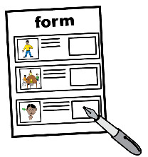 | About this form
 | The Australian Women’s Health Alliance wrote this form.
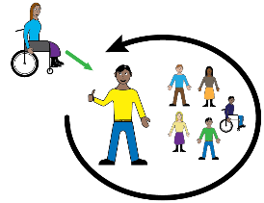 | You can use this form to join the Australian Women’s Health Alliance.
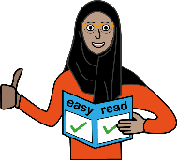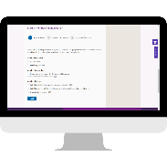 | This form is an Easy Read version of an online form.  You can find the online form at https://www.australianwomenshealth.org/join-us/
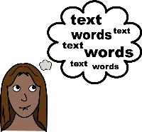 | We have written some words in bold.
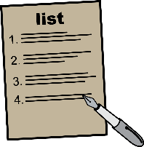 | We explain what these words mean. There is a list of these words at the end of this document.

Completing the form

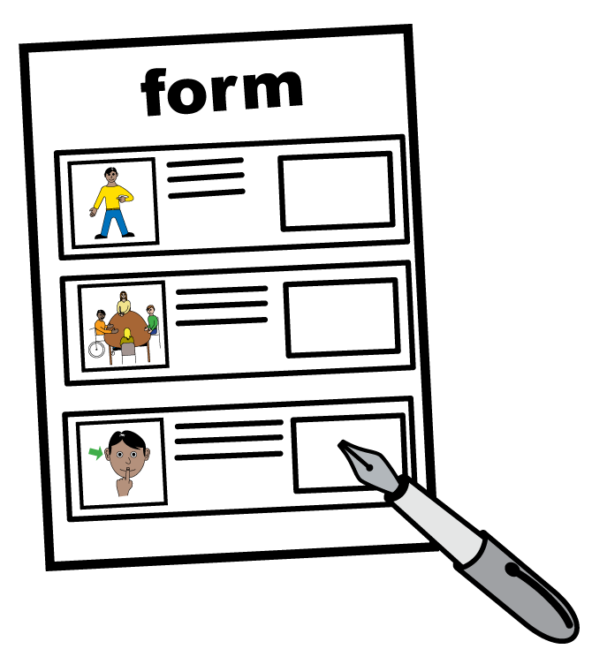
To complete the form

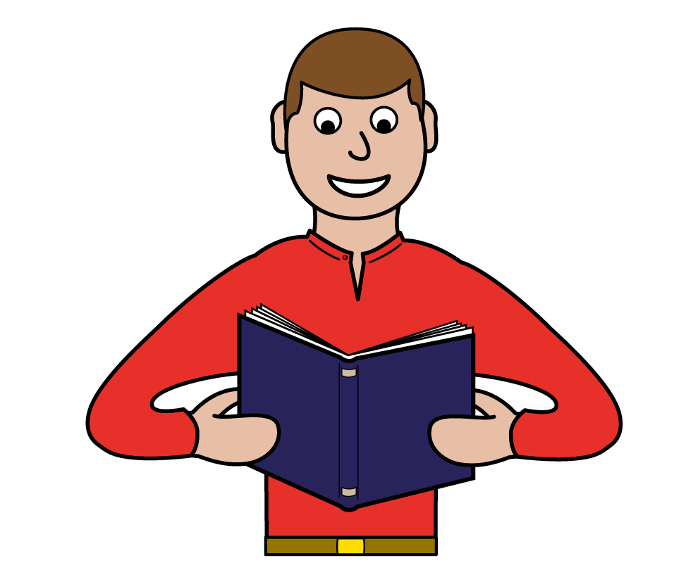
- read the information

- tick the boxes

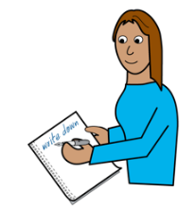
- write on the lines

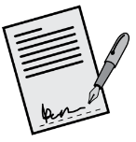
- sign the form.

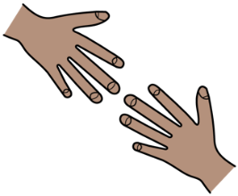
You need help
You can ask for help to fill in this form.
You can ask someone you trust. Like
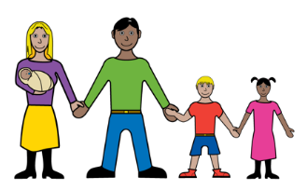
- a family member

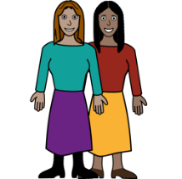
- a friend

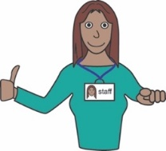
- a support worker.

What’s in this form?

About this form 2
Completing the form 3
You need help 4
What’s in this form? 5
Who are we? 6
Our Statement of Purposes 7
Membership type 8
Membership cost 9
Membership 10
About you 11
Payment 15
How to send us your Membership Form 18
Other ways to join the Australian Women’s Health Alliance 19
Word list 20
Acknowledgements 23

 | Who are we?
 | Australian Women’s Health Alliance is a national voice for health.
 | This means we:
 | - speak up about health issues that affect women
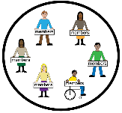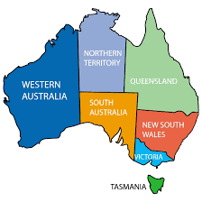 | - have members across every state and territory in Australia.
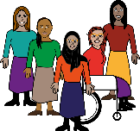 | Our aim is to achieve gender equity in health for all women.
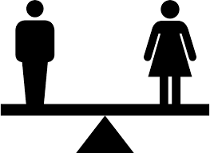 | Gender equity is when things are fair for people of all genders.

.

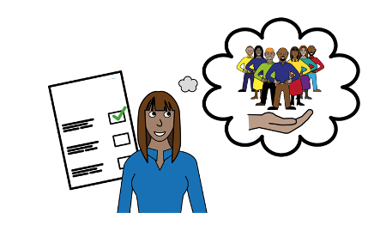
Our Statement of Purposes
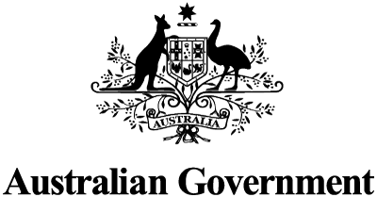
We support women’s heath by doing things like:
- talking to government about women’s health
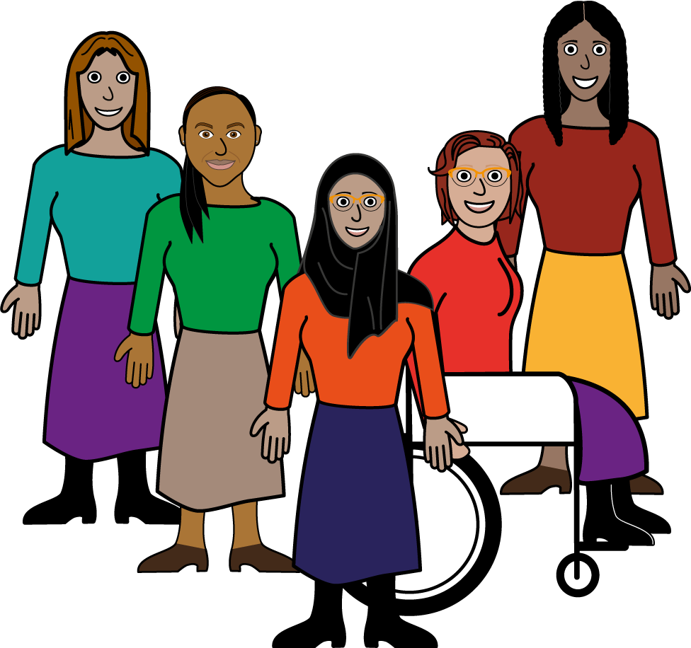
- telling others how women’s health can be supported
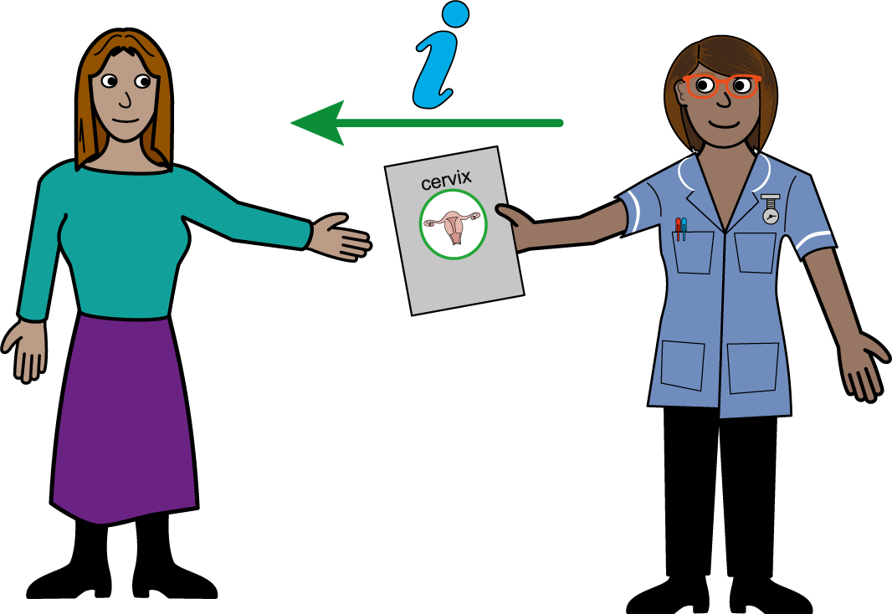
- linking state and territory groups that support women’s health
- asking for improved access to women’s health
- sharing information and resources about women’s health
- doing research on women’s health
- supporting women to take part in all decisions about their health
- doing other activities that support women’s health and well-being.

This is called our Statement of Purposes.

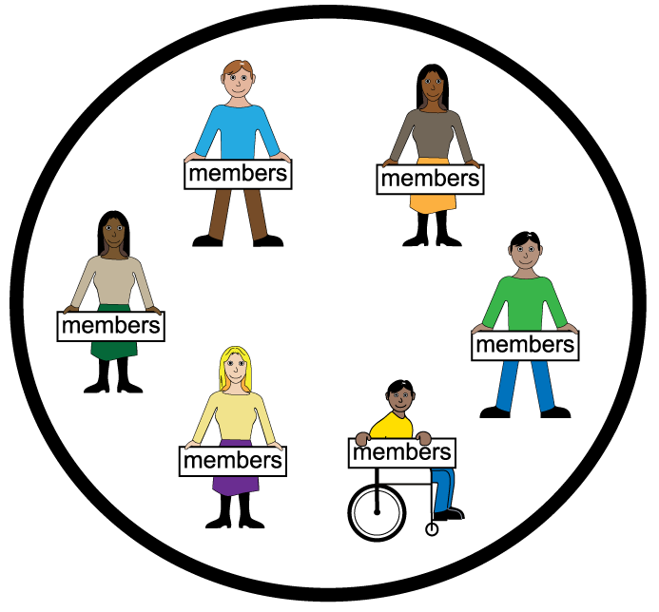
Membership type

Membership is open to all people that support the work of the Australian Women’s Health Alliance.

There are 2 types of membership:
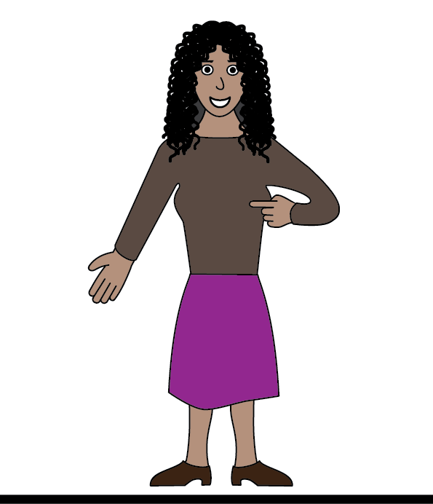
- Individual membership

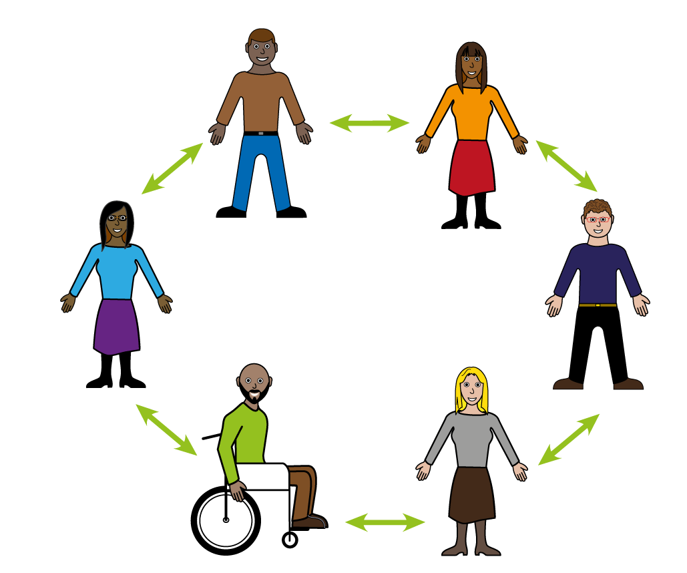
- Organisation membership.

This form is only for Individual Membership.
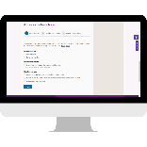
To apply for Organisation membership, go to https://www.australianwomenshealth.org/join-us/

Membership cost

You have to pay money to be a member of the Australian Women’s Health Alliance.
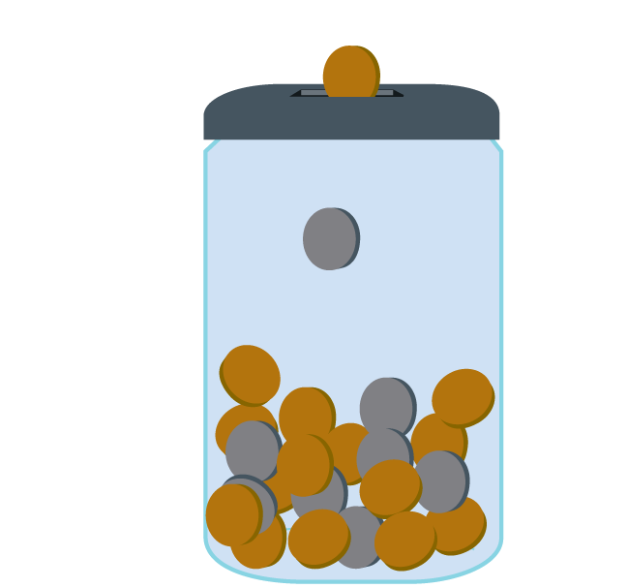
The cost is based on how much money you earn.

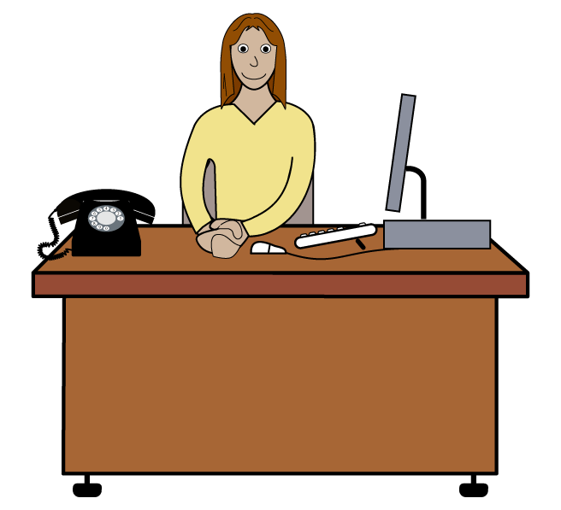
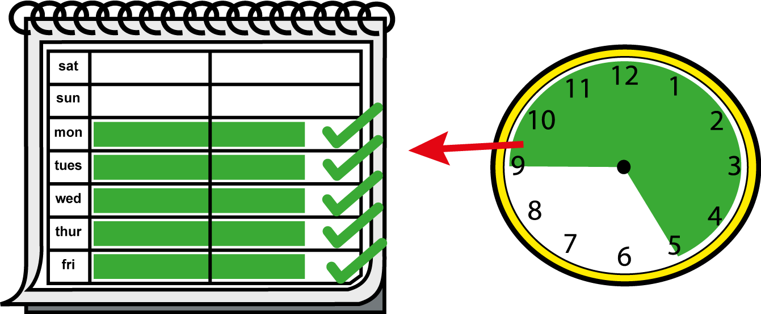
If you work in a job full-time you pay $33
If you do not work full-time you pay $11

You can pay by
PayPal

If you want to pay a different way you can send an email to info@australianwomenshealth.org

Membership

What would you like to do:
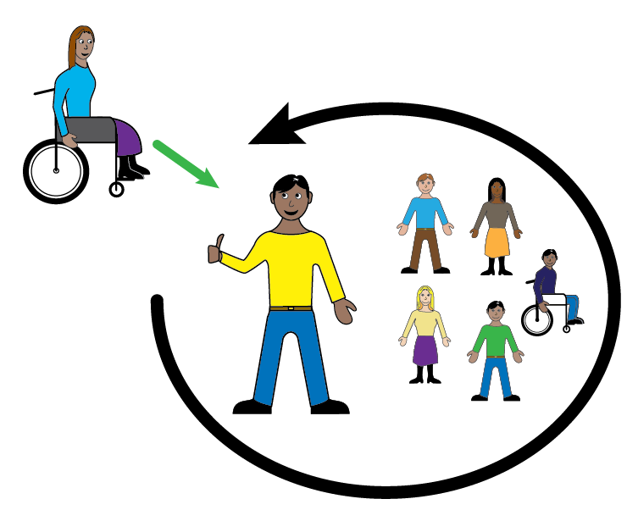

- Join as a new member

- Renew your membership.
Note: Choose this box if you have joined Australian Women’s Health Alliance before.

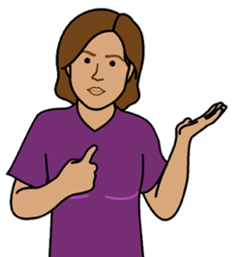
About you
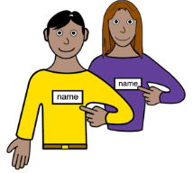

My name is

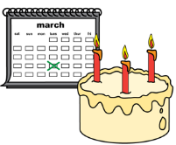
I was born on
Write the day / month / year

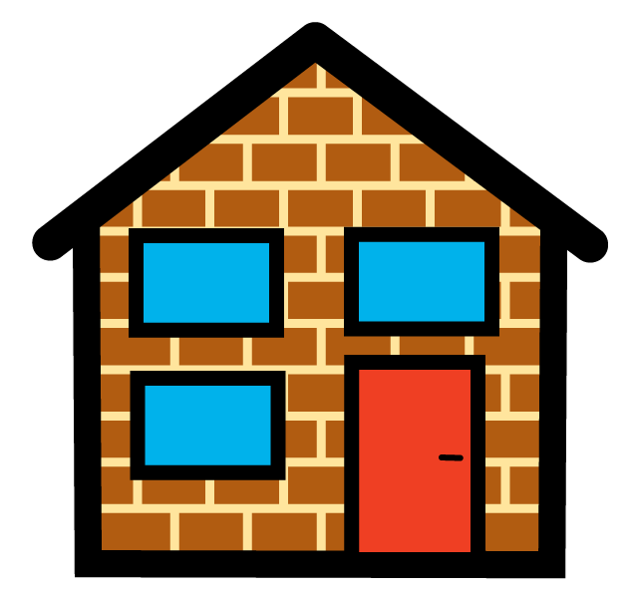
I live at

My phone number is

My email is

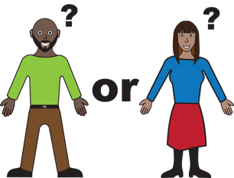
My gender is

- woman

- man

- non-binary
I am
- not a woman
- or a man.

- other (tell us below).

I am (tick all that apply)
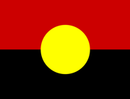

- Aboriginal

- Torres Strait Islander

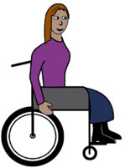

- a person with disability

- LGBTIQA+
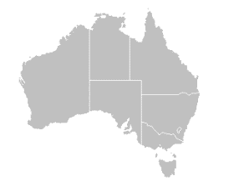
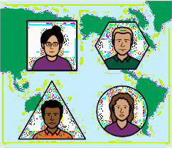

- migrant

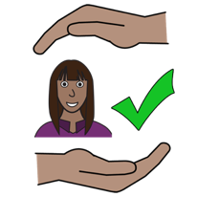

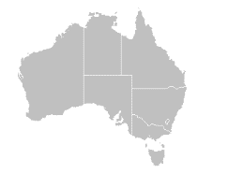
- refugee

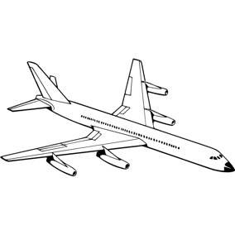

- on a Temporary Visa

Do you agree with the Statement of Purposes?

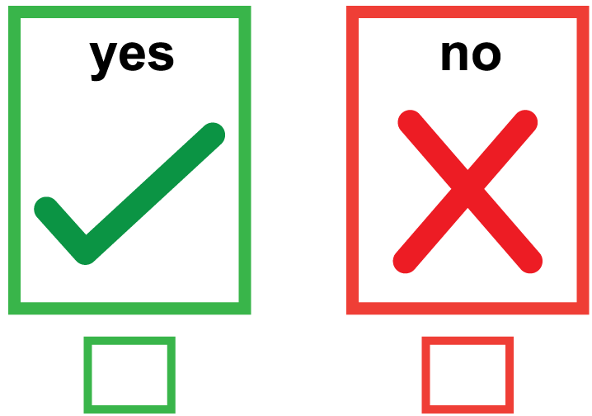

Yes

No

Payment
Please tick the box that describes you

- I work full-time ($33)

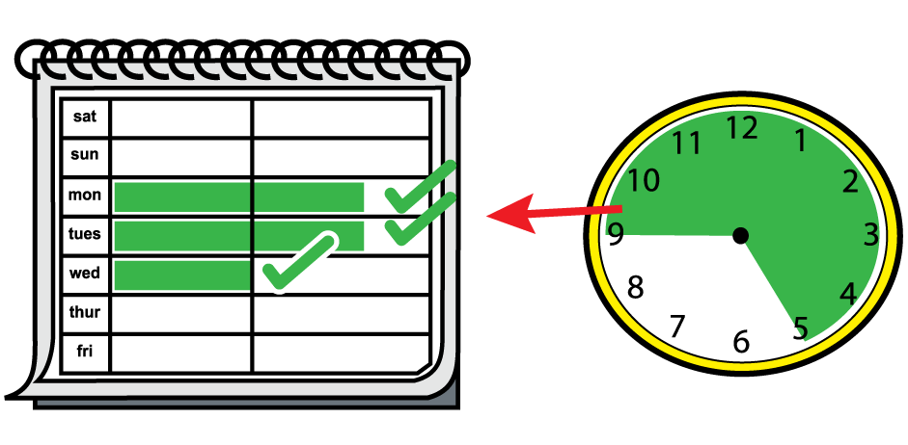

- I work part-time ($11)

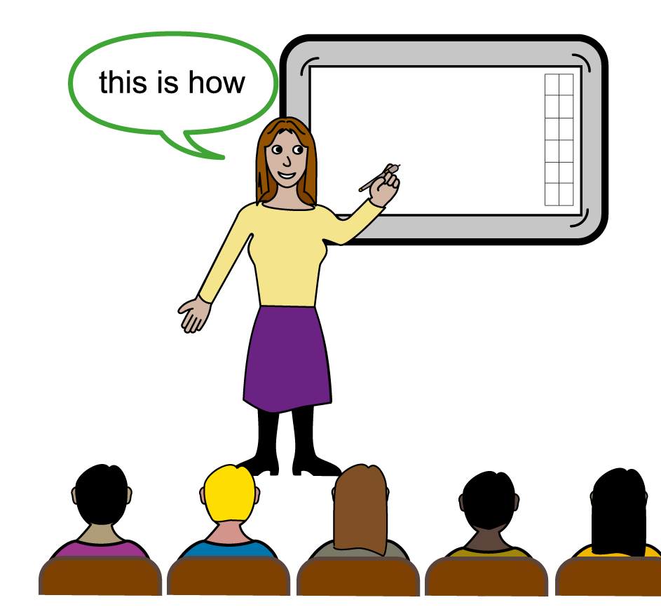

- I am a student ($11)

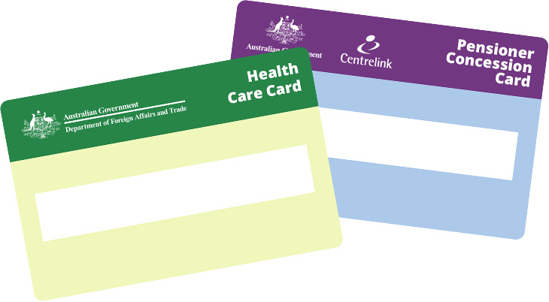

- I have a concession card ($11)

- I am Aboriginal and/or Torres Strait Islander ($0)

I will pay using:

- PayPal

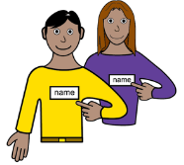
Note: Write your name in the description when you pay.

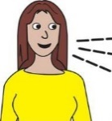
Is there anything else you would like to tell us?
Please write it in the space below:

Click or tap here to enter text.

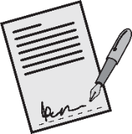
Your signature

Date today (Date/Month/Year)
Click or tap here to enter text.

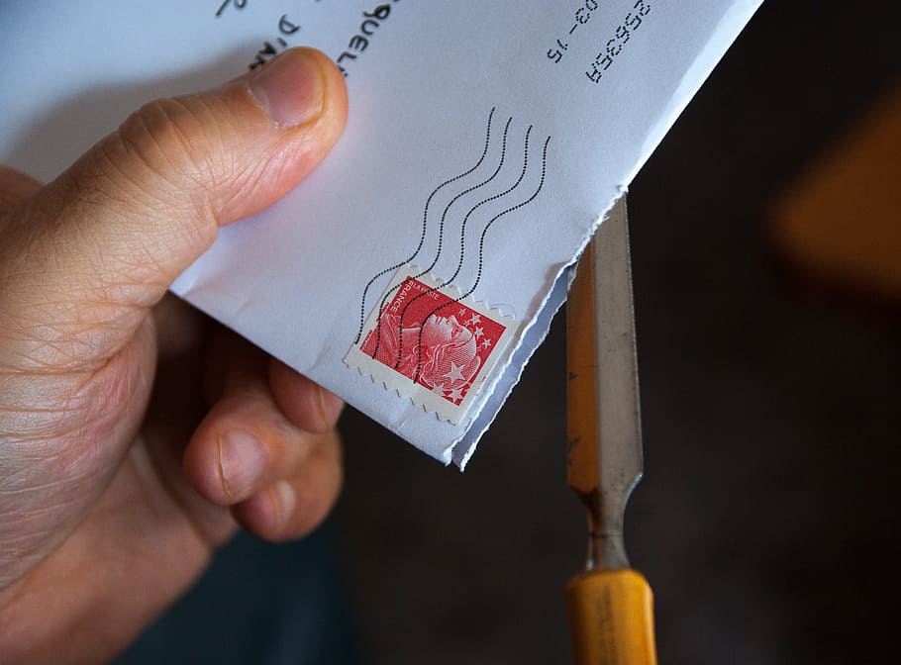
How to send us your Membership Form

You can send your Membership Form:
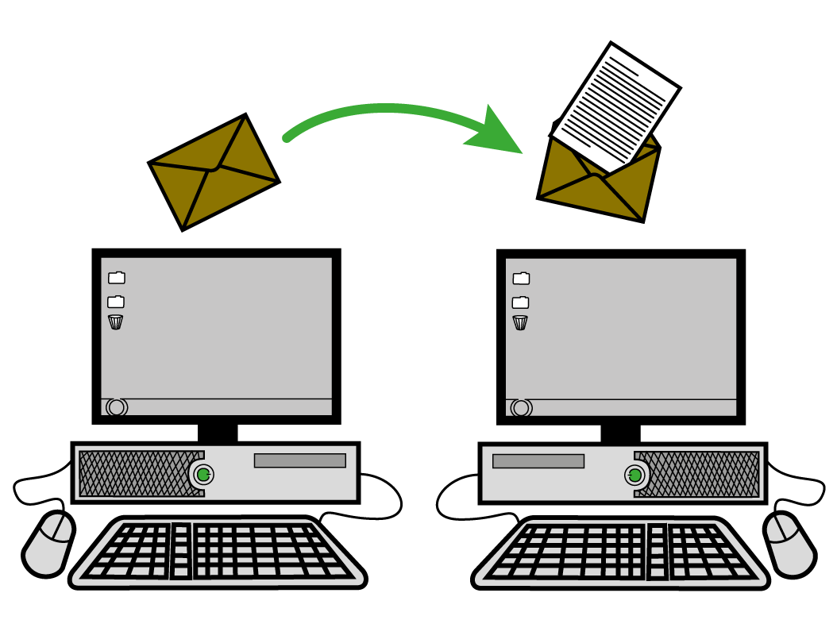
By email: info@australianwomenshealth.org
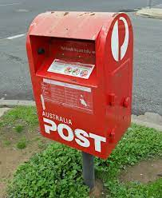
By post: PO Box 341, Leichhardt, NSW 2040

Other ways to join the Australian Women’s Health Alliance
If you don’t want to fill out this Membership Form, there are other ways you can join.
You can send an email to info@australianwomenshealth.org

You can go to our website at www.AustralianWomensHealth.org

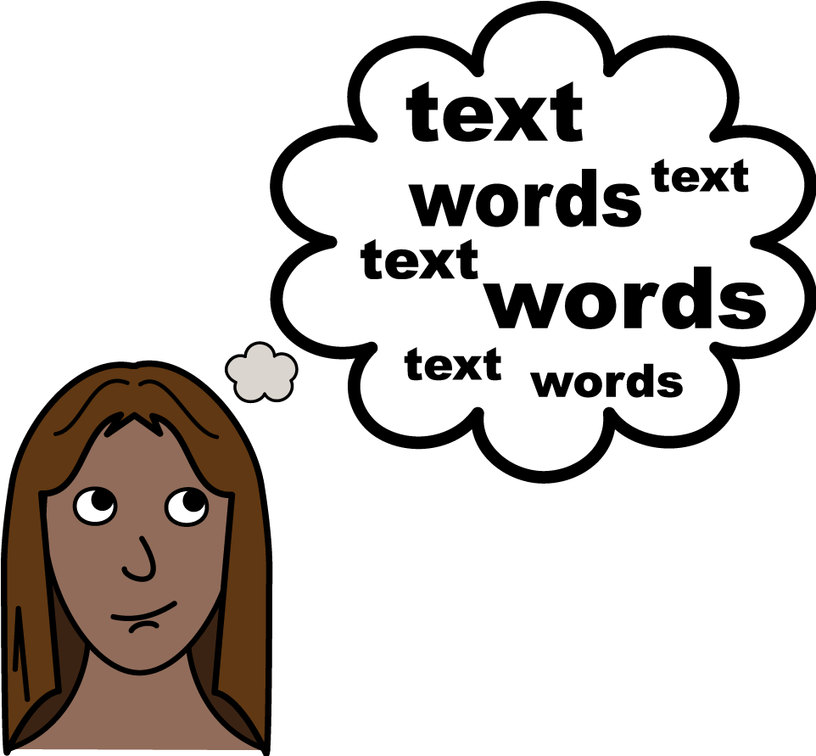
Word list

Bank Transfer is when you move money from one bank account to another. This is usually done on the internet.
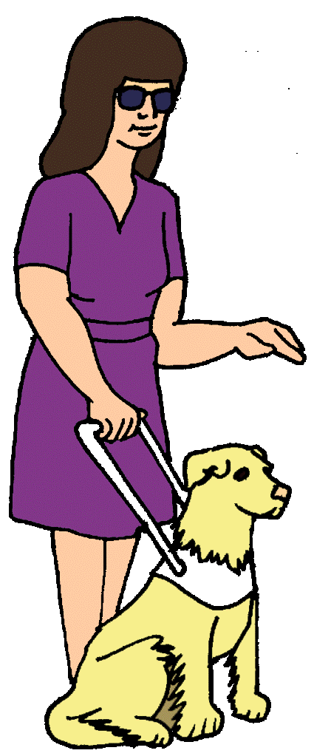
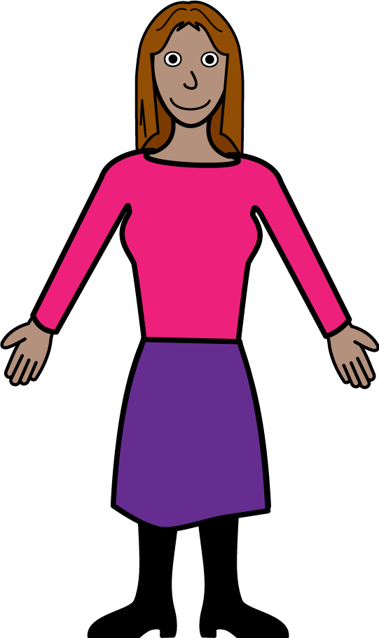
A person with Disability is someone that faces barriers to taking part in some or all areas of life. Sometimes we can see disability. Sometimes we cannot. There are lots of different types of disability.

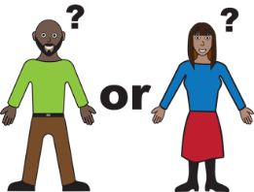
Gender is a word that is used to talk about how people see and express themselves as women, girls, men or boys, or something else. The ways we see and express ourselves have been shaped by many things, including the social and historical times in which we live.

Gender equity is when things are fair for everyone regardless of your gender.
LGBTIQA+ means diverse sexualities and genders. The letters in LGBTIQA+ stand for Lesbian, Gay, Bisexual, Transgender, Intersex, Queer, Questioning, Asexual and other.

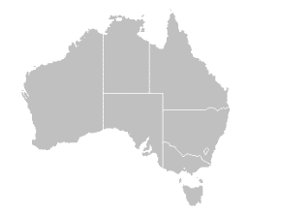
A Migrant is a person that moved to Australia from a different country.
PayPal is an online website that helps people to give and receive money. Australian Women’s Health Alliance uses PayPal for when people want to join and pay money to become a member.
A Refugee is someone that came to Australia to be safe. Refugee’s often come from countries that are or have been in war.
Statement of Purposes is a list of sentences that tell you how Australian Women’s Health Alliance support women’s health.

A person on a Temporary Visa is in Australia for a short time. They are usually in Australia for a holiday, work or to study. They will go back home at some time.

Acknowledgements

Who wrote this form?
The Australian Women’s Health Alliance wrote this form in 2023.

Copyright
© Copyright
Australian Women’s Health Alliance Inc. 2023.

All intellectual property rights, including copyright and patents, in this book is owned and licensed by the Australian Women’s Health Alliance.
The images used in this fact sheet
Easy on the I Images
Google images. Creative Commons Licences.
Microsoft Word Stock Images.
Inspired Services

