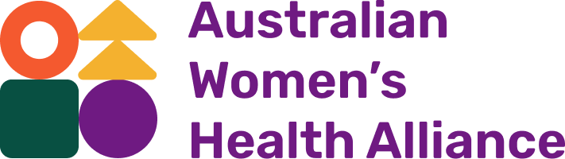

Annual
Report

2022 -
2023

AustralianWomensHealth.org

Acknowledgement of Country
We acknowledge the Traditional Custodians of the lands and waters on which we live and work. We pay our respect to Elders past and present. Sovereignty has never been ceded.

Publication
Australian Women’s Health Alliance
Annual Report 2022 - 2023
Leichhardt, Australia

© Australian Women’s Health Alliance 2023
The Australian Women’s Health Network Pty Ltd is now trading as the Australian Women’s Health Alliance

Reg. No. A02383 ABN 84 238 300 000

Graphic design support and logo by Ximena Jiménez
Illustrations by Josie Ford

Our Vision
Health equity for all women.

Our Purpose
The national voice for women’s health.

Guiding Principles
Our work is guided by feminism, gender equity and human rights.

Leadership Structure
The Australian Women’s Health Network, now trading as the Australian Women’s Health Alliance, formed in 1986. We have members across every state and territory, working in areas of women’s health, gender and health equity. Effort is made to ensure the Board reflects a diversity of experience, views, skills and connection into existing networks, so that we can collaborate in providing a national perspective.

Chair
Bonney Corbin

Deputy Chair
Dr Romy Listo

Treasurer
Denele Crozier AM

Secretary
Megan Elias

Subcommittee Chairs
Business Services and Risk Subcommittee Chair:
Dr Angela Brown
Communications and Brand Subcommittee Chairs:
Holly Brennan OAM and Gemma Black
Governance, Partnership and Membership Subcommittee Chair:
Jo Flanagan
Policy Subcommittee Chairs:
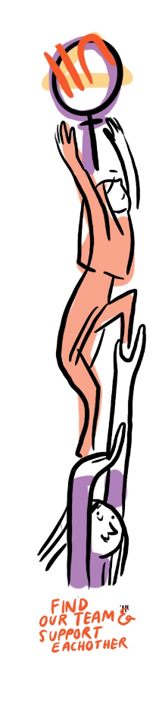
Professor Helen Keleher and Dr Romy Listo

General Board Members
Dianne Hill
Emma Iwinska
Eva Perroni
Heidi La Paglia Reid
Karen Martin
In August 2022 Karen Martin stepped down, and in May 2023 Professor Helen Keleher stepped down and Eva Perroni moved onto the Board.

Contractors
Bonnie Laxton-Blinkhorn – Copy Editor
Kim Blattner – Administration Officer
Min Houseman – IT support
Sienna Aguilar – Senior Project Officer
Ximena Jiménez – Graphic Designer
Thank you to Bobbie Trower and Vanamali Hermans for policy advice, and DropIN solutions for web design support during 2023. Acknowledging Women’s Health NSW for supporting our contractors and administrative work through a business services partnership agreement.

Foreword
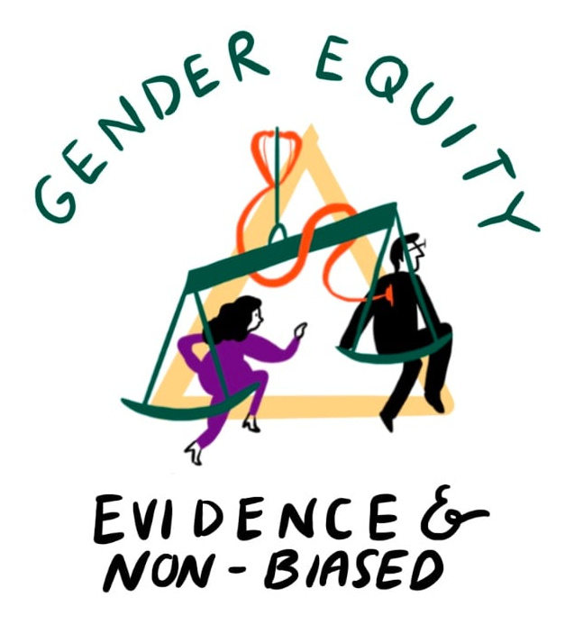
As the cost-of-living increases, viewing health through a social lens has never been so important. Access to housing, education, infrastructure, and community kindness and connection are some of the protective factors that are critical for everyday survival. Changes over the past year highlight the importance of gender responsive budgeting, and how that has the potential to translate to gender responsive health.
National emphasis on women’s health has been accelerated with the launch of a new National Women’s Health Advisory Council, chaired by the Assistant Minister for Health, the Honourable Ged Kearney MP. This was also the first year of our Department of Health and Aged Care, Health Peak and Advisory Body Grant, where we worked within Australia’s health peaks to reflect on and renew our communications, brand and online presence.
Employing methods of co- development, throughout the year we engaged a broad cross-section of key contributors in the broader health ecosystem who are dedicated to improving women’s health outcomes. Given the breadth and depth of this redesign work, we also took the opportunity to refresh our visual identity and name for the organisation. Subsequently we evolved from the Australian Women’s Health Network to the Australian Women’s Health Alliance. Our refreshed brand identity reflects our role as a contemporary organisation that is evidence-based, inclusive and collaborative.
Within our organisational identity we weave the same ethos and values from when we were established in 1986 - we are individuals, who are part of communities, organisations and groups, who are all incredibly passionate about health policy, gender equity and the social models of health.
We continue to rely upon membership fees, volunteer energy and donations to resource administrative costs such as licenses, fees and membership support. Whether you donate funds, resourcing support, time or energy, thank you for being a part of advancing gender and health equity.
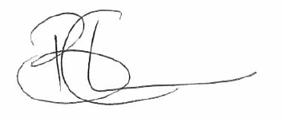
ff

Bonney Corbin
National Board Chair

Strategic Priority 1: Policy and Reform
The Alliance is a national leader in developing, advancing, and responding to public policy and practice as it impacts on women’s health. We provide independent advice from a broad evidence-base to promote a gendered approach to women’s health care.
A national spotlight on women’s health policy has been accelerated with the launch of a new National Women’s Health Advisory Council, chaired by the Assistant Minister for Health, the Honourable Ged Kearney MP. The Council will meet 6 times per year to monitor and provide advice on the implementation of the National Women’s Health Strategy (2020-2030). We have one seat on the Council, which has begun with identifying best practice gender responsive health initiatives, alongside identifying where and how gendered discrimination occurs in Australian healthcare settings.
Our policy focus this year has prioritised a review, renewal and refresh of the Women’s Health Hub, with a focus on establishing solid foundations and an effective approach. This work was a core part of the first year of deliverables under the Australian Government Department of Health and Aged Care, Health Peak and Advisory Bodies Program. It makes strategic links between the National Women’s Health Strategy (2020-2030) and the National Preventive Health Strategy (2021-2030), to embed a gender responsive approach at the national level.
“Yeah, it seems like there's been a lot of like different touch points for feedback… I think it's good that you've got like a really diverse sort of range of channels to feed back.” – Project officer, member organisation.
“From the very beginning the Women’s Health Hub project has fostered an inclusive and collaborative environment where everyone’s contributions have been valued, our expertise has been used to address specific challenges and opportunities… It’s rewarding to know that [the service’s] insights are helping to shape the projects outcomes.” – Member representative, domestic and family violence service.
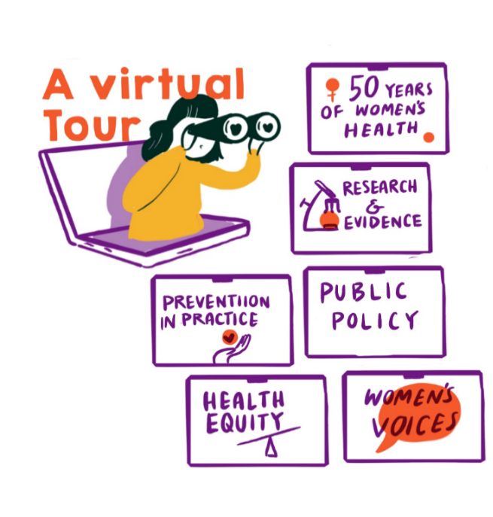
The Hub will continue to be a national resource for people dedicated to improving women’s health outcomes – whether in policy, research, health care or across the broader health ecosystem. It will build on previous iterations and builds on a recognition of how valuable it is to have a central entry point to national information on women’s health to inform research, public policy and practice. It affirms our focus on prevention, to support a gender equity approach to health and healthcare across Australia.

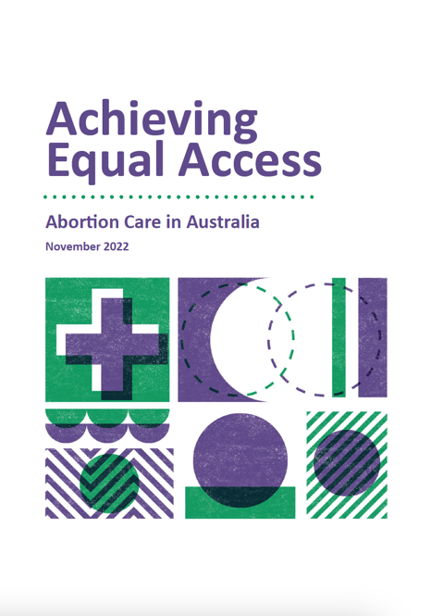
Impact Focus: Reproductive Rights
On International Safe Abortion Day in 2022 we brought together pro-choice advocates from across the federal parliament to draw media attention to the practical barriers that prevent timely and affordable access to abortion care in Australia, as well as the need for federal government action. This action enabled significant media attention on abortion access barriers and helped to secure a Senate Inquiry into Universal Access to Reproductive Healthcare.
To make the most of the opportunity presented by this Senate Inquiry, we then worked to draw attention to, and build momentum for, action on the key barriers we know impact people who are trying to access abortion.
Together with key stakeholders, we published the report ‘Achieving Equal Access: Abortion Care in Australia’, highlighting 5 key barriers to abortion access in Australia at the time, specifically: affordability, lack of clinical services, healthcare workforce barriers, over-regulation of medication, and lack of data. The report also highlighted 2 key solutions that could address these problems: immediate federal government action to address affordability, and the creation of an expert-led National Taskforce on abortion care, with a mandate to develop a comprehensive plan to improve abortion access across the public healthcare system.
We made this resource the focus of our submission to the Senate Inquiry, and secured endorsement from a variety of other stakeholders to show the scale of support for action in these areas. Through the campaign we also supported 150 community members to make submissions through the Senate Inquiry process and gave testimony before the Senate Committee to as part of the Hearing process.
In May 2023 the Senate Committee handed down the findings from the Inquiry, making 36 recommendations for action. We were pleased to see the Senate Inquiry recommended changes in relation to all 5 of the areas that we had identified as key systemic barriers, and that these recommendations were endorsed by all parties represented on the committee, multilaterally.
The recommendations did collectively provide a blueprint to deliver progress in many of the areas we had called for action. We are now collaborating with the National Women’s Health Advisory Council and the Department of Health to ensure the recommendations made regarding improving abortion access are actioned.
The report ‘Achieving Equal Access: Abortion Care in Australia’ is available on the Women’s Health Hub.

Strategic Priority 2: Connect and Collaborate
The Alliance is a vehicle for women’s health organisations, consumers, and advocates to connect and collaborate through our membership base and effective processes to represent the views of members and their constituents.
Thank you to our members, partners and key contributors who participated in co-development opportunities throughout this year. We facilitated co-development sessions, a survey, online forums, and co-authored submissions with other national women’s and health alliances. We supported media campaigns for increased investment in women’s health and wellbeing, and investment in women’s specialist services. We established an inaugural pool of ‘critical friends’, with representation from the disability sector, migrant and refugee women, research and consumer groups.
The national Women’s Health Policy community of practice was established, which includes researchers, health and community service providers, policy and advocacy professionals and health consumers. An informal Women’s Health communications group was established to support member organisations and partners to access and share relevant resources.
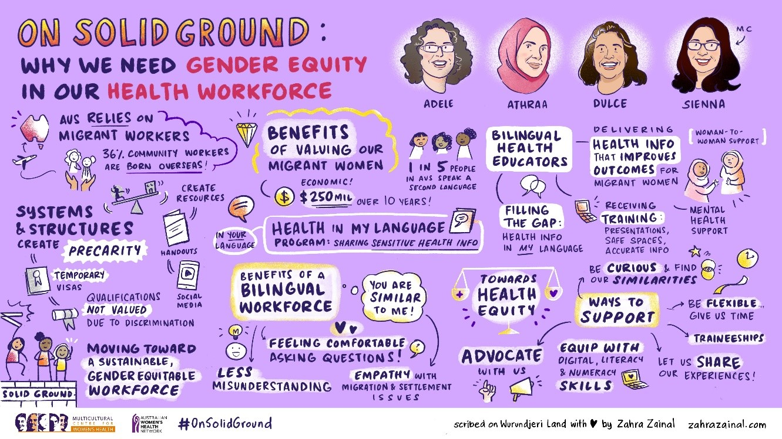
A joint seminar was co-hosted with organisational member Multicultural Centre for Women’s Health on the importance of gender equity in our health workforce and shared insights from the Health in My Language bilingual health education program.
"The 3 presentations with powerful messages about the important roles of bilingual health educators [was my key takeaway]." – Webinar attendee.
"Evidence-base is important but hearing about lived experiences drives the point more effectively. So, when presented together, like in today's webinar, it is insightful and informative." – Webinar attendee.
“Thank you so much for including me in this Webinar and for all the presentations. I think that the job that you are doing is amazingly important for women from different cultural backgrounds!” – Webinar guest speaker.
This year we partnered with Fair Agenda to collaborate on several campaigns and activities related to gender and health equity, including reproductive rights and abortion access, legal system responses to sexual violence, and sexual and gender-based violence prevention.
We participated in media interviews, co-authored articles, and supported the development of documenting and sharing evidence on the evolving nature of the women’s health. We continued to use e-newsletters as a primary point of contact with members. Across social media platforms we now have more than 7,600 followers.

Strategic Priority 3: Governance and Agency
As an independent peak and health promotion charity, the Alliance demonstrates best practice in its governance, leadership, and operations.
The Alliance has been through a change in leadership process, with a number of new Board members beginning this year. We had 4 subcommittees in action throughout the year:
- Policy subcommittee
- Partnership, membership and governance subcommittee
- Communications and brand subcommittee
- Business services and risk subcommittee

Working groups arose as needed to progress particular areas of work, such as recruitment.

We reviewed and maintained our partnership agreement with Women’s Health NSW, which provides business services and administrative support functions. We worked to mitigate the risk of outdated organisational systems and structures, moving all Board Members and contractors to SharePoint following all our records being uploaded to a Microsoft cloud last financial year. We mobilised new social media tools to streamline communications across platforms.
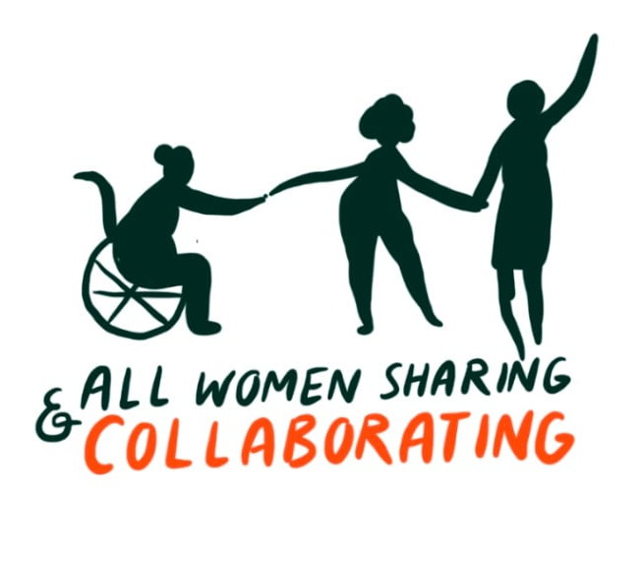
Feedback from board evaluations and member surveys in 2021-22 demonstrated a need for renewed systems and processes. Feedback was incorporated into risk reviews, continuous improvement, and we have planned for strategic and constitutional reviews in the next year.

Finance
Audited Financial Accounts for the 2022-2023 Financial Year are tabled at the Annual General Meeting and available on request to the membership. We currently have a 3-year grant from Australian Government Department of Health and Aged Care, Health Peak and Advisory Bodies Program. The primary source of our other income remains membership fees, philanthropy, and one-off donations all of which have slightly increased.
We have a small but strong finance team coupled with good financial systems and projected budgets for the year ahead overseen by our Business, Finance and Risk Committee. We started this year with a projected budget and ended with an unqualified audit.
The Australian Women’s Health Alliance continues to operate to budget and asserts that there are reasonable grounds to believe it will be able to pay its debts, if, and when, they fall due.
 | 2021/2022  ($) | 2022/2023  ($)
Revenue  Project grants | - | 151,002
Memberships | 2,570 | 3,900
Donations received | 1,402 | 178,371
Interest | 3 | 269
Other income  Less donations distributed | 99 | 89  (172,168)
Revenue from ordinary activities | 4,074 | 161,463
Expenses  Accounting and audit fees  Consultancy  Human resources expenses  Infrastructure expenses  Governance and strategy  Marketing and communications  Other expenses | -  -  363  2,070  -  -  - | 5,300  6,695  125,452
 |  | 2,076
3,265
4,098
 |  | 357
Total expenses by function | 2,433 | 147,243
Surplus/(deficit) from ordinary activities | 1,641 | 14,220
Plus other comprehensive income | - | 1,227
Total equity | 22,150 | 37,597

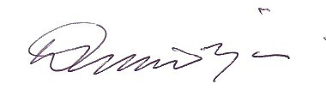

Denele Crozier, AM
Treasurer

Join
Online: australianwomenshealth.org/join-us/

Connect
Web: AustralianWomensHealth.org
LinkedIn: linkedin.com/company/australianwomenshealth
Facebook: facebook.com/AustralianWomensHealth
Instagram: @AustralianWomensHealth

Mail
Email: info@australianwomenshealth.org
Post: PO Box 341, Leichhardt, NSW, 2040

Donate
Online: australianwomenshealth.org/donate/

Reg. No. A023 83 ABN 84 238 300 000

