Social Media Kit

E-learning user testing campaign
15 November 2023
Contents
Key messages 1
Article 2
LinkedIn / Facebook / Instagram 2
Twitter/X 2
Assets 3
About us 4
Contact us 4

Key messages
- The Australian Women's Health Alliance is creating new online learning resources to support greater understanding about gender equity in health.
- The Alliance is looking for people to help test these resources between November 2023 and February 2024.
- There will be a range of opportunities, which could include reviewing content and case studies and testing the platform for useability and accessibility.
- Express interest via https://bit.ly/UserTestE-learningMaterials.

Article
The Australian Women’s Health Alliance is creating new online learning resources to draw links between gender, health and prevention.

To make these resources as useful as possible and to make it easier for us to collectively build a gender responsive health system, they need your input.

People can help us test these resources between November 2023 and February 2024.

Not a content matter expert? Don’t worry, these resources are all about building knowledge and capacity and your feedback will be valued, no matter your level of expertise.

There will be a range of opportunities, which could include reviewing content and case studies and testing the platform for useability and accessibility.

Keen to learn more? Express your interest or encourage colleagues, friends and family to get involved via https://bit.ly/UserTestE-learningMaterials

There are also a limited number of gift cards for health consumers who wish to be involved and are not in a paid role in an organisation. If that’s you, be sure to tick the box on the form.

LinkedIn / Facebook / Instagram
Are you interested in gender responsive health?

The Australian Women’s Health Alliance is creating new online learning resources to support greater understanding about gender equity in health.

They are looking for people to help test these resources. Opportunities include reviewing content and case studies and testing the platform for useability and accessibility.

Keen to learn more? Express your interest at https://bit.ly/UserTestE-learningMaterials

#GenderResponsiveHealth #HealthEquity #WomensHealth #PreventionMatters

Twitter/X
Wondering what #GenderResponsiveHealth is? Help @AusWomensHealth test new e-learning resources to support better understanding about #GenderEquity in health. There will be a range of opportunities & all welcome, complete the EOI: https://bit.ly/UserTestE-learningMaterials #HealthEquity #Prevention

Assets
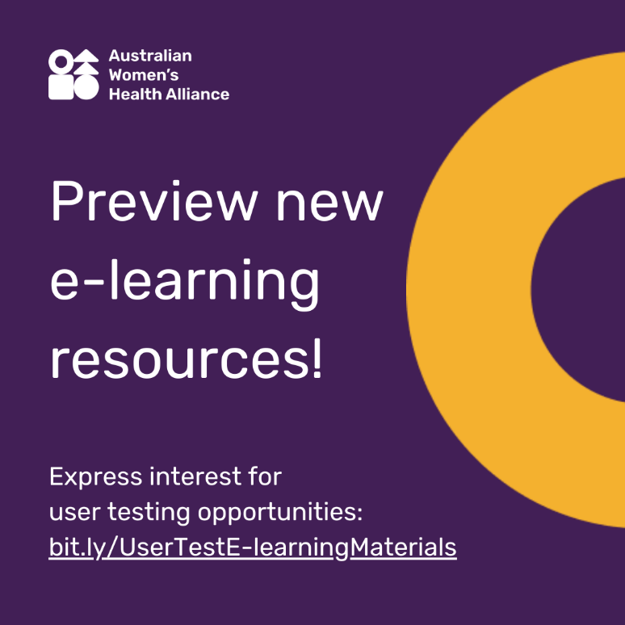
Image description/alt text:
White text on a dark purple background that says, "Preview new e-learning resources! Express interest for user testing opportunities: bit.ly/UserTestE-learningMaterials. In the top left-hand corner is the Australian Women's Health Alliance logo in all white. On the right-hand side of the image is a yellow half-donut shape. The cropped donut shape comes from the Alliance logo and represents inclusion.

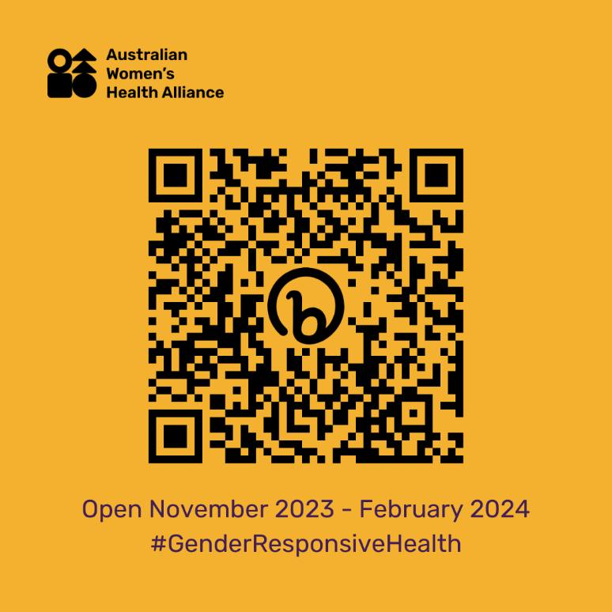
Image description/alt text:
A black QR code on a burnt yellow background takes users to an online form to express interest in user testing opportunities. In the top left-hand corner is the Australian Women's Health Alliance logo in all black. At the bottom of the page under the QR code is black text that says "Open November 2023 - February 2024 #GenderResponsiveHealth".

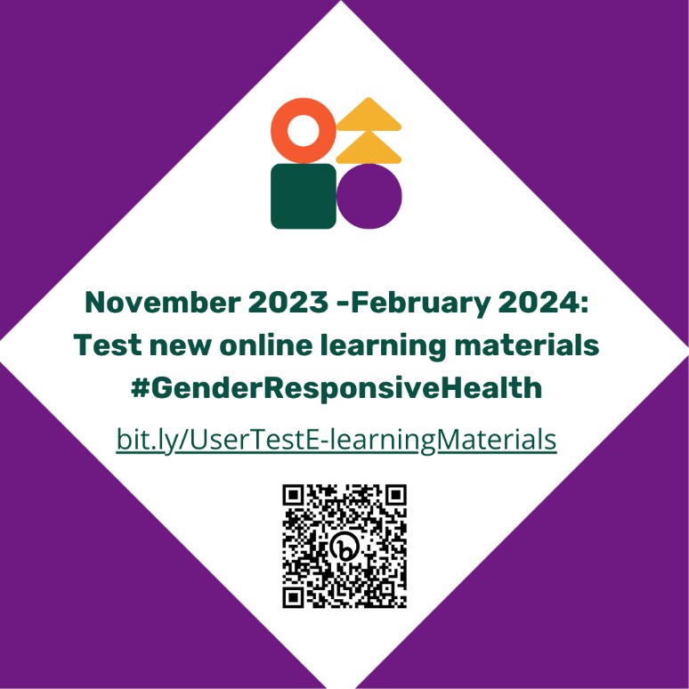
Image description/alt text:
A purple background with a white diamond contains the Australian Women's Health Alliance (symbols only).
Underneath is text that says “November 2023 - February 2024: Test new online learning materials #GenderResponsiveHealth
bit.ly/UserTestE-learningMaterials”
At the bottom is a black QR code that takes users to an online form to express interest in user testing opportunities.

About us
Australian Women’s Health Alliance provides a national voice on women’s health. We highlight how gender shapes experiences of health and health care, recognising that women’s health is determined by social, cultural, environmental, and political factors.

Contact us
Enquiries: sienna.aguilar@australianwomenshealth.org
Web: www.AustralianWomensHealth.org

We acknowledge the Traditional Custodians of the lands and waters on which we live and work.
We pay our respect to Elders past and present. Sovereignty has never been ceded.

