Social Media Kit

Launch of ‘Introduction to Gender-Responsive Health’
22 May 2024
Contents
Key messages 1
Article 2
Social media 2
Assets 3
About us 4
Contact us 4

Key messages
- Australian Women’s Health Alliance is proud to launch the prototype of a new free e-learning course: ‘Introduction to Gender-Responsive Health’.

- The online training modules will support workplaces and individuals across health, well-being and social services and policy.

- Register to attend a free webinar on Wednesday 19 June 2024, time as per your time zone:
  - 5:00 PM - 6:00 PM AWST (WA)
  - 6:30 PM - 7:30 PM ACST (NT/SA)
  - 7:00 PM - 8:00 PM AEST (ACT/NSW/Qld/Tas/Vic)
  - https://bit.ly/e-learninglaunch or
  - https://zoom.us/webinar/register/WN_nHj7PB-xRgu6eVmgg0DJ5w

- At the online launch you can:
  - Gain an overview of the course and how it can support ongoing professional development
  - Learn how you can introduce this training into your workplace or community
  - Tune into a conversation with guest speakers about the possibilities of embedding gender-responsive approaches to health in practice.

Article
National health peak body Australian Women’s Health Alliance is launching a new free e-learning course: ‘Introduction to Gender-Responsive Health’ on Wednesday 19 June, 7 PM – 8 PM AEST [and/or time as per time zone].

Their online training modules will support workplaces and individuals across health, well-being and social services and policy.

[If you or your organisation has been involved in its co-development, such as user testing, attending a focus group or gave feedback etc., consider including a positive quote about what you think of the course so far, or why you think it’s important for your members/networks to attend.]

Register to attend the free webinar via Zoom:
- Gain an overview of the course and how it can support ongoing professional development
- Learn how you can introduce this training into your workplace or community
- Tune into a conversation with guest speakers about the possibilities of embedding gender-responsive approaches to health in practice

https://zoom.us/webinar/register/WN_nHj7PB-xRgu6eVmgg0DJ5w

Social media
For health and social/community service professionals:
Looking to add to your continuous professional development (CPD)? Strengthen your person-centred care with knowledge about gender-responsive approaches to health and prevention.

Australian Women’s Health Alliance is launching a new e-learning course, ‘Introduction to Gender-Responsive Health’. Register to attend a free webinar on Wednesday 19 June (time as per your time zone) and learn more: https://bit.ly/e-learninglaunch

#GenderResponsiveHealth #HealthEquity #WomensHealth #PreventionMatters

For policy, advocacy etc.:
Policy makers across government are invited to attend the launch of a free new e-learning course, ‘Introduction to Gender-Responsive Health’ by Australian Women’s Health Alliance.

Register to attend a free webinar on Wednesday 19 June (time as per your time zone) and learn more: https://bit.ly/e-learninglaunch

#GenderResponsiveHealth #HealthEquity #WomensHealth #PreventionMatters

Assets
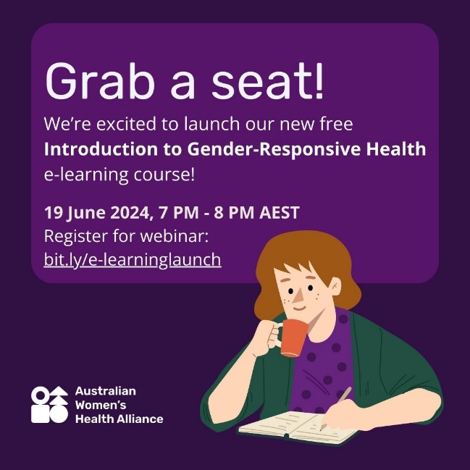 | Image 1 description/alt text:  White text on a purple background that says, "Grab a seat! We're excited to launch our new free Introduction to Gender-Responsive Health e-learning course! 19 June 2024, 7 PM - 8 PM AEST, Register for webinar: bit.ly/e-learninglaunch. At the bottom left hand is the Australian Women's Health Alliance logo in white, and on the bottom right hand side is an illustration of a white woman with brown shoulder length hair, holding a mug and writing in a notebook, wearing a purple top with polka dots and a dark green cardigan.
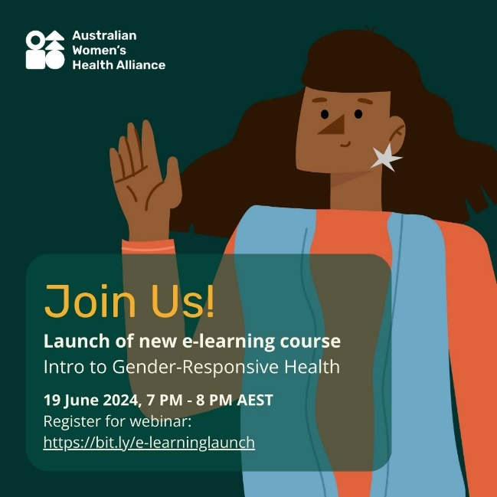 | Image 2 description/alt text:  The Australian Women's Health Alliance logo in white is in the top left-hand corner of a dark green image. There is an illustration of a brown woman with wavy long dark brown hair and a star earring smiling and waving, wearing an orange long sleeved top and light blue vest. In front of her is text that says, "Join Us! Launch of new e-learning course, Intro to Gender-Responsive Health, 19 June 2024, 7 PM - 8 PM AEST, Register for webinar: https://bit.ly/e-learninglaunch
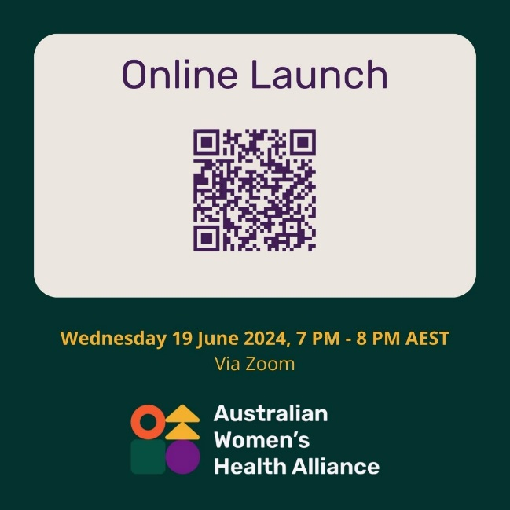 | Image 3 description/alt text:  Dark purple text in a beige coloured rectangle with soft edges that says, “Online Launch”. Underneath is a QR code that takes users to an online form to register for a webinar. Towards the bottom of the image is yellow text that says, “Wednesday 19 June 2024, 7 PM - 8 PM AEST Via Zoom” and the Australian Women’s Health Alliance logo.
Instagram tiles
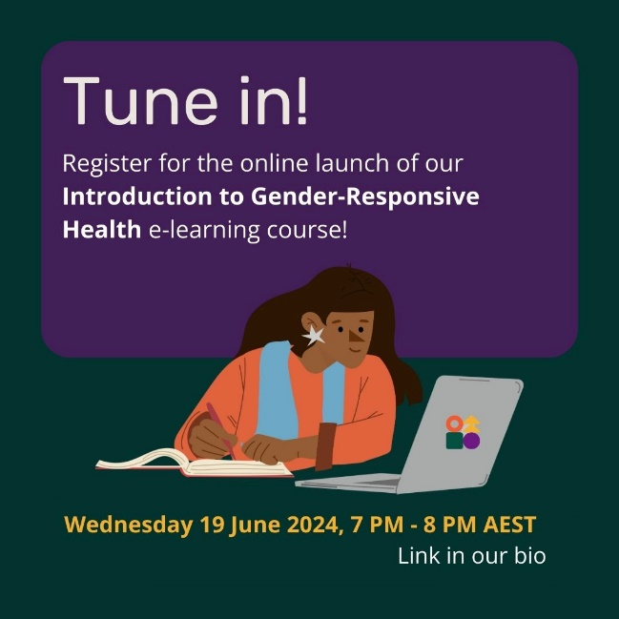 | IG Image 1 description/alt text:  Text on a purple background that says, "Tune in! Register for the online launch of our Introduction to Gender-Responsive Health e-learning course!” Underneath is an illustration of a brown woman with wavy long dark brown hair and a star earring, wearing an orange long sleeved top and light blue vest, studying at a computer. At the bottom of the image is yellow text that says, “Wednesday 19 June 2024, 7 PM - 8 PM AEST” and white text that says, “Link in our bio”.
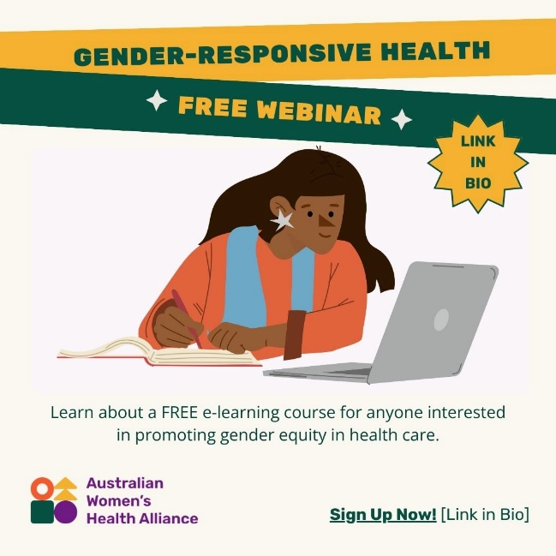 | Image description/alt text:  A heading that says, “Gender-Responsive Health, Free Webinar” and a multi-pronged star with text inside that says, “Link in bio”. Underneath is an illustration of a brown woman with wavy long dark brown hair and a star earring, wearing an orange long sleeved top and light blue vest, studying at a computer. At the bottom of the image is the text: “Learn about a FREE e-learning course for anyone interested in promoting gender equity in health care.” In the bottom left corner is the Australian Women’s Health Alliance logo, and in the bottom right corner is text: “Sign Up Now! [Link in Bio]”.

About us
Australian Women’s Health Alliance provides a national voice on women’s health. We highlight how gender shapes experiences of health and health care, recognising that women’s health is determined by social, cultural, environmental, and political factors.

Contact us
Enquiries: sienna.aguilar@australianwomenshealth.org
Web: www.AustralianWomensHealth.org

We acknowledge the Traditional Custodians of the lands and waters on which we live and work.
We pay our respect to Elders past and present. Sovereignty has never been ceded.

