Introduction to Gender-Responsive Health

e-Learning Course Social Media Kit

Contents

About Australian Women’s Health Alliance 1
Key messages 2
How to access the course 2
Social media 2
Newsletter content 7
More information 8
Contact us 8

About Australian Women’s Health Alliance
We are the national voice on women’s health. Our aim is to achieve gender equity in health for all women.

About Introduction to Gender-Responsive Health
This e-learning course is made up of 5 short online modules that support learners to understand and apply a gender-responsive approach to health and prevention.

Women and gender diverse people experience health, illness and health care differently to men. This course aims to increase understanding about these differences and how gender-responsive approaches can improve health equity.

The following modules are now available:
- What’s Gender Got to Do with It? Understanding Gender-Responsive Health
- What Can Gender-Responsive Health Look Like? Gendered Inequities vs. Gender-Responsive Approaches

Who is this training for?
This training is for workplaces and individuals who play a role supporting the health and wellbeing of their community. This includes people who know a bit about gender-responsive health as well as those who are starting from scratch.
People who will benefit from completing this course include:
- health care professionals
- researchers
- policy makers
- community workers
- social care providers
- students and those who aspire to join the health and social care workforces.

Key messages
- This e-learning is for anyone who has a role supporting the health and wellbeing of their community.
- Gender-responsive health is good for gender equity.
- This course is evidence-based, free, flexible and highly accessible.
- This course was co-developed with health experts and people with lived experience.
- This course can support workplaces and individuals committed to improving health outcomes for women.

How to access the course
We developed this e-learning course as one of our Prevention in Practice resources for the Women’s Health Hub. The course is available on the Australian Women’s Health Alliance e-learning platform.

You can learn more about Prevention in Practice on the Women’s Health Hub.

Social media
Please use the social media collateral below across your social media channels and in your newsletter or online blog posts. Please tag Australian Women’s Health Alliance!
- LinkedIn: @australianwomenshealth
- Facebook: @AustralianWomensHealth
- Instagram: @australianwomenshealth
- X: @AusWomensHealth

Blogs articles by Australian Women’s Health Alliance
- About the course: E-Learning Course: Introduction to Gender-Responsive Health
- Recapping the e-learning course launch: Learn Now: What is Gender-Responsive Health?

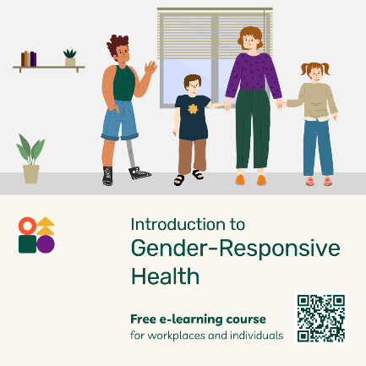 | An illustration of 4 people standing in a room. The first person is a person with an artificial leg. To their right is a woman wearing a purple top and green pants holding the hands of 2 children. The words say, ‘Introduction to Gender-Responsive Health free e-learning course’, ‘Free e-learning course for workplaces and individuals’ and there is a QR in the bottom right corner.
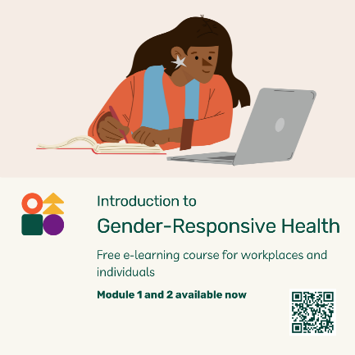 | An illustration of a woman with long black hair and brown skin looking at a laptop computer. One of her hands holds a pen and she has a notebook on the desk which she is writing in. The words say, ‘Introduction to Gender-Responsive Health free e-learning course’, ‘Free e-learning course for workplaces and individuals’, ‘Module 1 and 2 available now’ and there is a QR code in the bottom right corner.
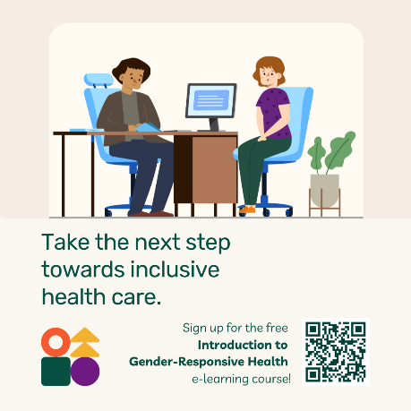 | An illustration of 2 people sitting in a health care setting with a desk and a computer on the table. On the left is a health professional on a chair wearing a brown top and blue pants. On the right is a woman with red hair wearing a purple top and green pants. The words say, ‘Take the next step towards inclusive health care. Sign up for the free Introduction to Gender-Responsive Health e-learning course!’ There is a QR code in the bottom right corner.
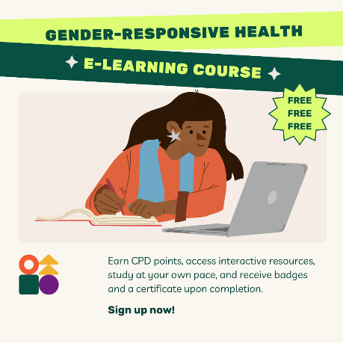 | Text that says, ‘Gender-Responsive Health E-Learning Course’. Underneath is an illustration of a woman with long black hair and brown skin looking at a laptop computer. She is holding a pen and writing in a notebook. To her right is text that says, ‘Free Free Free’. At the bottom of the page is text that says, ‘Earn CPD points, access interactive resources, study at your own pace, and receive badges and a certificate upon completion. Sign up now!’
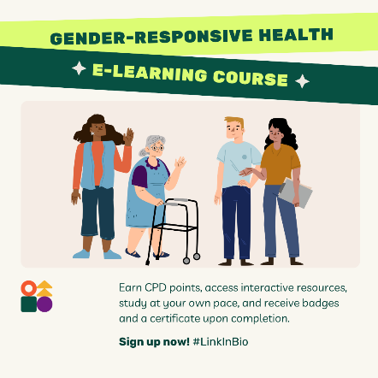 | Text that says, ‘Gender-Responsive Health E-Learning Course’. Underneath is an illustration of 4 people from diverse backgrounds and wearing different coloured clothes. One is an elderly woman is using a walker. Underneath is text that says, ‘Earn CPD points, access interactive resources, study at your own pace, and receive badges and a certificate upon completion. Sign up now! #LinkInBio’.

Suggested hashtags
#GenderResponsiveHealth  #AustralianWomensHealth  #AusWomensHealth  #GenderEquity  #ImproveGenderEquity | #HealthEquity  #ImproveHealthEquity  #WomensHealth  #WomensHealthHub  #PreventionInPractice

Suggested copy (short)
Committed to improving health outcomes for women and building a better health care system? Learn about gender-responsive health, right here, right now: https://womenshealthhub.learnworlds.com/home #AusWomensHealth #GenderResponsiveHealth

What even is gender-responsive health? Complete free e-learning and help us #makeadifference: https://womenshealthhub.learnworlds.com/home #AusWomensHealth #GenderResponsiveHealth

#GenderResponsiveHealth made easy. Co-developed with health experts and people with lived experience, the Australian Women’s Health Alliance e-learning course is free, flexible and evidence based: https://womenshealthhub.learnworlds.com/home #AusWomensHealth

What does #GenderResponsiveHealth look like? Complete Module 1 and 2 of the Australian Women’s Health Alliance e-learning course and find out now: https://womenshealthhub.learnworlds.com/home #AusWomensHealth #GenderResponsiveHealth

Suggested copy for workplaces/stakeholders
The following content can be used and edited for longer social media posts or online notices for your workplace or other organisations in your networks who may benefit from completing this course.

What is Gender-Responsive Health?

- Curious about health equity?
- Keen to make your workplace more gender-responsive?
- Committed to improving health outcomes for women?
- Unsure where to start…?

Start here >>> The Australian Women’s Health Alliance has launched a new e-learning course to increase understanding about gender-responsive approaches to health and how they improve health equity.

This free, flexible, evidence-based course is ideal for organisations looking to upskill and build confidence among existing staff, as well as for training new starters.

Course overview:
- 5 evidence-based modules co-developed with health experts and people with lived experience.
- Learners can work at their own pace or as part of team training, receive a badge for each module and earn a certificate at the end of the course.
- Ideal for mandatory training and professional development for workplaces committed to health equity.
- Applicable, relevant, and accessible content, that includes key terms, practical examples and additional reading.
The first 2 modules are available now:
Module 1: What’s Gender Got To Do With It?
Module 2: What Can Gender-Responsive Health Look Like?

Complete our training and make your organisation more gender-responsive! Learn more at: https://womenshealthhub.learnworlds.com/

#GenderEquity #HealthEquity #GenderResponsiveHealth #HealthCareProfessionals #ProfessionalDevelopment #WomensHealth #MandatoryTraining #AustralianWomensHealthAlliance #WomensHealthHub #PreventionInPractice

Suggested copy for professionals and individuals

Build your expertise in gender-responsive health!

Did you know that women and men experience health care differently? When health is gender-responsive, it not only improves health outcomes for women, but also promotes health equity across the board.

Australian Women’s Health Alliance has created a free e-learning course designed to give health professionals—and anyone committed to gender and health equity—the tools they need to provide gender-responsive care.

Course overview:
- 5 evidence-based modules co-developed with health experts and people with lived experience
- Learn at your own pace, receive a badge for each module and a certificate at the end of the course
- Ideal for mandatory training and professional development for workplaces committed to health equity
- Practical, relevant, and accessible content, that includes key terms, case studies and additional reading.

The first 2 modules are available now:
Module 1: What’s Gender Got To Do With It?
Module 2: What Can Gender-Responsive Health Look Like?

Start learning and start making a difference: https://womenshealthhub.learnworlds.com

#HealthEquity #GenderResponsiveHealth #HealthCareProfessionals #ProfessionalDevelopment #WomensHealth #MandatoryTraining #AustralianWomensHealthAlliance #WomensHealthHub #PreventionInPractice

Newsletter content
The following suggested content can be used for online blog posts and newsletters.

Suggested titles:
- Help us build a better health care system
- How to build a gender-responsive health care system
- Gender-responsive health starts here

Women and men experience health and health care differently. When the health care sector provides gender-responsive care it enhances health outcomes for women, and it also improves health equity.

The Australian Women's Health Alliance has built a free e-learning course to ensure health care professionals, and those committed to gender and health equity, have the information and resources necessary to provide gender-responsive health care.

Introduction to Gender-Responsive Health is a series of 5 evidence-based modules which can be completed by individuals or workplaces.

Co-developed with health experts and people with lived experience, this course is practical, relevant and accessible. It builds workplace confidence by:
- increasing understanding of gender-responsive health
- using practical examples to demonstrate gender-responsive approaches to health and prevention.
- defining key terms and using clear language to communicate about gender equity in health and prevention
- encouraging learners to reflect on their own context and identify actions to strengthen their approach to gender-responsive health in practice.

Learners complete the course in their own time and receive a badge for completing each module and then a certificate of completion at the end of the course.

This course is ideal for mandatory training and professional development in workplaces committed to health equity.

The first 2 modules are available now with the final 3 to be rolled out in coming months.
Module 1 – What’s Gender Got To Do With It?
Module 2 – What Can Gender-Responsive Health Look Like?
Start learning at https://womenshealthhub.learnworlds.com.

More information
To raise awareness about our e-learning course we have created a range of promotional posters which are available to download and print. We encourage you to share these widely:

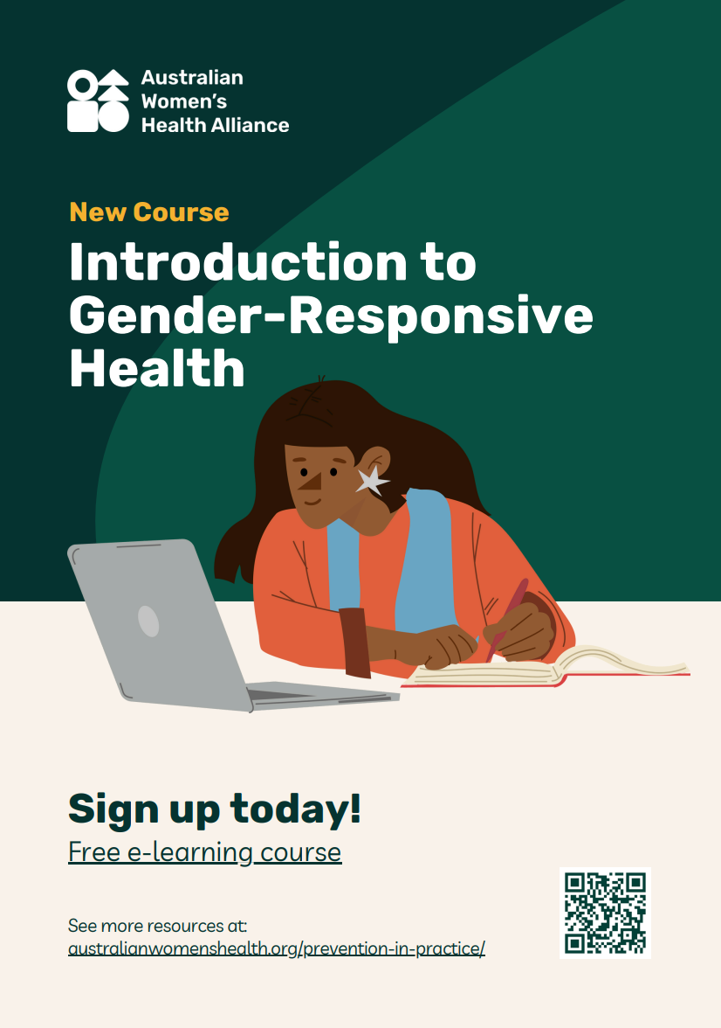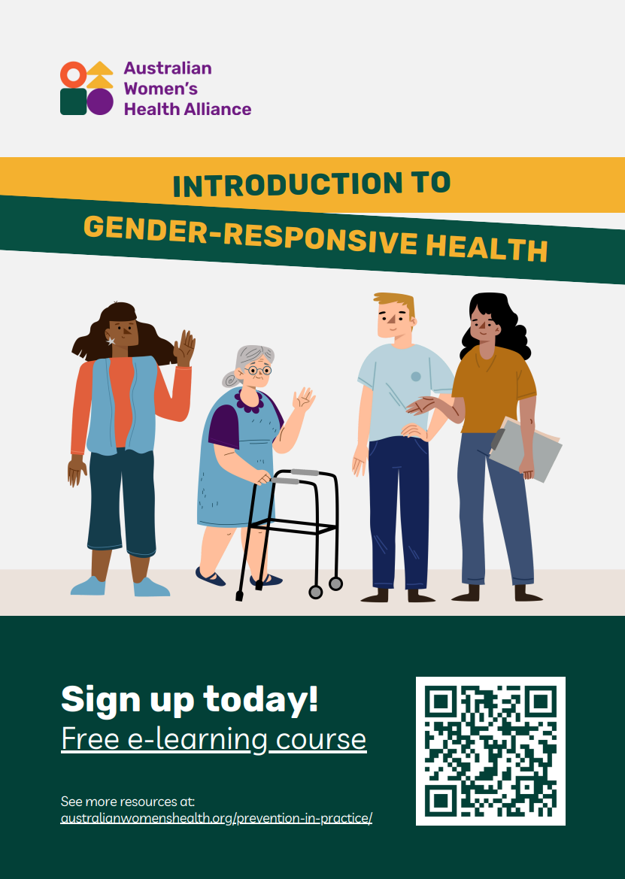

Visit the Women’s Health Hub to learn more about the Introduction to Gender-Responsive Health e-learning course.

Contact us
Enquiries: Sienna.Aguilar@AustralianWomensHealth.org
Web: www.AustralianWomensHealth.org

We acknowledge the Traditional Custodians of the lands and waters on which we live and work.
We pay our respect to Elders past and present. Sovereignty has never been ceded.

