Toolkit Resource

Policy Activity: Think nationally, act locally
Pick one national health strategy and find a related state/territory policy document. This could be a strategy, action plan, framework or another relevant document that links to a priority or focus area in your chosen national strategy. (If you are unsure, you can also choose one of the example sets provided.)

- Are there any gender-responsive actions in the policy document for your state/territory? If so, have you seen this implemented in your local community? If not, what gendered considerations might be missing?

- If you work in an organisation that interacts with the local community, how might your workplace contribute to this state/territory and national priority?

- What organisations and groups play a role in implementing this national priority in your local community or state/territory?
(For example, health providers, specific peak bodies, consumer groups, education settings, local community organisations, migrant and refugee services, Aboriginal and Torres Strait Islander community-controlled organisations, community legal services etc.)

Example 1: Women’s health
National strategy | State/territory document
National Women's Health Strategy 2020-2030  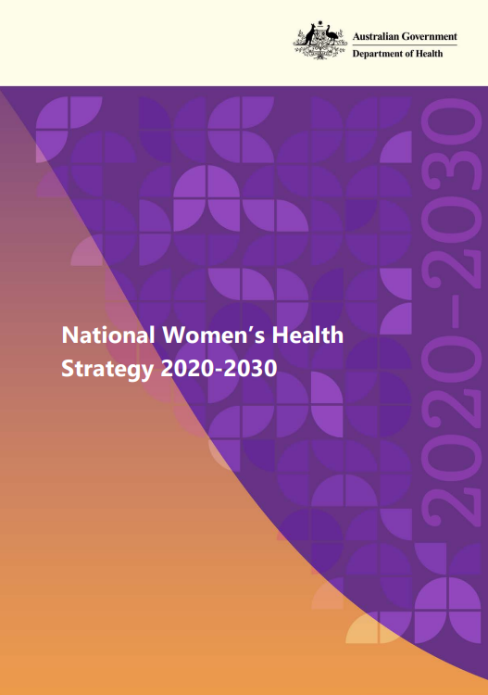 | Queensland Women and Girls' Health Strategy 2032  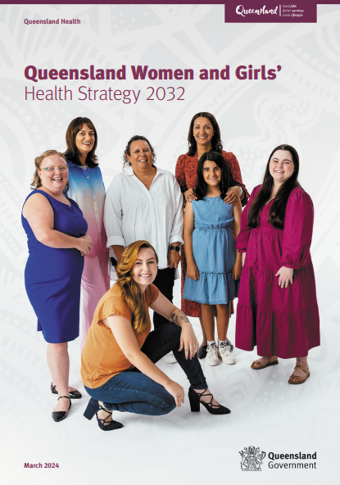

Both strategies have identified mental health and wellbeing as a priority area:

- Queensland Mental Health Week grants support local communities host events that raise awareness of mental health, bolster belonging and create connections
- 1800 4 WOMEN – Women's Health and Equality Queensland funded under the strategy was established in 2025 to provide free phone counselling for women in regional and remote Queensland
- Some local councils organise mindfulness and meditation programs at local libraries. Some offer free yoga and meditation classes in the community.
- Are there any examples of local health services running support groups for older women? School based programs for young women and gender diverse youth?

Example 2: Alcohol and health
National strategy | State/territory document
National Alcohol Strategy 2019–2028  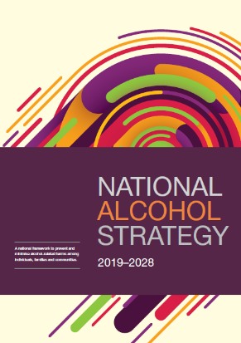 | NSW Alcohol and Other Drugs Workforce Strategy 2024-2032  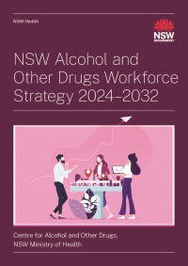

National priorities include ‘supporting individuals to obtain help and systems to respond’.

NSW goals include to ‘build capability of the health system to respond to AOD use and harms, while reducing stigma’.

- The national strategy considers the impacts of consuming alcohol during pregnancy and measures to reduce risks of long-term damage to the developing baby, such as fetal alcohol spectrum disorder (FASD).
- Women as part of the alcohol and other drug (AOD) workforce or as part of the community are not mentioned once in the NSW strategy.
- The Women’s Alcohol and other Drug (AOD) Services Network, supported by the Network of Alcohol and other Drugs Agencies (NADA) in NSW previously developed a gender responsive model of care for women’s only AOD service provision. This was developed with support of funding from the then NSW Ministry of Health.
- Are there any examples of local women’s support groups? Community based groups for young women and gender diverse youth experiencing or caring for someone who uses alcohol or other drugs? Regional or remote based support groups?

This resource is from the ‘Introduction to Gender-Responsive Health’ e-learning course by Australian Women’s Health Alliance.

Last updated May 2025

