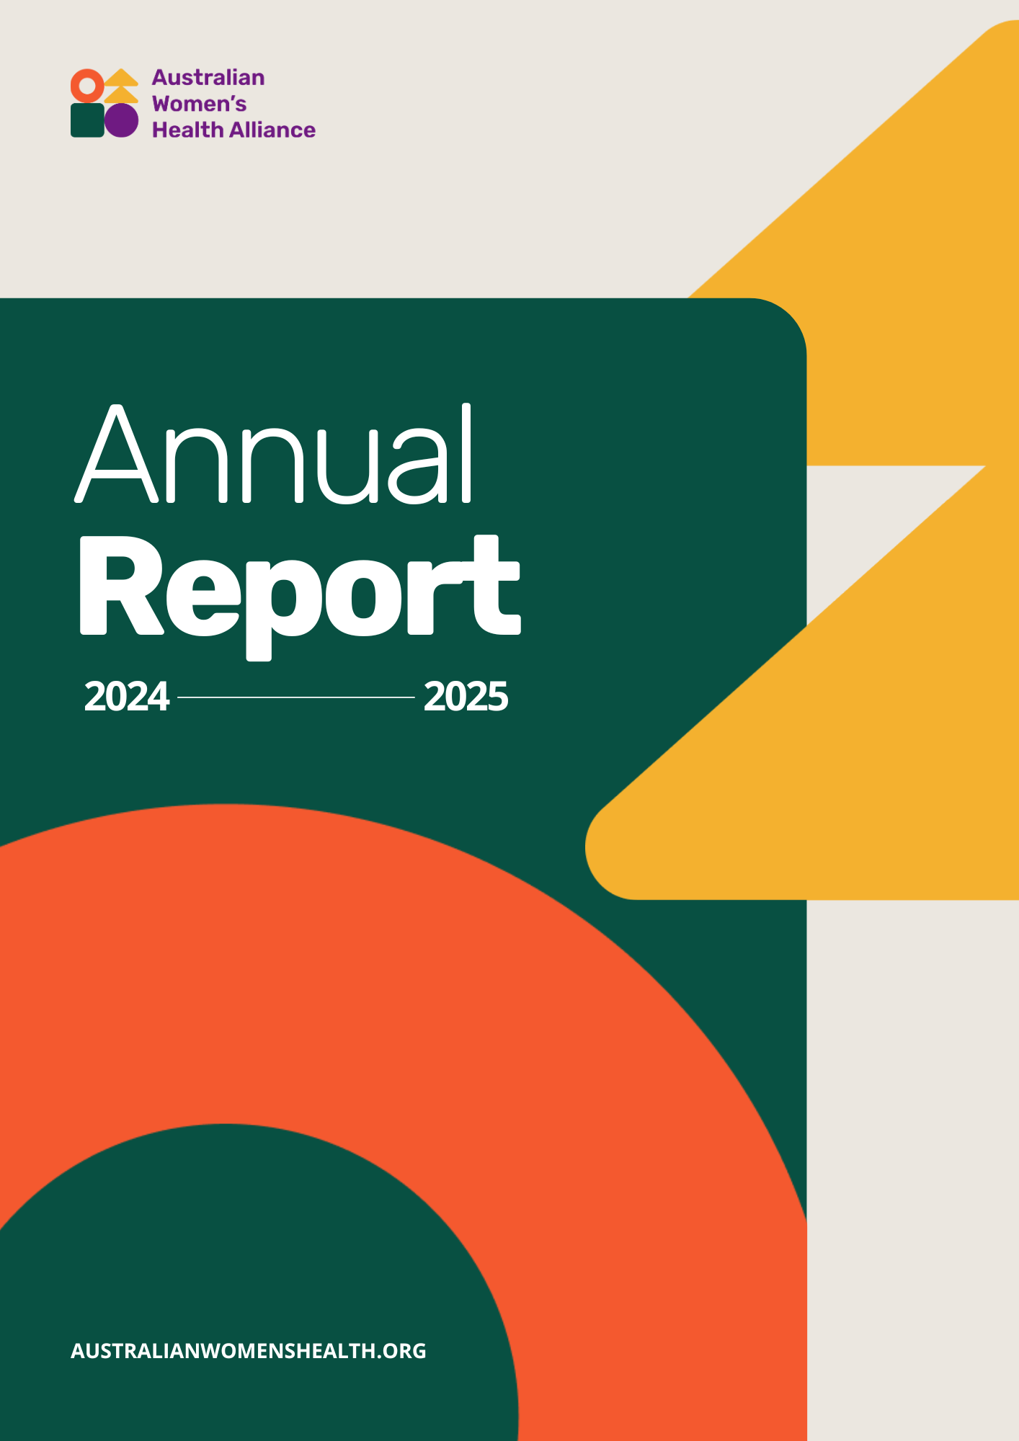

Acknowledgement of Country
We acknowledge the Traditional Custodians of the lands and waters on which we live and work. We pay our respect to Elders past and present. Sovereignty has never been ceded.

Publication
Australian Women’s Health Alliance
Annual Report 2024-2025
Leichhardt, Australia

© Australian Women’s Health Alliance 2025
The Australian Women’s Health Network Pty Ltd is now trading as the Australian Women’s Health Alliance

Reg. No. A02383 ABN 84 238 300 000

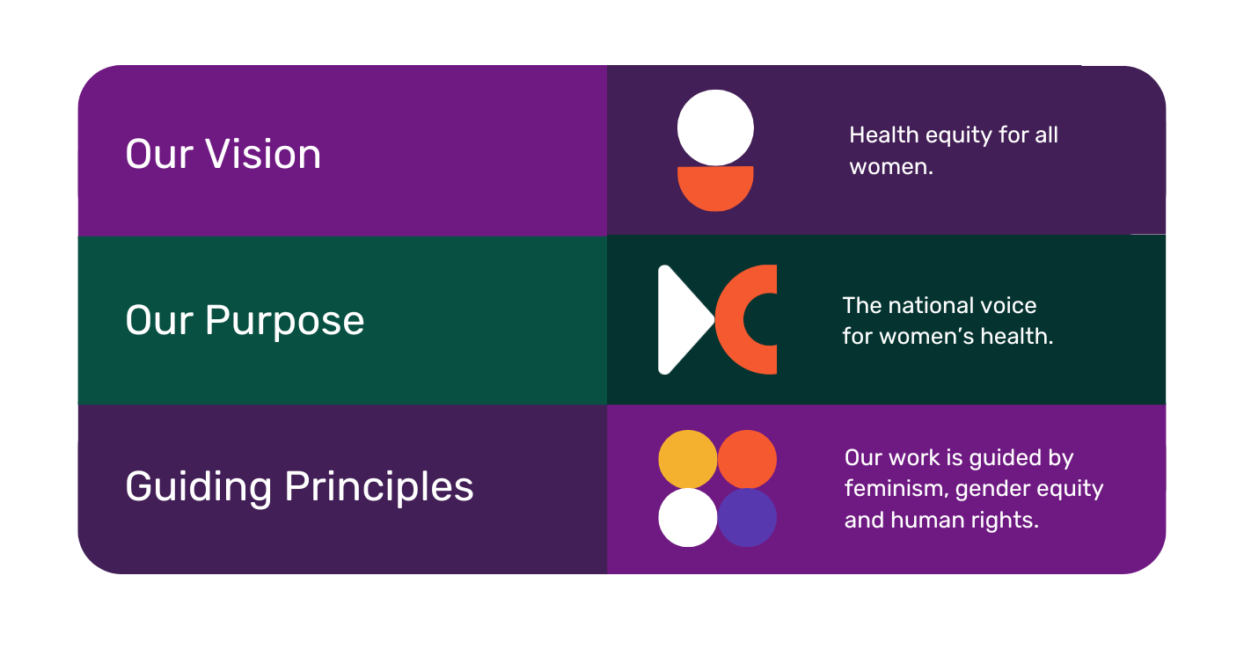
Graphic design by Ximena Jiménez

Leadership Structure
The Australian Women’s Health Network, now trading as the Australian Women’s Health Alliance, formed in 1986. We have members across every state and territory, working in areas of women’s health, gender and health equity. Effort is made to ensure the board reflects a diversity of experience, views, skills and connection into existing networks, so that we can collaborate in providing a national perspective.

Chair Bonney Corbin

Treasurer Denele Crozier AM

Secretary Megan Elias

Deputy Chair and Public Officer Dr Romy Listo

Business Services and Risk Subcommittee Chair Dr Angela Brown

General Board Members
Angelina Inthavong
Daile Kelleher
Eva Perroni (resigned June 2025)
Heidi La Paglia Reid (resigned April 2025)
Holly Brennan OAM
Jo Flanagan
Le Smith
Lobna Rouhani (casual vacancy appointment June 2025)
Margherita Coppolino
Rachael Uebergang
Rosemary Listing (resigned June 2025)
Tahlee Blade Stevenson

CEO Professor Sandra Creamer

Thank you to Kim Blattner, Min Housman, Sienna Aguilar, Bonnie Laxton-Blinkhorn, Bobbie Trower, Illawarra Women's Health Centre, Jana Ventura, Kate May, Kate Whelan, Margherita Dall'Occo-Vaccaro, Phoebe Nagorcka-Smith, Dr Samara McNeil, Tess Moodie and Vanamali Hermans for facilitating conversations, collating content, policy advice, and developing online learning and peer support mechanisms.

Also, acknowledging Women’s Health NSW for supporting our contractors and administrative work through a business services partnership agreement.


Chair’s Foreword
Much like women’s health in this country, the past year has been one of transition for the Australian Women’s Health Alliance. Over the past year we have continued our work building and expanding the Women’s Health Hub, funded by the Australian Government Department of Health and Aged Care. The Hub, and its resources defining gender equity in health through a social determinants lens, now move from a development phase into part of the Alliance’s foundation and impacts. The 6-week challenge saw the translation of our resource into tangible changes to workplace policies, service delivery practices and internal training.
In the same year, we have also welcomed our CEO, Sandra Creamer AM, with funding from a philanthropic funder. This funding, and our CEO, have been game-changing for the Alliance. Sandra has deepened and broadened our engagement, opening our work to reach a broader audience, and importantly, to reach more Australian women. We have found new methods of engagement through our representation on webinars and podcasts, developed new partnerships and engaged with new networks. At the same time, we have continued our partnerships, including those with Women’s Health New South Wales and Fair Agenda, and our representation on consultative bodies and policy networks to ensure that gender equity is considered in health policymaking.
The past few years have seen significant commitments toward women’s health. How these will be implemented is equally important. Women’s health experts and women’s voices will be essential for these commitments to lead to meaningful change. For the Alliance financial sustainability continues to be a priority to support our contributions this change for women, and the ongoing requests for our collaboration and expertise.
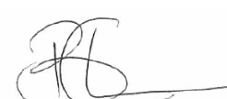
We move into 2025-26 with renewed energy to bolster our reserves and with a new Strategic Plan to continue our advocacy for health equity. With attention to women’s health continuing to grow, it is critical that we also continue our growth and direct our energies to ensuring that our voice, with a social model of health and a commitment to inclusion and diversity at its centre, remains on the agenda.
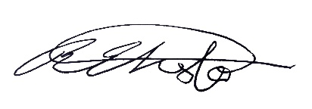
f

Bonney Corbin Dr Romy Liso
Chair Deputy Chair

CEO’s Report
This annual report provides an overview of Australian Women’s Health Alliance engagement, sector reach, focus areas, and digital impact. It highlights key statistics, website performance, and engagement with community, peak bodies, partners and other valued stakeholders. Significant progress has been made against our strategic plan with the annual report demonstrating a number of achievements:
- increased engagement with members, community, universities and non-government partnerships
- membership growth
- creation of case studies highlighting women’s health issue for better outcomes
- development and successful launch of an e-learning platform
- development of several sector strengthening plans
The Australian Women’s Health Alliance is made up of a CEO and Board Directors from each state and territory across Australia. We have diverse individual members and member organisations, to enhance a culturally informed organisation to bring a broader collective knowledge to provide a better understanding of women’s health and wellbeing.
As the CEO, I continue to work with the board of directors and staff to achieve our strategic plan vision, foster a positive accountable culture, ensure effective communication and maintain strong stakeholder relationships.
We thank all our individual and organisation members as well as those who reach out or participate in any of our online sessions. We welcome new members and donations so that we can continue to advocate for the health rights of all women.
Warmest regards,
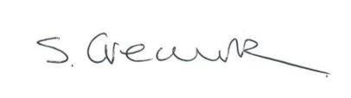

Sandra Creamer AM
CEO


The Alliance is a national leader in developing, advancing, and responding to public policy and practice as it impacts women’s health. We provide independent advice from a broad evidence-base to promote a gendered approach to women’s health care.
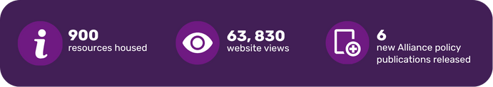
This year, we have continued our work to grow, maintain and expand the reach of the Women’s Health Hub. This national resource is a vital repository of information for people dedicated to improving women’s health outcomes. The resources on the Women’s Health Hub support health advocates, practitioners, policymakers, governments, funders, people with lived experience, and others working across the health eco-system, to embed a gender equity lens through their prevention work. This year also saw the release of the Women’s Health Hub Monitoring, Evaluation and Learning Report, a comprehensive report on the reach, relevance and impact across the 3 years delivering the project.
The Alliance continues to develop policy publications and professional learning resources to strengthen understanding and implementation of gender-responsive health and prevention. This year we added six new Alliance policy publications to the Hub:
- A Gendered Lens on Acquired Brain Injury
- Policy Brief: Investing in Official Development Assistance
- Statement on the Importance of Displaying Flags in Health Care Settings
- The Gendered Experience of Chronic Conditions: Insights, Challenges and Opportunities
- The Importance of Women’s Health: 2024–25 Federal Budget Policy Brief
- Towards Climate, Health and Gender Justice: Addressing the Intersecting Impacts of Climate Change
We also released four new e-learning modules, supported by rigorous user testing and evaluation. The Introduction to Gender-Responsive Health self-paced e-learning course now contains 5 modules:
Foundational modules:
- What's Gender Got to Do with It? Understanding Gender-Responsive Health
- What Can Gender-Responsive Health Look Like? Gendered Inequities vs. Gender-Responsive Approaches
Bonus modules:
- The Gendered Framework for Action on Prevention and Healthcare
- What’s Policy Got to Do with It? Gender Equity in Public Health and Workplace Policy
- What's Next? Taking Action
The Alliance resources and publications continue to be housed on the Women’s Health Hub and are freely available to download, ensuring they are accessible for all.

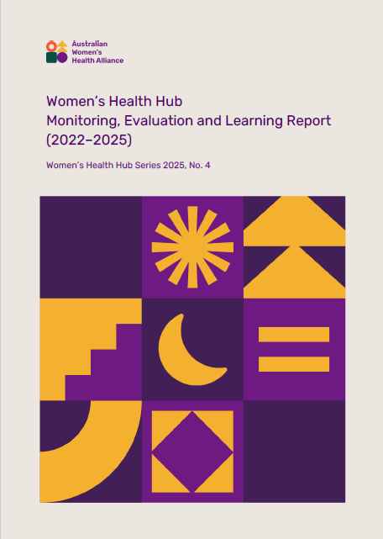
Impact Focus: Women’s Health Hub Monitoring, Evaluation and Learning Report (2022-2025)
2024-2025 was the final year of the Women’s Health Hub project. The Monitoring, Evaluation and Learning Report captures the breadth, depth and impact of the project delivered by the Australian Women's Health Alliance from 2022-23 to 2024-25.
Feedback from members, partners, and stakeholders consistently highlights how Hub activities and resources have been used to inform internal policy development, influence external advocacy, and shift institutional cultures toward more inclusive, evidence-based and intersectional practice. In this way, the Women’s Health Hub has exceeded its original scope, playing a key role in building momentum for systems reform and sector-wide advocacy grounded in lived experience.

Impact Focus: 6-Week Gender-Responsive Health Challenge
“We are now embedding gender-responsive frameworks into leadership strategy and service design. The Hub has reshaped our approach.” - 6-Week Challenge organisation.
In early 2025 seven organisations from across Australia united to take part in our 6-Week Gender-Responsive Health Challenge, a national initiative aimed at strengthening gender equity in health policies, services and practices. The challenge created space for learning, reflection and action to advance health equity for women and gender diverse people as participants worked through the modules in our e-learning course Introduction to Gender-Responsive Health.
Each week, representatives from national health peak bodies, regional women’s services, a local community organisation, and a grassroots advocacy group completed e-learning modules, explored resources on the Hub, participated in Community of Practice sessions, and identified practical ways to apply what they learned to improve policies and practices within their organisations and communities.
Participants reported strengthened confidence and capacity to review and update internal workplace policies, identify ways to support inclusive practice, and embed the Gendered Framework for Action on Prevention and Healthcare into operational processes and written communications. By the end of the challenge many of the organisations had already taken meaningful steps to further embed gender-responsive approaches in their work, from incorporated more intersectional gendered perspectives into policy writing to updating website content and langue to consider accessibility and address barriers.
“We redesigned our onboarding forms with guidance from the Challenge materials.” – 6-Week Challenge organisation.


The Alliance is a vehicle for women’s health organisations, consumers, and advocates to connect and collaborate through our membership base and effective processes to represent the views of members and their constituents. We extend our heartfelt gratitude to all the members, partners and contributors who shared their expertise, time and energy to grow the Women’s Health Hub throughout the year.
This year saw the Alliance partner with organisational member Women’s Health Tasmania to co-host the 2025 Access and Quality: Tasmanian Reproductive Health Conference. We also supported organisational and individual members led advocacy and collaborated on joint statements, publications and actions including Reproductive Health and Rights for PALM Scheme Workers Statement, submission to the Consultation on the Draft NDIS Supports List, Strengthening Responses to Gender-Based Violence in the Alcohol and Other Drug, Women’s and Disability Sectors, climate action, bilingual health education, raising awareness and gender-responsive support for acquired brain injury (ABI), and universal access to contraception. Alliance representatives were guest speakers at a range of webinars and conferences advocating for gender and health equity in policy and practice such as for Australian Health Promotion Association, Fair Agenda, Multicultural Centre for Women’s Health and Western CapeHER.
It has been promising to see the Women’s Health Hub’s emergent role as an enabler of collective advocacy and as a platform for the Alliance’s coordinated efforts to influence policy, amplify community and member voices, and provide leadership to advocate for systemic reforms in women’s health.
Alliance representatives continue to be positioned across a number of government and non-government committees and advisory boards, including the National Women’s Health Advisory Council, the Health Peak and Advisory Bodies Program, the Therapeutic Goods Association Women’s Health Products Working Group, Climate and Health Alliance, the Early Pregnancy Loss Coalition, the Women Deliver Oceanic Committee, the Health Equity Learning Lab Oz by Stretton Institute at the University of Adelaide, the SPHERE Women's Sexual and Reproductive Health Coalition and the National Women’s Equality Alliance.

Impact Focus: Engagement
In 2024-25 we have seen a significant increase in engagement with our social media posts and in the number of visits to the Women’s Health Hub, demonstrating our capability in creating impact. Our website views have nearly doubled, increasing from 22,162 views in Australia and 34,859 views globally in 2023-24, to 36,325 views in Australia and 63,830 views globally in 2024-25.
We also had a significant focus on building our organisational reach through our membership. We now have 50 organisational members, representing all States and Territories, national and internal organisation. Similarly, we now have 249 individual members with a large number increase in South Australian and Queensland membership, due in part to membership promotion at our webinars.
The chart below illustrates Alliance engagement across different sectors in our membership base. Community and Grassroots Organisations form the largest segment, followed by Peak Bodies and Advocacy, and Women’s Health Services.
This distribution reflects the strong local and advocacy-based network.

Alliance Member Engagement by Sector
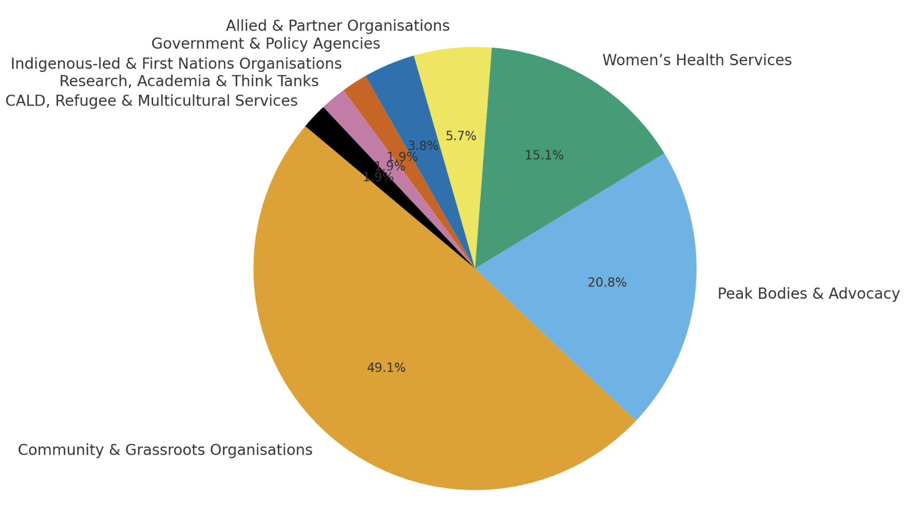

Impact Focus: Fair Agenda
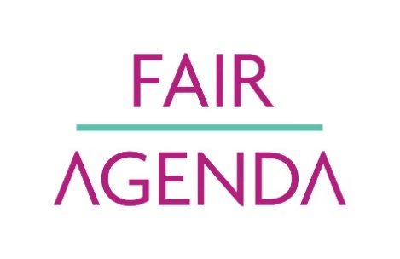

We have also continued our successful partnership with Fair Agenda, collaborating on campaigns that progress our shared vision of a more gender equitable future and activities that improve women’s health and wellbeing. Our collaboration provides an opportunity for the Alliance to contribute to significant campaigns on issues that impact women’s health and wellbeing.
This year the major campaigns supported through the partnership have focused on protecting and supporting improved access to abortion care, improving support for victim-survivors of sexual violence, and focusing a spotlight on reforms needed for women’s health and wellbeing in the lead up to the Federal election.



As an independent peak and health promotion charity, the Alliance demonstrates best practice in its governance, leadership, and operations. The board met every second month.
The Board also invested in the Business Services and Risk subcommittee, chaired by Dr Angela Brown, as a priority for investment and action. The Business Services and Risk Subcommittee oversees all aspects of business including project management, the Fair Agenda partnership agreement, donor reporting, finance, risk, record management, administration and contractors.
We reviewed and maintained our business services agreement with Women’s Health NSW, which provides critical business services and administrative support functions. Previous advice from board evaluations and member feedback was incorporated into risk reviews, continuous improvement, and ongoing organisational development.
With a CEO to lead our operations from 2024-25, we have also been able to prioritise the review of a significant number of organisational policies and procedures, ensuring our organisational practice is kept up to date.

Finance
Audited financial accounts for the 2024-25 financial year are tabled at the Annual General Meeting and available on Australian Charities and Not-for-profit Commission (ACNC) website. We are currently at the end of an extended 4 year grant from the Australian Government Department of Health and Aged Care, Health Peak and Advisory Bodies Program which will end 30 June 2026
Our non-institutional sources of income are membership fees, philanthropy, and one-off donations all of which slightly increased in the last financial year. This includes our grant management agreement with Fair Agenda to collaborate on campaigns related to women’s health and wellbeing.
We have a small but strong finance team coupled with good financial systems and projected budgets for the year ahead overseen by our Business Services and Risk Committee. We started this year with a projected budget and ended with an unqualified audit.
The Australian Women’s Health Alliance continues to operate to budget and asserts that there are reasonable grounds to believe it will be able to pay its debts, if, and when, they fall due.
 | 2024/25($) | 2023/24($)
Revenue  Project grants | 179,854 | 166,048
Memberships | 3,540 | 3,400
Donations received | 598,151 | 250,889
Interest | 1,089 | 758
Other income  Less donations distributed | 47,521  (583,750) | 89  (241,895)
Revenue from ordinary activities | 246,404 | 179,289
Expenses  Accounting and audit fees  Consultancy  Human resources expenses  Infrastructure expenses  Governance and strategy  Marketing and communications  Other expenses | 7,300  7,411  179,830  13,864  13,950  23,645  740 | 5,282  7,861  130,171  9,723  4,880  14,977  308
Total expenses by function | 246,740 | 173,202
Surplus/(deficit) from ordinary activities | -336 | 6,087
plus other comprehensive income |  | 220
Total equity variation | -336 | 6,307

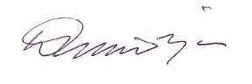

Denele Crozier AM
Treasurer
